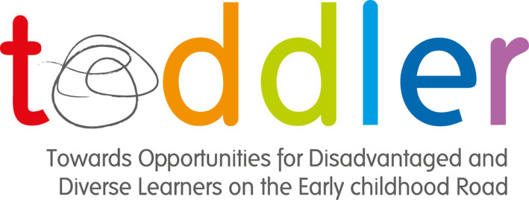

Work Package 4
4:1 - Report
Promoting the Wellbeing of Toddler’s within the European Union

Compiled by: Helen Sutherland and Jan Styman
Kingston University, England
Contribution from: Annelies Depuydt and Veerle Martens
University College Arteveldehogeschool, Belgium
Julie David
Haute Ecole Libre Mosane, Belgium

Ove Steiner Rasmussen
University College South Denmark, Denmark
Helen Sutherland and Jan Styman
Kingston University, England

Alexandra Hackel
University of Education Schwäbisch Gmünd, Germany

Monika Rothle and Elisabeth Ianke Morkeseth
University of Stavanger, Norway

Maria João Cardona
Instituto Politécnico de Santarém, Portugual

Mona Vintila
West University of Timisoara, Romania

Carme del Flores Muxi
Universitat Ramon Lull, Spain

Contents | Page Number
Introduction | 2
Belgium – Flemish | 3
Belgium – French | 9
Denmark | 15
England | 21
Germany | 26
Norway | 31
Portugal | 40
Romania | 45
Spain | 52
Lecturer Guidance Notes | 61

Work Package 4 – deliverable 4:1 - Report
Promoting the Wellbeing of Toddler’s within the European Union

Each partner has been asked to provide a definition of wellbeing and to identify their country’s underpinning legislation and research on wellbeing. This information has been compiled into a report/handbook which can be used as teaching materials in conjunction with the PowerPoint.
Contents include:
- Definitions of wellbeing
- Theoretical backgrounds
- Literature Reviews
  - Curriculum documents
  - Piece of National Research
  - Recommended Reading
These materials are photocopiable for teaching purposes.

Belgium – Flanders

Definitions of wellbeing
“When we want to know how each of the children is doing in a setting, we first have to explore the degree to which children feel at ease, act spontaneously, and show vitality and self-confidence. All this indicates that their emotional well-being is OK and that their physical needs, the need for tenderness and affection, the need for safety and clarity, the need for social recognition, the need to feel competent and the need for meaning and moral value in life are satisfied. Interventions that secure the well-being of children make them stronger and keep them in touch with their feelings and emotions.”

Reference:
Laevers F. (2005) Experiential Education – Deep Level Learning in Early Childhood and Primary Education. University of Leuven

Belgium – Flanders

Theoretical background to children’s wellbeing
Belgium has a long history of a split system between education and care. Childcare for children from zero to three is under the auspices of the Ministry for Welfare, while children from 2.5 years of age attend kindergarten centres, which come under the responsibility of the Ministry of Education. Vandenbroeck, Pirard and Peeters, (2009). Therefore both settings are described in their use of the concept of “well-being”.

Toddlers and well-being in CARE settings
As part of its policy to improve the quality of care provisions, Kind & Gezin [Child & Family] -the Flemish agency that supervises the care sector - took the initiative to develop an instrument that had to meet three requirements:

(1) it has to serve as a tool for self-assessment by care settings;
(2) it must take the child and its experience of the care environment as the main focus to look at quality and;
(3) it must be appropriate for the wide range of care provision including care for the under three’s in day care centres and family care as well as the out of school care for children up to the age of twelve.

The instrument has been developed by a team based at the Research Centre for Experiential Education (Leuven University – Belgium) under the supervision of Dr. Ferre Laevers. SiCs is based on a conceptual framework that has been developed during the last decades in the context of innovative work in pre-school, primary, secondary and higher education. Two indicators of quality are central to this ‘experiential’ approach: ‘well-being’ and ‘involvement’. Well-being refers to feeling at ease, being spontaneous and free of emotional tensions and is crucial to secure ‘mental health’. Involvement refers to being intensely engaged in activities and is considered to be a necessary condition for deep level learning and development.
SiCs is designed to help settings to get aware of their strengths and weaknesses when it comes to create the best possible conditions for children to develop. Although heads of settings or coordinators are collecting most of the data through observation, every supervisor in the settings is actively involved in the procedure of self-assessment. The process of reflection and action is seen as the responsibility of the whole team.

Further information is available at:
http://www.kindengezin.be/algemeen/english-pages.jsp
http://www.youtube.com/watch?v=5AAmAUPbFIE&feature=related
Toddlers and well-being in EDUCATIONAL settings
In the core curriculum for preschool education, set out by the Flemish government in, the following goals are detected, related to the concept of well-being:

ME AND MYSELF

The pre-school children:
3.1 are aware when they are afraid, happy, angry or sad themselves and are able to express this simply;
3.2 are able to describe a situation which has recently happened and in which they were involved in simple language in a dialogue with an adult and say how they felt;
3.3 in specific situations reveal sufficient self-confidence about their own abilities.

ME AND THE OTHER
The pre-school children:
3.4 are able to recognise different ways of interacting in specific situations and talk about them;
3.5 are able to recognise feelings of anger, joy, fear and sadness in others, and empathise with that feeling;
3.6 know that people can experience the same situation in different ways and can respond differently;
3.7 reveal sensitivity to the needs of others;
3.8 are able to stand up for themselves by giving signals which are understandable and acceptable to others.

ME AND OTHERS: IN A GROUP
The pre-school children:
3.9 are familiar with and understand ways of interacting, rules and arrangements which are important for being together in a group;
3.10 are able to make arrangements in specific situations, with the help of an adult;
3.11 are able to check whether others are following the rules in an activity or game in a small group.

These goals are common for all schools in Flanders, private as well as public schools. Often the concepts of well-being and involvement (defined by the Research Centre for Experiential Education (Leuven University – Belgium)) are used to put these goals into practice. The Research centre developed ‘A Process-Oriented Monitoring System for Early Years’ as a tool for quality control in pre-school. This system focuses on the major indications for quality: well-being and involvement. Children are screened using a 5-point scale for both dimensions. For those who fall below level 4 practitioners are guided to more advanced observations. This approach gives a sense of purpose and efficacy: you get immediate feedback and can get to action without delay. Screening of the group four times a year has not only proven to be practicable but also most effective to raise levels of well-being and involvement in all children and improve achievements.

Further information is available at:
http://www.ond.vlaanderen.be/dvo/english/index.htm
http://www.cego.be/en

References:
Laevers, F. (2011): Experiential Education: Making Care and Education More Effective Through Well-Being and Involvement. Published online.

Laevers, F,. Declercq, B., Colleen, M., Moons, J. en Stanton F. (2011): Observing involvement in children from birth to 6 years. CEGO Publishers NV, Leuven.
http://www.averbode.be/observing-involvement-in-children-from-birth-to-6-years

Laevers, F. (Ed.) (2005): Well-being and Involvement in Care Settings. A Process-oriented Self-evaluation Instrument. CEGO, Leuven.

Agentschap voor kwaliteitszorg in Onderwijs en Vorming, Curriculum (2010): Ontwikkelingsdoelen en eindtermen voor het gewoon basisonderwijs. Brussel,

Belgium – Flanders
Literature Review
Curriculum Documents
Core curriculum for preschool education, Flemish government, Belgium

In the core curriculum for preschool education, the following goals are detected, related to the concept of well-being as described lower.

ME AND MYSELF

The pre-school children:
3.1 are aware when they are afraid, happy, angry or sad themselves and are able to express this simply;
3.2 are able to describe a situation which has recently happened and in which they were involved in simple language in a dialogue with an adult and say how they felt;
3.3 in specific situations reveal sufficient self-confidence about their own abilities.

ME AND THE OTHER
The pre-school children:
3.4 are able to recognise different ways of interacting in specific situations and talk about them;
3.5are able to recognise feelings of anger, joy, fear and sadness in others, and empathise with that feeling;
3.6 know that people can experience the same situation in different ways and can respond differently;
3.7 reveal sensitivity to the needs of others;
3.8 are able to stand up for themselves by giving signals which are understandable and acceptable to others.

ME AND OTHERS: IN A GROUP
The pre-school children:
3.9 are familiar with and understand ways of interacting, rules and arrangements which are important for being together in a group;
3.10 are able to make arrangements in specific situations, with the help of an adult;
3.11 are able to check whether others are following the rules in an activity or game in a small group.
National Research
Laevers F. (2011) Experiential Education: Making Care and Education More Effective Through Well-Being and Involvement. Belgium: Leuven University / Centre for Experiential Education,(Published online February 14, 2011)

Recommended Reading
Laevers F. Declercq B and Stanton F. (2011) Observing involvement in children from birth to 6 years. Cego Publishers NV
http://www.averbode.be/observing-involvement-in-children-from-birth-to-6-years
Belgium - French
Definitions of wellbeing
The wellbeing is a pleasant result of meeting the needs of the body and calm. When we talk about wellness in children, the most common dimensions in the research and literature are:
 Quality of life
 Physical and psychological health
 Self-confidence

In the specific literature in the French Community of Belgium, the Centre for Children, Youth and Youth Welfare has identified five indicators of well-being in children:

- Availability positive. This is the opportunity to live a life as a child adapted to the stage of development in which the child is, due to the fact that no material or moral factor (fear or anxiety) will destroy the possibility that al subjective child to enjoy his rights under the Declaration of the Rights of the Child.
- Well-being "received". Welfare receipt is the well-being that comes alone without the child should be anything for the cause.
- The cultural well-being and social development. It requires both a framework and approach of the child. This dimension relates to finding a place (a role, status) within a social group more or less structured.
- The psychological and moral well-being concerns the fact of feeling good about oneself, to be comfortable (or pleased) with what we are and what we want to become
- The right to express his own vision and claim what is estimated to be eligible. In other words, the right to have an impact not only on hardware but also the rules established, or even on the principles of legitimacy of the established rules.

Belgium - French
Theoretical background to children’s wellbeing
Pirard F. (2010) Pour une évaluation participative de la qualité effective de l'accueil, in collectif sous la direction de Marie-Paule Thollon-Behar : La qualité de l'accueil : quel défi aujourd'hui? .
(For a participatory evaluation of the actual quality of reception, in the collective under the direction of Marie-Paule Thollon-Behar: The quality of the home: what a challenge today?)
In the rapidly changing landscape of childcare from early childhood, the main purpose of government is to extend the offer to host, often a loss, at lower cost. Faced with this research to optimize the amount, what about quality? What about values ​​that are defended by the services and associations that offer their facilities to smaller, while the clock is ticking, the pressure exerted on the attendance and organization of the service? Must we choose between cost and quality or would it be possible to find a compromise between the two? The key word of this book is "participatory approach", involving all partners, teams, coordinators, parents, policy makers, managers, trainers, but also in mobilizing to provide all children an environment conducive to their well-being and their emotional, intellectual, social
Environments in early childhood are still heavily influenced by an author called Françoise Dolto. Two books seem well represented the views of children and their influence on the choices made in welcome organizations for Toddler.
Dolto françoise, La cause des enfants, 1985 “The cause of children”
Never, perhaps, had they spoken in a way as beautiful and fair to the child. Of its truth, of his desire. Faced with a collective investigation of multiple subjects: the representation of children in history, its place in society, hospitality at birth, school, Dolto, through his own past, experience as a psychoanalyst of children, mother, too, reacts. In his usual way, stating truths sometimes difficult to hear, through defending the cause of education that children against perverts on the side of protection, against the cult of the single standard, the submission to the fashions of the day, the imposition parental model. All their answers are guided by one idea: by respecting the child, we respect the human being.
Dolto françoise, “Tout est langage” 1989 “Everything is language”,
Dolto appears as an author who addressed not only to specialists but also to a wide audience. This book contains the contents of a lecture addressed to psychologists, doctors, and social workers. Dolto highlights in this book the importance of speaking the truth to children. In his book, Dolto deals in particular the following questions: how far can we tell the truth to children and are there limits? How can we make certain truths and avoid taboos?
Map document:
I. biography
II. psychosomatic effect
III. The child does not meet the desire of its parents in its development
III. The difference between need and desire in the education of children
IV. The importance of truth to children
V. The green houses: a transitional place to live
Belgium - French
Literature Review
Curriculum Documents
Eurochild (2010) Annual Report. Eurochild : avenue des Arts, 1-2B à 1220 Bruxelles (Belgium), available at: www.eurochild.org (improving the quality of life of children and young people).

Further information is available at:
decet.org : Diversity in early childhood education and training, Available at: www.one.be

National Research
OMS (2004) Les determinants sociaux de la Santé, (Social determinants of health)

Houtman F. (2002) Accueillir les tout-petits, Oser la qualité, un référentiel psychopédagogique pour des milieux d'accueil de qualité. ONE.
(Caring for young children, dare the quality , a repository for community psychology quality reception)
The process of developing this standard, based in the reality of the French Community of Belgium, is based on the crossroads of different looks, theoretical approaches and experiences, to better understand and transform the reception of toddlers in variety of contexts. The authors' objective is to provide a set of knowledge considered relevant to improve the reception of early childhood.
• Need to work on the relationship between friendly and children (joint-link separation, separation and preparation of the accompanying separation). This requires a partnership between parents and professionals. This position requires a particular professional;
• Accompany the child on the way to strive for self-socialization of the child and the initiative (this can be encouraged during times of personal care, during meals, when toilet training). Also, the practices of cultural awakening that seem indispensable to self chamin;
• The free activity is essential to the welfare of the child: to act is to understand, to express and to exist.

Observatoire de l’enfance, de la jeunesse et de l’aide à la jeunesse (communauté française, wallonie, Bruxelles cfwb)-indicateurs de bien-être de l’enfant (Observatory on Children, Youth and Youth Welfare (French Community, Walloon, Brussels CFWB))
- Availability positive.
- Well-being "received".
- The cultural well-being and social development The psychological and moral well-being
- The right to express his own vision and claim what is estimated to be eligible
O.N.E., Pedagogical file
Say, when I go to school?
Pedagogical file is produced as part of the campaign "Serve the entrance to kindergarten" for professionals to facilitate the approach of this theme in a dialogue with parents. This file is divided into chapters ranging from the preparation, separation, at the start and adaptation to the new environment.

Recommended Reading
OCDE (2009), assurer le bien-être des enfants (provide the wellbeing of the children)

Laffont R. (1985) La cause des enfants. Pocket (On behalf of children)
Lorsque l'enfant paraît, t. I, II et III, Seuil, 1977, 1978, 1979; coll. « Points », 1999 (When the child appears)
Parler juste aux enfants, (1977 - 1981), entretiens avec Danielle Marie Lévy, Mercure de France, coll. « Le Petit Mercure », 2002 (talk just to children)
Welcome in the spirit of Dolto can be reduced to "put words" situations, emotions, and the feelings of children and the risk of mistakes because there is nothing worse than the unsaid.
Throughout his work, Dolto shows us that the child understands many things.
The human being, even infants, has this ability to develop this understanding.
It is first intuitive and emotional and then become more complex with the emotional and intellectual dimensions. We are far from the image conveyed long a "small animal", it is sufficient to monitor in order to satisfy their basic needs.
The child must first find the base consists of security and love in forming his personality.
It starts with the best possible experience separation from mom and dad and also implies the respect of his emotions and the value of its initiatives with an appropriate word.
Thus, self-confidence will grow.
"Putting words on 'does not mean" tell all "to the child ... It would not be good for the child!
But with words appropriate to his age, and what concerns and the child is not an adult to best help the child to be structured, it is necessary, in addition to verbalizations, it set limits, to designate the rules and prohibitions: the name and explain the meaning.
When the child feels it is important to us, when the adult takes care of him by structuring its environment: it can grow.

Denmark
Definitions of wellbeing
Wellbeing is in a meta-perspective connected to an understanding of the welfare state and democracy and the idea of care.
A study in dictionary of the Danish language defines ´trivsel´ (wellbeing) as:
- that a living being ( a tree or a child) thrive, get good and healthy growth, health and vitality
- About people or a society's development, progress in happiness, wellbeing, prosperity, spiritual values ​​etc., or whether the conditions in which people live well, living happily and in good conditions.
In the field for Toddlers wellbeing is closely connected to the idea of care. Wellbeing is essential for the Childs activity and attention to the world. It is related to development of social relations such as development of contact between children and social contact to parents and adults in the crèche and day-care. The professionals must be able to take care of and look after. Developing the Childs ability to take and give care as a part of the Childs understanding of giving and taking care is the core of the Danish pedagogic for Toddlers. The concept of care and wellbeing is closely connected to the concept of learning and teaching, which is a part of the concept of wellbeing.
Wellbeing and care is often related to an individual understanding, and can therefore be a central matter for discussions.

Denmark
Theoretical background to children’s wellbeing
There is a common understanding in the Nordic countries of early childhood, day care and of the general didactics as well as in the legislation. You can find minor diversifications between the countries.
In Denmark The Act on Day-Care is using the word welfare (in Danish ´trivsel´) which is a synonym for the word wellbeing (for more information please look at item 5). In the Act on Day-Care they translate ´trivsel´ by the term Welfare. Welfare appears to times in the Act on Day-Care. First time in the purpose of the Act (§1.1):
“The purpose of this Act is to promote the welfare, development and learning of children and young people thru day-care, after-school and club facilities and other socio-pedagogic after-school facilities”
and in section [§ 7.1] Purpose of day-care facilities:
“Children in day-care facilities shall have a physical, mental and aesthetical child environment that promotes their welfare, health, development and learning.”
In the explanatory notes to the Act on Day-Care the government underlines our commitment to the UN Convention on the Rights of the Child (1989), but we do not have a national definition or description of what ´trivsel´/ welfare / wellbeing is.
Language is one of the sixth categories in the Pædagogiske Læreplan (curriculum for day-care) :
- Personal competence
- Social competence
- Language
- Body and movement
- Nature and natural phenomenon
- The act of expressing culture, cultural artefacts and cultural values

Here to come a specially demand and focus on social deprived children.
Further information is available at:
http://english.sm.dk/social-issues/children-and-youth/daycarefacilities/Sider/Start.aspx
Since the 1. August 2004 a day-care institution in Denmark has to have at curriculum. The Act of Day-care is the frame for the local institutions curriculum.
In Denmark it is possible to have maternity or paternity leave for one year. Statistic documents that women takes the main part of the child’s first year.
A child can start in day-care in private home or in a day-care institution from the age of 10 – 12 month. For day-care in private home there is no demand on special education. When the child is tree years of age it starts in kindergarten. When the child becomes 6 years of age it is integrated in the public-school system.
Day-care facilities coves in Denmark crèche (´vuggestue´), family day-care (´dagpleje´), nursery schools (´børnehave´) and age-integrated institutions (´aldersintegrerede institutioner´).
In day-care institutions you will find a mix of educated and no-educated people taking care of the children.
Statistics Denmark (2009) tells us that 28.200 kindergarten teachers, 21.300 kindergarten assistants (uneducated) and 18.600 uneducated child-minders takes care of 312.000 children. Denmark is cover by 1.900 kindergarten, 325 crèche and 2.400 age-integrated institutions.
A person with adequate education comes from a University College as kindergarten-teacher.
The Danish government guarantees the family via local authority a place in day-care facilities.
In Denmark (2009) over 95, 6 % of the children in the age of one to six years of age is enrolled in crèche, day-care and kindergarten. You may think that it is a large institutionalization of the early childhood, and you are right. We have never had a fundamental discussion about this phenomenon. It has just become that way.
As my contribution to the project I have made a peer review on litterateur concerning Toddler in a Nordic country perspective. I have added links to this paper (please have a look in WP 2).
In 2006 the Danish government presented a national strategy for “Vicious circle of deprivation and equal opportunities”. The 2007 finance act allocated DKK 9 million for the period 2007 – 2010 “for at study of the help to the most disadvantaged 0 – 3 year-olds and for identification of the optimum methods for meeting their needs.” The final report is still to come.
Further information is available at:
http://english.sm.dk/social-issues/children-and-youth/viciouscircleofdeprivationequalopportunities/Sider/Start.aspx
In January 2009 the government presented the bill Children’s Reform: “The objective of the reform is to improve initiatives targeting disadvantaged children and young people. The central element of the reform is to ensure that consideration for the child outweighs everything else.
The overall objectives are:
- To secure continuity in placement outside the home
- To secure a stable and close relation to an adult
- To strengthen the focus on the child rather than focusing on the parents
- To secure the rights of the child
- To secure early efforts to improve the child´s opportunities”
Further information is available at:
http://english.sm.dk/social-issues/children-and-youth/childrensreform/Sider/Start.aspx

Denmark
Literature Review
Curriculum Documents
http://www.toender.dk/subhtml/pdf/Vuggestuen.pdf
Suggestion: Try using the Google translator. It is not perfect, but the translation can give you an impression of a Danish curriculum.
Within the framework of The Act of Day-Care each Danish crèche, day-care, nursery and kindergarten must prepare a local curriculum (The Act on Day-Care 2005)
I quote from the curriculum for Tønder kommunes Vuggestue:
“Goal-settings are as follows:

- to preserve, strengthen and enhance children's self-esteem
- to give children love, care and warmth
- to preserve and enhance each child's personality
- to preserve and strengthen the children's needs and happiness of being in contact with other people
- children must learn the use of language options in contact and play with others, and the joy in singing and making music
- ensure that children go through a healthy physical development

“What is a child in vulnerable position?
It is in our experience:
- a child with physical disabilities
- mentally ill parents
- parents with drug problems
- families with physical and / or psychological violence
- families with incest / pedophilia
- a child living in a family that does not support child's needs
- a child without a secure base and safe connection
- a child who is delayed in its development
- a child who is born too early
- family with temporary crisis - divorce, death

Professionals recommend using a month for introduction before starting.
The exemplary institution in this study use Sally Ward’s book Baby Talk (2004).

National Research

Knowledge-based Efforts for Socially Disadvantaged Children in Day-care

http://webcache.googleusercontent.com/search?q=cache:YNZds4wHSyMJ:www.dpu.dk/en/research/researchprogrammes/organisationandlearning/vida/

VIDA – Vidensbaseret indsats over for udsatte børn i dagtilbud. Statusrapport 1. 2011
http://www.dpu.dk/fileadmin/www.dpu.dk/e-boeger/VIDA_rapporter/VIDA_statusrapport_foraar_2011.pdf

VIDA – forskningskortlægning. Programmer for 0 – 6 årige med forældreinvolvering i dagtilbud. 2011
http://pure.au.dk/portal/files/37957789/VIDA_forskningskortl_gning_BILAG2.pdf

Recommended Reading
Sommer D. Pramling Samuelsson I. and Hundeide K..(2010) Child Perspectives and Children´s Perspectives in Theory and Practice. International perspectives on early childhood education and development. Springer. New York:

Dion Sommer is, in my view, our foremost Danish researcher in early childhood. He is professor at the University of Aarhus (Denmark), Ingrid Pramling Samuelsson is a Swedish professor in early childhood at the University of Göteborg (Sweden). Karsten Huneide is former professor at the University of Oslo, and has developed The ICDP-program – International Child Development Program.
I think this is the most important book for years concerning wellbeing / welfare for early childhood presenting Scandinavian and international research.
England

Definitions of wellbeing

Wellbeing is a state of being or condition of existence that characterises an individual realising their full potential through their own prosperity, welfare, life satisfaction, health, eudemonia (human flourishing) and happiness.

Styman J. and Sutherland H.

England

Theoretical background to children’s wellbeing
In September 2003, the Every Child Matters (ECM) agenda was published, outlining the previous Government’s vision for children’s services. It proposed reshaping children’s services to help achieve the outcomes which children and young people are said to be key to well-being in childhood and later life.

The Five Outcomes are:
1. Be Healthy:
2. Stay Safe:
3. Enjoy and achieve:
4. Make a positive contribution:
5. Achieve economic well-being

This agenda underpinned the Children Act 2004, and the Childcare Act of 2006, which created a basis for the Early Years Foundation Stage (EYFS) framework. This was followed by a piece of research Key Elements of Effective Practice (KEEP, 2005) carried out for the Department for Education and Skills (DfES).This emphasised the importance of “effective learning is dependent on secure relationships, and appropriate learning environment and high-quality teaching.” (DfES, 2005:5) This has underpinned the development of the Early Years Professional (EYP) in supporting early years as a graduate lead profession. The Effective Provision of Pre-School Education Project (EPPE, 2004) kicked off the research into effective practice in England and was the first longitudinal study of its kind. This explored the different types of provision in England and how it influenced a child’s development identifying good practice. These two initiatives have promoted high quality early years provision by supporting wellbeing through practice.

The Allen Report (2011) into early intervention highlighted children’s social and emotional development as a ‘bedrock’ in supporting children’s physical and mental health. He identified 80 different early intervention programmes that demonstrated good practice stating that “if we intervene early enough, we can give children a vital social and emotional foundation which will help to keep them happy, healthy and achieving throughout their lives and, above all, equip them to raise children of their own, who will also enjoy higher levels of wellbeing” (Allen, 2001:ix)

Dame Claire Tickell (2011) carried out a comprehensive review of the Early Years Foundation Stage (EYFS) drawing on the Allen Report (2011) reviewing four areas:
- Regulation
- Learning and Development
- Assessment
- Welfare

The recommendations that she then put forward aimed to:

- “Address ways to prevent children from falling behind in their learning through early intervention
- Address ways to engage parents more in their children’s learning
- Clarify ‘safeguarding and welfare’ requirements – link to Munroe review – training
- Overhaul the EYFS curriculum framework
- Devise a join-up approach to early progress checks between health and education
- Reduce paperwork for providers of early learning
- Simplify current assessment procedures”(Langston, 2011)

The Early Years Foundation Stage (EYFS) will continue to ensure that children’s wellbeing is promoted through a variety of strategies put forward by Alllen (2011) and Tickell (2011). For example, Sure Start Children’s Centres were set up within each Local Authority to support quality of children’s learning in each centre for birth to five years. These centres follow the principles of the Early Years Foundation Stage (EYFS) to promote the development of children and to improve outcomes for children and their families through a range of different services which meet the localities’ needs, such as, integrated care, education and health services.

References:
Allen, G. (2011). Early Intervention: the Next Steps. London: Cabinet Office
Great Britain. Department for Education and Skills (2005) Keep – Key Elements of Effective Practice. Nottingham: Department for Education and Skills
Great Britain. Department for Children, Schools and Families. (2008) Early Years Foundation Stage. Nottingham: Department for Children, Schools and Families.

Langston A. (2011) EYFS REVIEW special - what it means for you and your practice. Nursery World, 30 March 2011. [Online] Available at: http://www.nurseryworld.co.uk/news/1062969/EYFS-REVIEW-special---means-practice/ (Accessed: 13th June 2011)
Sylva K., Melhuish E., Sammons P., Siraj-Blatchford I. and Taggart B. (2004) Effective Provision of Pre-School Education: Findings from end of pre-school to the end of Key Stage 1. Nottingham: Department for Education and Skills
Tickell, C. (2011) Early Years Year’s: Foundations for life, health and learning. London: Cabinet Office
England
Literature Review
Curriculum Documents
Great Britain. Department for Children, Schools and Families. (2008) Early Years Foundation Stage. Nottingham: Department for Children, Schools and Families.

http://webarchive.nationalarchives.gov.uk/20110202093118/nationalstrategies.standards.dcsf.gov.uk/node/157774

The Early Years Foundation Stage (EYFS) provides the national legal framework for all early year’s provision within England. It was part of the previous government’s ten year strategy to improve the outcomes for children. The EYFS states the statutory/legal requirements that are central in underpinning early year’s provision within settings. It was designed to support and guide settings in helping children reach their full potential.

There are four principles that underpin the EYFS and these are:
- A Unique Child
- Positive Relationships
- Enabling Environments
- Learning and Development
The principle of a unique child (‘principles into practice’ guidance cards 1.4) informs early year’s practitioners about the importance of emotional well-being, physical well-being, effective practice, challenges and dilemmas and reflecting on practice. (DCSF, 2008: practice card 1.4)
The EYFS has six areas of Learning and Development:
- Personal, Social and Emotional Development
- Communication, Language and Literacy
- Problem Solving, Reasoning and Numeracy
- Knowledge and Understanding of the World
- Physical Development
- Creative Development

Personal, Social and Emotional Development “means for children, being special to someone and well cared for is vital for their physical, social and emotional health and wellbeing.” (DCSF, 2008:24) Underpinning this area of development “providers must ensure support for children’s emotional well-being to help them know themselves and what they can do.” (DCSF, 2008:24) Settings must therefore demonstrate how they are meeting children’s wellbeing within their provision.

National Research
Elfer P. & Dearnley K. (2007) Nurseries and emotional well-being: evaluating an emotionally containing model of professional development. Early Years: An International Journal of Research and Development, 27, (3), pp. 267–279

With the increase of nursery provision for young children within England, comes a growing concern about how their wellbeing is being facilitated by early year’s practitioners. The Early Years Foundation Stage (EYFS) (DCSF, 2008) emphasises the ‘key person approach’ but how this was not always translating into practice. The possibly explored through this piece of research is that staff training does not always sufficiently address children's attachments. The paper therefore addresses this through the use of action research with a group of nursery heads who participated in a continuing professional development programme (CPD) which was designed in two phases with evaluation strategies to explore the emotional experience in professional work.

Recommended Reading

Roberts R. (2010) Wellbeing from Birth. London: Sage

The book, Wellbeing from Birth, by Rosemary Roberts is a key text on Wellbeing. It introduces the concept of wellbeing, outlines a new model of wellbeing, and the provides research and policy background. Wellbeing is defined and the theory underpinning wellbeing is discussed. Examples are provided of ideas and strategies to promote wellbeing for both the home and early years setting. For the early years' practitioner, issues such as observation, assessment and planning, the key person approach, and integrated childcare services are discussed.
This book highlights the importance of collective wellbeing, arguing that all young children need experiences of individual and collective wellbeing, in their families and their communities.
Brownell C. & Kopp C. (2007) Socioemotional Development in the Toddler Years- Transitions & Transformations. London: The Guildford Press

This book explores the key developmental transitions that toddler’s experience investigating aspects of the socioemotional development of toddlers. While it does not specifically deal with wellbeing the underpinning concepts that this book presents supports the readers understanding of a toddler’s wellbeing.

Germany
Definitions of wellbeing
The well-being of children and parents is intrinsically tied to the individual ego-strength, the self-esteem. Humans who are aware of their skills and who possess self-confidence do have greater achievement potential, a stronger degree of assertiveness, a greater sense of responsibility. They are presumed to be more attractive to others, and last but not least well-being has an impact on health. (cf. Schubert 2004: 53)

Schubert points out the third and fourth level of Maslow’s hierarchy of needs whereupon children often do not experience affiliation, love and appreciation. But self-contentment is directly linked to the feeling of being accepted by his/her social environment. For the development of self-confidence the feeling of security is the decisive factor, i.e. the person must be satisfied with his/her own achievements but he or she must also experience acceptance by others.

Reference:
Schubert A. (2004): Der Einfluss der Schule auf das kindliche Wohlbefinden. Zusammenhänge zwischen separierenden vs. integrativen Schulformen und Teilbereichen des subjektiven Wohlbefindens. Hamburg: Dr. Kovač.

Germany
Theoretical background to children’s wellbeing
In spite of the outcomes of international studies such as PISA, which found a strong correlation between poor social background and success in education, there has not been a lot of research on children’s well-being. This is particularly true for children under the age of three In the 16 German federal states, the conditions under which children grow up is affected very much by decisions made by each individual state or by local authorities (Hans & Kohl 2010:34). Thus there is no common basis concerning the support of well-being in German day care centres. The problem of a common ground for well-being is also regarded as problematic because demands based on different standards of living in different parts of Germany must be met. In other words, a day care centre in an urban setting (e.g. Berlin) must consider different aspects and factors concerning the wellbeing of a child than day care centres in very rural settings (Hans & Kohl 2010:36).

In Germany, the 16 different states have developed 16 different curricula for the education and support of children in kindergartens and day care centres. In the context of well-being, the curriculum developed for children aged 0 – 6 years in the state of Baden-Wuerttemberg, for example, emphasizes the following areas of support:

The experience of acceptance (acknowledgement) and well-being:
- Health
- Security
- Self-efficacy

Theoretical elaborations on well-being in day care centres often concern the support of physical and emotional health. Textor (no date) mentions nine aspects which have to be considered in the context of health education:

- Basic knowledge of body and mind (psyche)
- Maintaining a healthy body
- Healthy food and drinks
- Support of mental health
- Sex education
- Substance abuse prevention
- Personal hygiene
- Accident avoidance
- Knowledge of how to deal with medical conditions and special needs

References:
Hans, B. & Kohl, S. (2010): Zur Lage der Kinder in Deutschland 2010: Kinder stärken
für eine ungewisse Zukunft. Deutsches Komitee für UNICEF, Köln.

Textor, M. R.: Gesundheitserziehung. In: Textor, M. R. (Hrsg).
Kindergartenpädagogik. Online-Handbuch.
http://www.kindergartenpaedagogik.de/945.html

Ministerium für Kultus, Jugend, Sport Baden-Württemberg (2006): Orientierungsplan
für Bildung und Erziehung für die baden-württembergischen Kindergärten.
Weinheim, Basel.

Germany

Literature Review

Curriculum Documents
Ministerium für Kultus, Jugend, Sport Baden-Württemberg (2006): Orientierungsplan für Bildung und Erziehung für die baden-württembergischen Kindergärten. Weinheim, Basel.

The curriculum of Baden-Württemberg provides the legal framework for all early year’s provision within the state of Baden-Württemberg. It has been obligatory since 2009. It was designed to support and guide settings which help children to develop in an age-appropriate way.
The curriculum focuses on six areas of learning and development:
- Body
- Senses
- Language
- Cognitive Skills
- Empathy
- Values, Religion

In the context of well-being it basically refers to the experience of acceptance (acknowledgement) and well-being. Three areas are particularly emphasized:
- Health
- Security
- Self-efficacy

National Research
Hans, B. & Kohl, S. (2010): Zur Lage der Kinder in Deutschland 2010: Kinder stärken für eine ungewisse Zukunft. Deutsches Komitee für UNICEF, Köln.
This piece of research investigated the well-being of children in Germany in the context of an international comparative study. It was based on current empirical data. The study was carried out for UNICEF and it aimed at determining whether the well-being of children has improved and which measures have proven to be the most effective ones in promoting the children’s rights. In order to gain a holistic picture of the children’s situation the study took into consideration material, social and subjective factors.
The findings were obtained by comparing results of the current study to those of a former UNICEF study from 2007: “Child Poverty in Perspective: An Overview of Child Well-being in Rich Countries“. In this study the situation of children from 21 industrialized countries were compared on the basis of six dimensions: material well-being, health and security, education, relationship to parents and peers, behavioral risks and subjective (emotional) well-being.
Recommended Reading
Petermann, F. & Wiedbusch, S. (2008): Emotionale Kompetenz bei Kindern. Göttingen: Hogrefe.

Children characterized by a high emotional competence are able to express and regulate their feelings, recognize and understand feelings of others and show empathy. From a developmental psychological perspective the book describes how these fundamental competencies are developed within the first six years of life. In addition, it refers to social behaviour, school success and the well-being of children. A detailed description is given for age-specific methods in diagnosing emotional skills of toddlers, preschool children and school children.
Norway

Definitions of wellbeing
Wellbeing is a positive physical, mental and social state. It is enhanced by conditions that include positive personal relationships with adults and peers, an environment that promotes challenging indoor and outdoor play activities, and an inclusive community that allows the individual child to experience joy and happiness, to unfold his/her potential and to express his/her view on the ongoing activities.

Rothle M. and Morkeseth E. I.

Norway
Theoretical background to children’s wellbeing
There exists no official definition of well-being in legislation/political documents and very few books/articles are coded with the keyword well-being. This does not mean that children’s wellbeing is not focused on. The term wellbeing (Norwegian “trivsel”) is used frequently in everyday language and is also found in the national curriculum. We will present quotes about well-being from the Kindergarten Act (legislation) and the national Framework Plan (Curriculum), interpret and analyze these texts in order to unveil how children’s well-being is understood in Norway.
The Kindergarten Act
The Kindergarten Act (2005) mentions wellbeing in the description of the purpose of kindergartens:
Section 1 Mission statement of kindergartens (…) The kindergarten shall meet the children with confidence and respect, and recognize childhood as a phase of life with an intrinsic value. The kindergarten shall contribute to wellbeing and joy in play and learning and be a challenging and safe place for community and friendship. The kindergarten shall promote democracy and equality and counteract all kinds of discrimination.
Interpretation:
The term “wellbeing” is here connected to “joy”, describing positive feelings. The Norwegian word is for wellbeing is “trivsel” which derives from the same root as the English verb “thrive”. The term “trivsel” means something alike: good looking, feeling well, flourishing, growing evenly and developing harmoniously. It is not about a good mood in a short moment, more about a positive state of mind and feelings in general or in a specific situation. In the mission statement wellbeing is connected with “joy” and “learning”. Wellbeing and joy is intended to be some of the fruits of play and learning.
The Framework Plan for the Content and Tasks of Kindergartens
The issue of wellbeing is explained further in five sections of the national Framework Plan for the Content and Tasks of Kindergarten (Ministry of Education, 2006). In the following, we will show under which headlines wellbeing is mentioned, and then interpret the quotations from the national curriculum.
Collaboration with the homes of the children (…)Two concepts in the law, understanding and collaboration, cover different aspects of the contact between kindergartens and parents. Understanding means mutual respect and recognition of each other’s responsibilities and tasks in relation to the child. Collaboration means, regular contact during which information and reasoning is exchanged. Questions relating to the wellbeing and development of children shall be discussed, along with the pedagogical activities of the kindergarten. This collaboration shall make it possible to develop the mutual understanding needed to deal with dilemmas that may arise when the considerations of an individual child have to be seen within the context of the group of children.
Parents and the staff of kindergartens have a joint responsibility for the wellbeing and development of children (Framework Plan, 2006:9).
Interpretation:
This section is about the collaboration with the parents, which highlights the shared responsibility for the overall development and wellbeing of the children. Linking development and wellbeing means that wellbeing is seen as a condition for child development as well as developing will bring about the child’s wellbeing. The adults’ main task is defined as fostering children’s wellbeing and overall development.
Physical environments that promote the development of all children. Kindergartens shall have sufficient space and equipment to allow play and varied activities that promote a love of exercise, and provide a wide range of motor and sensory experiences, as well as the opportunity to learn and master skills. Alternating between play, learning, concentration and expression is necessary for physical and psychological well-being. The design of the physical outdoor and indoor environment provides an important framework for children’s well-being, experiences and learning. Staff in kindergartens must look at the physical frameworks for children’s learning environments as an entity. The countryside and local neighbourhood also provide opportunities for experiences and challenges (Framework Plan, 2006:11).
Interpretation:
In this section wellbeing is defined to comprise two aspects; a physical and psychological. The physical wellbeing has to be cared for by creating a varied physical environment to enhance a wide range of motor and sensory experiences (indoors and outdoors). The psychological wellbeing is dealing with children’s socio-emotional state and related to children’s encounters with peers and adults in the group.
An inclusive community with space for individual children. The content of kindergartens shall be designed in such a way that it feels relevant to the individual children and to the group. The care and learning environment at kindergartens shall promote the well-being, happiness, sense of achievement and self-esteem of children. Kindergartens must support and challenge individual children on their own terms, and help them to enjoy a meaningful life together with other children and adults (Framework Plan, 2006:12).
Interpretation:
In this section the enhancement of the individual wellbeing is intertwined within the community life in kindergarten. The promotion of children’s wellbeing is linked to the promotion of positive feelings like happiness, sense of achievement and self-esteem. The main task is children’s psychological growth, which can be supported by creating a caring, challenging and inclusive community of adults and peers. This means that the individual well-being is contingent upon the wellbeing of the group.
Play shall play a prominent role in life at kindergartens. Play has intrinsic value and is an important part of child culture. Play is a universal human phenomenon, which children are skilled at and enjoy. It is a fundamental lifestyle and way of learning through which children can express themselves.
Play has many forms of expression, and can lead to understanding and friendship across ages and linguistic and cultural barriers. Playing together forms the foundation for children’s friendships with one another. Participating in play and making friends form the basis for the well-being of children and for the opinions they form at kindergartens. Through interaction with each other, they form the foundations for learning and social skills. On the other hand, forced exclusion from play prevents friendship and appropriate relationships (Framework Plan, 2006:16).
Interpretation:
Play is seen as a universal human phenomenon, as children’s fundamental lifestyle and as a way of learning and expression. The interpersonal relationships in play and the creation of friendships are designated to be fundamental to children’s well-being.
Assessment of the kindergarten’s work. The quality of the everyday interaction between people at the kindergarten is one of the most important factors for the development and learning of the children. The well-being and development of the group of children and individual children shall therefore be observed and assessed on an ongoing basis. Attention must be paid to interaction amongst the children, between children and staff and amongst the staff. The work of the kindergarten shall be assessed, i.e. described, analysed and interpreted, in relation to criteria set out in the Kindergarten Act, this Framework Plan and any local guidelines and plans (Framework Plan, 2006:30).
Interpretation:
The curriculum tells that the ongoing assessment should focus on the wellbeing of the group as well as the wellbeing of the individual child. The quality of everyday interaction is emphasized as a key factor for children’s development, learning and wellbeing. Nevertheless, particular observation tools to assess wellbeing do not exist.
Children’s participation. The UN Convention on the Rights of the Child emphasizes the fact that children are entitled to express their views on everything that affects them, and that their views should always be taken into consideration. (…)

Children express their feelings both through body language and through words. The youngest children express their views through body positions, mimicry and other forms of emotional expression. Children’s emotional expressions shall be taken seriously. Children must be helped to wonder about things and to ask questions. They must be actively encouraged to express their thoughts and opinions, and must receive acknowledgement for doing so. The seeds of inconsiderate behaviour, bullying and lack of empathy may be found in violations to the child’s self esteem.

Kindergartens must operate on the basis of children’s own ways of expressing themselves. Staff must listen to and attempt to interpret their body language, and must be observant in relation to their actions, aesthetic expressions and eventually their verbal communications. Kindergartens must allow for the different perspectives of different children, and must respect their intentions and realms of experience (Framework Plan, 2006:8-9).
Interpretation:
The curriculum is concerned with the children’s right to express their opinion and underlines the adult’s task to take all kind of expressions into account. Especially the non verbal communication through body language is highlighted as an important message about the child’s emotional state. A listening and observant staff seems to be a condition for respecting children’s different intentions and realms of experience.

Summary
Based on the analyses of quotations from the Framework Plan as well as the Norwegian tradition within Early Childhood Education and Care, we can formulate more explicit what is meant by the term “children’s wellbeing in kindergarten”:
Wellbeing is a positive physical, mental and social state. It is enhanced by conditions that include positive personal relationships with adults and peers, an environment that promotes challenging indoor and outdoor play activities, and an inclusive community that allows the individual child to experience joy and happiness, to unfold his/her potential and to express his/her view on the ongoing activities.
A theoretical rationale for the importance of young children’s socio-emotional wellbeing and how it may be promoted, is outlined in the article written by Associate professor Gerd Abrahamsen, UiS.*
Reference:
Abrahamsen, Gerd (2011) The necessary interaction (work title) Article in progress.
Framework Plan for the content and Tasks of Kindergartens, Ministry of Education 2006
Further information available at: http://www.regjeringen.no/en/dep/kd/dok/lover_regler/forskrifter/2011/forskrift-om-rammeplan-for-barnehagens-i.html?id=631906 (Accessed 22.6.2011)

Norway

Literature Review

Curriculum Documents
Norway. Ministry of Education (2006) Framework Plan for the Content and Tasks of Kindergarten. Ministry of Education
Available at:
http://www.regjeringen.no/en/dep/kd/Selected-topics/kindergarden.html?id=1029
The first Framework Plan for Kindergartens came in 1995, and was built on the Norwegian kindergarten tradition, with emphasis on the social- emotional function of the kindergarten. The next plan came into force in 2006. This plan reflects that the kindergarten has got a new role to play in the educational system. It is built on the international conventions, to which Norway is a signatory, including the ILOs Convention number 169, concerning Indigenous and Tribal People, and the UN Convention on the Right of the Child. The child’s right to freedom of expression is strongly underpinned, so is also documentation as a basis for reflections and learning. The kindergarten is more seen as a pedagogical institution. The plan identifies seven learning areas that are of central importance to experience, exploration and learning. These areas are largely the same as the subjects that children subsequently encounter in school. The learning areas are:
Communication, language and text
Body, movement and health
Art, culture and creativity
Nature, environment and technology
Ethics, religion and philosophy
Local community and society
Number, spaces and shapes
The plan has also a chapter about collaboration with other services and institutions in the municipality, such as the child welfare service, mother and child health clinics, the schools and pedagogical -psychological counselling service.
In 2010, a new Kindergarten Act was introduced by the Storting (parliament), leading up to minor changes in the Framework Plan in 2011. This updated version of the Framework plan is still not, by the end of June 2011, translated into English.

National Research
Children’s participation in a relational perspective – focus on the youngest children in kindergartens .
The project is a network project between 6 Universities/University Colleges in Norway, funded by The Research Council of Norway. In close cooperation with practitioners in the field and through explorative designs the project studies various dimensions and situations which shed light on children’s participation.
The project consists of 6 sub-projects with a common focus on the youngest preschool children (ages 1-3). The projects investigate various themes such as playful expressions, learning situations, ethical and pedagogical challenges, meal times as spaces for participation and various ways to document children’s participation. An important overall theoretical conception is that children’s participation must be understood as something other than individualistic self-determination. Neither can it be reduced to top-down decided methods or routines. The various sub-projects presuppose that everyday meetings between people in kindergartens are central for children’s participation and learning. In addition, adults’ ethical beliefs and views about children and learning are regarded as essential.
The projects will investigate how practitioners, students and teachers in preschool teacher education can become more critical and conscious of their own ways of being and frames of reference in relation to children’s participation and learning.
Objectives:
- To develop new knowledge about young children as participants in everyday routines, play and learning activities in kindergartens.
- To contribute to opportunities for kindergarten staff to critically reflect on their own frames of reference and ways of being.
- To participate in collaborative processes, which can contribute to change.
- To contribute to new perspectives on learning and curriculum studies, and the development of professional thinking for use in preschool teacher education and in kindergartens.
- To develop a network across educational institutions.

6 sub-projects:
1. The learning areas of kindergartens in tension between adults’ authority and the participation of the youngest children. Assistant professor Anne Tove Fennefoss and Assistant professor Kirsten E. Jansen

2. Documenting and reflecting on young children’s participation in kindergarten – a cooperative project with kindergartens in Tromsø. Lecturer Toril Sverdrup and lecturer Anne Myrstad
3. Meal time with the youngest children in kindergarten – democracy’s cradle? Assistant professor/ PhD candidate Berit Grindland

4. Young children’s expressions and adults’ understanding. PhD candidate Nina Johannesen
5. The youngest children’s positioning in pedagogical processes in kindergarten. PhD ccandidate Ninni Sandvik

6. Playful-humoristic interaction as a part of children’s participation. Professor Berit Bae

The findings of the project is described in: Bae, B. (red)(2012): Medvirkning i barnehagen. Potensialer i det uforutsette. Bergen. Fagbokforlaget. www.medvirkning.no/formidling

Recommended Reading
Drugli, May Britt (2010) Liten i barnehagen. Forskning, teori og praksis, (in English: The youngest children in kindergarten. Research, theory and practice). Oslo: Cappelen Damm AS.
The book has its starting point in the transactional model (Sameroff 1975, 2000). The child’s development is understood as transactional processes between the child and its environment. For children in kindergarten this means processes between the child, the parents and the staff.
The attachment between the child and the adults, both the parents and the kindergarten staff, is discussed. So is also the adult’s self-insight and reflection on their capacity to build a secure base for the child. Through presentation of research, the author gives the reader a broad presentation of the kindergartens effect on the child’s development; emotional, physical development, cognitive and language development, social functioning and behavioral difficulties. Children at risk are also addressed.
The book is focusing on the responsibility the practitioner in kindergarten has to establish and maintain high quality in the relations both with the child and the parents, and within the staff-team. It shows, through research, how problems in one of the relations will foster problems in the other relation.
It discusses practical examples of how kindergartens can build up good environments; to give the child a good transition period between the home and the kindergarten, the importance of the encounters that is taking place in the morning and in the afternoon, the staffs understanding of small children in general and the specific child and its parents in special. We find the book important both because it present research, gives practical examples and strongly point out the role of the practitioners in kindergarten.
Abrahamsen, Gerd (2012) Holding the child in mind. The emotional quality of interaction between young children and their caregivers and its implications for the capacity to learn.
The article highlights the importance of socio-emotional wellbeing and supportive child-adult relationships and their implication for the child’s capacity to learn. The author presents a theoretical rationale for the toddler’s need of a ‘secure base’, ‘mirroring’ of feelings, ‘life company’ and ‘transitional objects’ in early years settings. Departing from examples of interaction episodes in toddler groups, the author will discuss possible challenges for the educational work. The author is an expert in early childhood studies at UiS, publishing research articles and books about the educational work with children under three.
Portugal
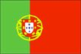
Definitions of wellbeing
Wellbeing is when the children - the learners in general - in a given context feel well, at ease, act spontaneously, show confidence, energy and basic needs (in the sense given by Maslow) are satisfied.

Laevers, F. (2005). Sics (Ziko). Well-Being and Involvement in Care a Process-Oriented Self-Evaluation Instrument for Care Settings. Research Centre for Experiential Education Leuven University: K &G.

Portugal

Theoretical background to children’s wellbeing
Within the overall framework of decisions on educational policies and investment in a quality education, since early years, is essential to the welfare, development and learning of children, educational success and, more broadly, it is a factor of prevention in social exclusion. This is the role of early childhood education, in the meaning of attendance, education and care for children from 0-6 years (OECD, 2001).

In this framework, we believe that early childhood education covers children from 0 to 6 years as essential, in the interface with social policies, linked to the families, who are combating social exclusion, to the creation of support networks for families and local development. Without an ecological perspective to the various levels of education and care for children, the impact of policies will remain ineffective. However, in Portugal, as it happens in other European countries, the children’s education under 3 years continues to be distinguished from pre-school education, defined in the Educational system law (Law 46/1986, amended by Law 49/2005) and the framework law for pre-school education (Law 5 / 1997) regarding children from 3 years until the age of compulsory school which is (6 years old).

The coordination of all host children under 3 years is currently taken by the Social Security Services, whose competence belongs to the Ministry of Education regarding to children under 3 years. This question has been a social and education concern, which has mobilized many efforts specially those that are related to professional organizations. This is clearly demonstrated by the study done in 2001 by the OECD, in Portugal, which, among other things is considered as a strategic error, this distinction defending that the pedagogical supervision of all nursery education should be assumed by the Ministry of Education and that the development of the network for care of children under 3 years should be a political priority (ME/OECD, 2001). In fact, a concept of lifelong learning, constantly reaffirmed by the European guidelines, can hardly conceive that education begins at age 3. The most recent data we have about the coverage rates of children from 0 to 3 years indicate the existence of coverage rates of only 12.6%. In a country whose rate of full-time women workers is the highest in Europe, where are children of those ages welcomed? Despite some troubling reports of situations that work clandestinely, it is still necessary to develop a regulation and supervision of all support structures for young children.

While much has been achieved after April 1974, and after the reform of preschool education in 1997, we found that there are still problems to be overcome in relation to the education of children under three years of teaching and supervision of preschool education establishments.

Beyond the main policy priority to develop the institutional network of early childhood in some parts of the country, lack of places for young children is still a difficult problem at the society level, given the large number of Women who work outside the home. In fact, Portugal deals with some specific and special conditions which have impact on social and educational system (OECD, 2004): more than 20% of such households with a child under the age of 6 lives on the poverty threshold; comparing to Northern Europe, Portugal seem less affected by single parenting households with at least one child under 6; women’s economic activity remains stable because in practice they continue to work while their children are under 6; Portugal stands out as the country with the most gender equitable allocation of paid work: about 9 out of 10 women (and mothers) works full time; in Portugal women work almost as many hours as men; participation rates in pre-primary education for under 3 is 25% and the economical contribution of the families is expected.

Although government efforts during the last years, institutional coverage rate is still very poor for children under 3 years - about 30% (based on available data in the web page of the Government). For children aged 3 to 6 years, the institutional coverage is about 80%, with a universal set for all children 5 years old. In other hand, several regulations were introduced, that directly or indirectly aimed at improving the work and family life reconciliation of families with children. We give some examples: with the framework law of social security a 13th month payment of child allowance was introduced for low-income families; greater focus on tailored professional training for labour market reintegration after longer periods of maternity leave or special leave to look after children; the new labour code introduced the possibility to extend maternity leave over a longer period while receiving a reduced benefit payment. (OECD, 2004)

To take into account also the latest report from the OECD, Starting Strong II (2006) points out that a set of lines that seem important to take into account when outlining strategies for this field of education. Following this work is in progress a new OECD study that aims at the development of early childhood education from 0 to 6 years, giving special emphasis to the development of education and social support of children under 3 years.

References:
ME/OECD (2001). Early Childhood Education and Care Policy in Portugal, Lisboa: ME

OECD (2001). Starting Strong: Early Childhood Education and Care. Education and Skills. Paris: OCDE.

OECD (2004). Babies and Bosses - Reconciling Work and Family Life (Volume 3). New Zealand, Portugal and Switzerland.

OECD (2006). Starting Strong II: Early Childhood Education and Care. Paris: OCDE.
Portugal

Literature Review

Curriculum Documents
Instituto de Solidariedade Social, I.P. (2005). Modelo de Avaliação da Qualidade – Creche. Portugal: ISS, I.P..
http://www2.seg-social.pt/preview_documentos.asp?r=16679&m=PDF
Instituto de Solidariedade Social, I.P. (2005). Manual de processos-chave – Creche. Portugal: ISS, I.P..
http://www2.seg-social.pt/preview_documentos.asp?r=16680&m=PDF
Instituto de Solidariedade Social, I.P. (2005). Questionários de avaliação da satisfação (clientes, colaboradores, parceiros) – Creche. Portugal: ISS, I.P..

http://www2.seg-social.pt/preview_documentos.asp?r=16681&m=PDF
Under the Social Welfare System, managed by the Institute of Social Security, IP, social support can be developed by social services and facilities to support individuals and families, involving the participation of different entities, namely, the integrated establishments, Private Social Solidarity Institutions (IPSS) and other public or private institutions.
Guarantee citizens access to quality services required to meet their needs and expectations is a challenge that requires the involvement and commitment of all stakeholders.
In this context, in order to provide a reference standard to assess the quality of services and consequently positively differentiate the social responses, ISS, IP, developed models for Quality Assessment of Social Responses, applicable to the Nursery and also seeking support the pedagogical level. However, as mentioned above is currently developing is a job that involved Social Security, the Ministry of Education, experts from various training institutions, with the OECD to support the development of institutional framework and guidelines for teaching children under 3 years.
For children over 3 years (inclusive) there are curriculum guidelines* set by the Ministry of Education.
http://www.min-edu.pt/data/Orientacoes_curriculares_preescolar.pdf

National Research
Diário da República, 2º série — Nº 79 — 21 de Abril de 2011. Recomendação nº 3/2011. A Educação dos 0 aos 3 anos.
Vasconcelos, T. (2011). Recomendação dos 0 aos 3 anos. CNE: Lisboa.
A set of questions concerned to education of children from 0 to 3 years, led to the preparation of this Recommendation, duly informed by the perspectives of government officials, local government and regional authorities, researchers, public entities and private responsibilities in monitoring children of this age level and the players "on the ground": children, families, professionals.
Beyond this reference, there are some doctoral and master's theses take place within the early childhood education, aimed at the education of children under 3.
There is also a project of the Ministry of Education Encouraging Quality in Early Childhood Education* (EEL model adapted from Tony Bertram and Christine Pascal) which began to cover children over 3 years and is now being adapted to children under 3 years.
http://sitio.dgidc.minedu.pt/recursos/Lists/Repositrio%20Recursos2/DispForm.aspx?ID=813&RootFolder=%2Frecursos%2FLists%2FRepositrio%20Recursos2

Recommended Reading
Portugal, G. (2003). Crianças, Famílias e Creches. Uma Abordagem Ecológica da Adaptação do Bebé à Creche. Porto Editora: Colecção CIDINE.
The theme of this book reflects recognition of the dilemma that many parents live on what is best for their children and the consequences of maternal separation in nursery and reception. It is intended as a work that makes available to educators in the broadest sense, a set of experiences that are judged worthy of reflection, helping to clarify and train all who are interested in promoting the welfare and development of children. It also aims to highlight any interaction child-family-day care, clarifying which factors or combination of factors that place the baby in a state of malaise clues pointing to the optimization of educational settings where the child develops.

Romania

Definitions of wellbeing

Children wellbeing refers to their needs and problems, refers to the society and its influence on children, to families, governments, agencies/organizations and professionals. Wellbeing refers to what we do for children and how to make them better. Children's wellbeing is dependent on the interaction between them and their environment.

Children’s Wellbeing is centered on family wellbeing because the family is the dominant part of the child's environment. The family is the major instrument for providing child wellbeing. The family is one that meets the needs of social care, education and child health. The family is negotiating with the whole environment to ensure that the child's needs are met. The whole society is involved when families prove to be unable to provide child wellbeing.
Lecturer Alin Stănescu, PhD

Romania
Theoretical background to children’s wellbeing
There’s no official definition of well-being or legislation/political documents on this topic in Romania. This does not mean that children’s wellbeing is not focused on. Even though child well-being is not explicitly present in legislation, such documents that provide normative in that direction exist.
Child protection is guaranteed by law in Romania:
- Constitution
- Family Code - United Nations Convention on Rights of the Child, ratified by Law no. 18/1990,
- Law no. 272 / 2004 and the regulations that were derived from this
One of those is the law 272/2004 on the protection and promotion of child rights, reflecting the international conventions to which Romania is part. Although is one of the most important lows on the field it’s implementation face difficulties, and on the other hand all national legislation on child protection should reflect all the policies, strategies and European recommendations, given the Romanian membership on the European Union since January 1, 2007.
Given the decision taken by Heads of State and Government at the conclusion of the Intergovernmental Conference in Lisbon on October 19, 2007, to grant legal status (in the Treaty of Lisbon) for the European Union Charter of Fundamental Rights - "Charter of Fundamental Rights of the European Union"- Article 24 it becomes a new legal basis for the development and implementation of future strategies on the Child Rights (Article 24 stipulates specific provisions on children's rights and explicitly states that "in all actions related to children public authorities or private institutions should take into account first the best interests of child");
At national level, the new legislative framework in the field of child protection is defined by Law no. 272/2004; unfortunately it doesn’t have the status of a framework law that provides general principles to be followed by other special laws. Law no. 272/2004 offers no opportunity to the Government to adopt methodological norms for the application of the law; items to be regulated later are specially listed and limited by law; so any gaps would be covered only by amending the law.
This law regulates the legal framework regarding the compliance, promotion and safeguarding children's rights.
The law is structured in 13 chapters as follows:
- General Provisions and Definitions
- Child rights

The term “wellbeing” is mentioned in this chapter in the section on family environment and alternative care, art.30: “Parental rights and obligations exercitation must consider the child's best interests and provide material and spiritual wellbeing of the child, especially through caring, maintaining personal relations with the child, ensuring growth, education and its maintenance, as well as legal representation and management of its assets.”
The term is also mentioned in the same chapter, the "Health and welfare of the child" section by reference to the child's right to receive medical services and ensure his physical and mental integrity.

- Special protection of children deprived, either temporarily or permanently, the protection of his parents
- Protection of refugee children and protection of children in armed conflicts
- Protection of children who have committed a criminal act and not criminally responsible
- Child protection against exploitation
- Institutions and services responsible for child protection
- Private institutions
- Licensing and inspection of services responsible to prevent child's separation from his family, and the special protection of children deprived, either temporarily or permanently, the protection of his parents
- Funding of child protection system
- Special Rules of Procedure
- Liabilities and Sanctions
- Transitional and final provisions

Another important Law is no. 123/2008 for healthy eating in educational institutions also known as the Law on prohibition of eating fast food in schools.

The Ministry of Public Health issued in 2008 a normative act providing a number of obligations for commercial units and educational establishments on the eating principles and recommended food for children and teenagers.

Child's diet should follow the following rules:

- Food should include a wide variety of ailments from the basic groups: bread, cereals, rice and pasta, vegetables, fruits, milk, cheese and yogurt, meat, poultry, fish and eggs.
- Food must be served before the children are really hungry, tired or irritated.
- Several types of food choice and at least one favourite food have to be provided.
- To ensure the daily ration of nutrients, meals must be supplemented with snacks consisting of cereal and milk, sandwiches, fruit, fruit juice, plain yogurt or yogurt with fruit, cheese.
- The menu has to contain aliments of different colour and consistency, in order to stimulate the appetite.
- The quantity of food must be appropriate to the child’s age.
- The meal must end when the child is satiated, becomes irritated or loses the interest.

List of unadvised food for preschool and school children:

Unadvised food | Limits of unadvised food | Example
High sugar content | over 15 g sugar/100g | Cookies, candies, lollypops
High fat content | over 20 g fat/100 g | Fried products, pizza, burgers
High salt content | over 1,5g salt/100g or over 0,6g sodium/100g | Chips, salted peanuts, salted pretzels
Juices |  | any type of soft drinks, except bottled water or bottled mineral water
High calories content | over 300kcal/ unit
Unpackaged food |  | Bulk foods, unpackaged sandwiches
Unlabeled food

Romania

Literature Review

Curriculum Documents
Romania. Ministry of Education, Research and Youth (2008) Early childhood education Curriculum for ages birth to 6 / 7 years.

Available at: http://www.edu.ro/index.php/articles/10133

The curriculum includes all the activities existing within the organizational structure of the kindergarten, to promote and stimulate intellectual, emotional, social and physical development of each child and intends to achieve the following finalities of early education (from birth to 6 / 7 years):
• The free, full and harmonious development of the child's personality, depending on his needs and its own rhythm, supporting its autonomous and creative development.
• The development of the ability to interact with other children, adults and the environment to gain knowledge, skills, attitudes and new conduct. Encouraging exploration, exercises, tests and experiments, as autonomous learning experiences;
• The discovery by each child of its own identity, autonomy and the development a positive self-image;
• To support the child in acquiring knowledge, abilities, skills and attitudes necessary for its entry into school and throughout life.

Development areas covered by the curriculum are:

Physical development, health and personal hygiene Area
- includes a wide range of skills and abilities (from large movements
such as jumping, running, to fine movements as drawing or modelling), and coordination, sensory development, also knowledge and practices concerning care and personal hygiene, nutrition, health maintenance practices and personal security.
Area’s dimensions:
- Physical Development
- Health and personal hygiene

Socio-emotional Area
-Aims the beginning of child's social life, his ability to establish and maintain interactions with adults and children. Social interactions mediate how children look at themselves and the world around them. Emotional development focuses especially children's ability to perceive and express their emotions, to understand and respond to other people emotions and also to develop self concept that is crucial to this area. Correlated with self-concept develops the child's self-image with a decisive influence on learning.
Area’s dimensions:
- Social Development.
- Emotional development

Language and communication development Area
-Aims to develop language (in matters of vocabulary, grammar, syntax, but also
understanding the meaning of messages), communication (including listening skills, oral and written, nonverbal and verbal communication) and early
acquisitions for literacy, accompanying development in each of the other areas.
Area’s dimensions:
- Language and communication development
- Developing reading and writing permissions

Cognitive development Area
- defined in terms of the child's ability to understand relationships between objects, phenomena, events and people beyond their physical characteristics. This area include logical thinking and problem solving skills, basic mathematical knowledge and those regarding the world and the environment.
Area’s dimensions:
- Logical thinking and problem solving development
- Basic mathematical knowledge and skills; knowledge and understanding of the world.

Capacities and attitudes in learning Area
- refers to how the child engages in an learning activity how to approach learning tasks and contexts, and his attitude towards interaction with the environment and people around, beside skills and abilities listed in the other areas of development.
Area’s dimensions:
- Curiosity and interest
- Initiative
- Persistence in activity
- Creativity

National Research

The Project on the Respect for Children’s Rights in Romania - conducted by the Federation of NGOs for Child - FONPC in September 2007 - July 2008, financed by UNICEF Romania and France MFA.

The Country Report gives the broad picture, focusing mainly on describing the set of laws that entered into force on January 1st 2005. The Country Report is highly technical and it points out most of all the changes to some legal texts and procedures, failing to provide an effective analysis of the progress made in relation to the application of laws and of the UN Convention on the Rights of the Child.

This project involved a total number of 83 NGOs and professional associations and experts in the field of child protection and wellbeing. Representatives of these associations and organizations have made ​​available to the Federation materials (reports, studies, research, case studies etc) and have directly participated in working groups in this project.
They organized 11 working groups and three workshops in Bucharest and in other regions of the country (Cluj-Napoca, Timisoara, Iasi). Each working group was coordinated by a professional representative of an organization / association, an expert in the child protection and wellbeing.

The report contains few concrete examples or statistical data for the general principles of child rights and civil liberties. Moreover, the overall feature of the report is to analyze and interpret in a theoretical manner the convention articles formulations.
In other words, the report is presented rather as a statement of intent of what should be done and not what has actually been done. A serious analysis to highlight the serious situation of child rights observance in Romania in accordance with the requirements and provisions set out in the Convention is missing.

Recommended Reading
Lecturer Alin Stănescu, PhD, (2007) Child Wellbeing – course support, University of Bucharest, Faculty of Sociology and Social Work.

The book is a course to social work students without being available to be purchased by the public. The subject of child wellbeing it’s approached in an extensive and theoretical manner.

The main topics are:
- Introduction to child wellbeing
- Child growth and development
- Child rights convention
- Principles of child protection rights
- Definitions and indicators
- Social policy for child wellbeing
- Child in difficulty
- National adoption
- Abuse and maltreatment
Spain
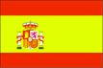
Definitions of wellbeing
Creating the necessary conditions so that children’s wellbeing can be guaranteed is the axis around which the main aims of Infant Education 0-3 (Early childhood education) revolve. Wellbeing is the physical and emotional state that lets the child fully develop his/her autonomy according to his/her possibilities, individually or in relation with others, in a specific context and through different languages, considering each and every need they have, every instinct and ability.

Spain
Theoretical background to children’s wellbeing
The term Wellbeing (bienestar in Spanish/benestar in Catalan) is not frequently used in official documents. It is a concept implicitly included in the main goals of Early Childhood Education in Spain. Few books include the word wellbeing as a key word. Instead, there are other terms or expressions that could be considered synonyms as their definitions may include similar conceptual content. Examples of such words are emotional experience (vivencia emocional), emotional education (educación emocional), catering for children’s needs and interests (dar respuesta a las necesidades e intereses de los niños y niñas), happiness (felicidad), self-esteem (autoestima), affective safety/confidence (seguridad afectiva), everyday activities (actividades cotidianas) and autonomy learning (aprendizaje de la autonomía), among others.

In Spain there exists a main Educational law (LOE), which establishes the guidelines and framework for the development of the different core curricula that each autonomous community must elaborate. The LOE includes the term wellbeing only twice and none of the two terms is directly linked to Infant Education:

- Section: Introduction

Las sociedades actuales conceden gran importancia a la educación que reciben sus jóvenes, en la convicción de que de ella dependen tanto el bienestar individual como el colectivo. La educación es el medio más adecuado para construir su personalidad ordinariamente entre los seis y los doce años de edad...

- Section: Primary Education

La finalidad de la educación primaria es proporcionar a todos los niños y niñas una educación que permita afianzar su desarrollo personal y su propio bienestar, adquirir las habilidades culturales básicas relativas a la expresión y comprensión oral, a la lectura, a la escritura y al cálculo, así como desarrollar las habilidades sociales, los hábitos de trabajo y estudio, el sentido artístico, la creatividad y la afectividad.

In the Catalan core Curriculum the term wellbeing appears only once. It is one of the contents to be developed that belong to the first curricular area (Self-awareness and awareness of others). The two other areas are Awareness of context and Communication and languages. Here the concept wellbeing relates explicitly to physical wellbeing, but not emotional.

- Progrés en l’adquisició d’hàbits relacionats amb el benestar corporal i la seguretat
personal, la higiene i la salut, així com en l’inici d’hàbits d’ordre, constància i
organització en les activitats en què participa.

http://phobos.xtec.cat/edubib/intranet/file.php?file=docs/infantil/decret_ed_infantil.pdf

Unfortunately, the official documents, books and research on early childhood education and wellbeing published or carried out in the Spanish and Catalan contexts are only written in the official languages of the country. This means that the bibliography provided will be mainly in Spanish or Catalan. We have made the effort of translating and summarizing some parts, but it is impossible to translate all the work being done. We think that the possible use of some translators from the internet could be very useful for the PDF versions we provide in the bibliography.

Spain
Literature Review
Curriculum Documents
Catalan Core Curriculum (first key-stage: 0-3) http://phobos.xtec.cat/edubib/intranet/file.php?file=docs/infantil/decret_ed_infantil.pdf (p.61481)
From the Catalan Core Curriculum, we have selected several sections that can relate to the concept of wellbeing in a more direct way:
En l’estructura del sistema educatiu es defineix l’educació infantil com una etapa educativa única, organitzada en dos cicles, amb identitat pròpia, que ha de contribuir al desenvolupament emocional i afectiu, físic i motor, social i cognitiu dels infants en col·laboració amb les seves famílies, proporcionant-los un clima i un entorn de confiança.

The structure of the educational system defines Infant Education (Early Childhood Education) as an educational stage, divided into two key-stages, with its own identity, and which must contribute to the children’s emotional, affective, physical, motor, social and cognitive development, in collaboration with the families and providing them with a confident context and environment.

(…)en el moment en què l’infant entra en el món escolar aquesta responsabilitat educativa es comparteix. El centre és un espai privilegiat que permet l’adquisició de coneixements, de vivències emocionals i socials. És, després de la família, el primer espai socialde cohesió, integració i participació. El centre ha d’oferir als infants ple suport i un acompanyament coherent i eficaç en el seu desenvolupament personal i social.

(…)the moment the child steps into the school world, this educational responsibility is shared. The institution is a privileged setting which allows for and promotes the acquisition of knowledge, of emotional and social experiences. After the family, the school is the first social place for cohesion, integration and participation. The school must offer the child full support and a coherent and efficient company in his/her personal and social development.

El centre educatiu ha d’acollir els infants i acceptar-los íntegrament amb estima, conèixer-los i comprendre’ls des del respecte i l’afectivitat, i assegurar les relacions de confiança amb les persones adultes i amb la resta dels infants propers.

The educational institution should welcome children and accept them integrally with love, it should get to know and understand them well through respect and affectivity, consolidating confidence towards adults and towards the rest of the children.

(…)així com establir els mitjans necessaris perquè cada infant se senti atès, orientat i valorat, sense veure’s condicionat per estereotips culturals i de gènere, quan ho necessiti i sense cap tipus de discriminació…

(…)and establish the necessary means so that every child can feel catered for, oriented and valued, without being conditioned by cultural and genre stereotypes, when he/she needs it and without any kind of discrimination…

La finalitat de l’educació infantil és contribuir al desenvolupament emocional i afectiu, físic i motor, social i cognitiu dels infants, proporcionant-los un clima i entorn de confiança on se sentin acollits i amb expectatives d’aprenentatge. L’acció educativa ha de permetre el desenvolupament afectiu, el creixement personal dels infants, la formació d’una imatge positiva i equilibrada d’ells mateixos, el descobriment de l’entorn, de les possibilitats del seu propi cos, del moviment i dels hàbits de control corporal, perquè actuïn cada vegada d’una manera més autónoma.

The aim of Infant Education is to contribute to children’s emotional and affective development, physical and motor development and social and cognitive development, providing them with a confident context and environment, where they can feel welcome and develop learning expectations. The educational act/practice should lead to affective development, to children’s personal growth, to the building of a positive and balanced self-image, to discovery and awareness of one’s context, of one’s possibilities concerning body, movement and body control, so that children can progress more autonomously.

Assolir progressivament seguretat afectiva i emocional i anar-se formant una imatge positiva de si mateixos i de les altres persones. (objectiu)

(To) Progressively acquire affective and emotional safety/confidence and (to) build a positive image of oneself and of others. (aim)
Progrés en l’adquisició d’hàbits relacionats amb el benestar corporal i la seguretat personal, la higiene i la salut, així com en l’inici d’hàbits d’ordre, constància i organització en les activitats en què participa.

Progression in the acquisition of habits related to one’s physical wellbeing and personal confidence, to hygiene and health and, also, to habits related to order, perseverance and organization in the activities one is involved in.

National Research
L’Estat de l’Educació a Catalunya. Anuari (2008)
Fundació Jaume Bofill. Desember 2009
IP Research: Ferran Ferrer

http://www.fbofill.cat/intra/fbofill/documents/publicacions/509.pdf

Translation: Education in Catalonia. Year 2008

The chapter focusing on 0-3 is particularly interesting. It starts on page 233 (see page 238), and the conclusions on page 257 also develop the idea of wellbeing. However, there are moments in which wellbeing refers to the Welfare State (l’Estat del Benestar), a different concept that relates to a more sociological perspective.

D’aquí se’n dedueix que en pro del benestar del conjunt de la societat hem de proveir els millors recursos i facilitats per als menors per tal que desenvolupin al màxim les seves potencialitats. Això també es tradueix en vetllar perquè els infants rebin una bona atenció de ben petits tant a l’entorn familiar com a l’entorn educatiu.

For maintaining the Welfare State, we need to provide the resources for the very young so that they can fully develop their potential. It also implies that we need to cater for the children from the very beginning, providing them with good care at home and in their educational environment.

Els estudis semblen avalar la importància de l’entorn familiar i escolar en el benestar de la infància.

The studies seem to confirm the importance of the home environment and the school for the wellbeing of children.

Recommended Reading
Anton, M. (coord) (2007): Planificar la etapa 0-6. Compromiso de sus agentes y práctica cotidiana. Graó (Book written in Spanish)
Comments, Summary and translation (into English) of key sections relating to wellbeing:
Title of the book: PLANNING THE 0-6 STAGE. Commitment and daily practice of agents involved
Montserrat Antón (coord.)
Biblioteca de Infantil Publishing house: Graó
The book contains a series of chapters written by professionals and experts in the 0-6 age group who put forward a methodological perspective that takes into account daily practice and the commitment of all agents involved in the education process of children from 0 to 6. They are the true protagonists of their own learning, which takes place in daily life contexts with the participation of the education professionals, families and other adults that children interact with.
The book includes the following chapters:
- The school at childhood
- Families also count
- Emotional experience at childhood
- Young and competent: from daily activities to autonomy learning
- Playing to live, living to play: playing as driving force of learning
- Together but not mixed up: different groupings as learning strategies
- Looking inside the school: the organization of space and materials
- Looking outside the school: sharing education
We believe it is interesting to focus primarily on the third and the fourth chapters to address the issue of wellbeing. However, it is also necessary to take into account most of the aspects dealt with in all the chapters to address children’s wellbeing fully. Implicitly, the issue of wellbeing needs to be present in all the methodological and organizational proposals made by early childhood educational and non-educational centres.
Emotional experience at childhood:
Individual upbringing places the person in a particular surrounding, a context, a culture. The relationships that each person establishes with this culture shape his/her emotional world, a world of beliefs and values, a world of emotions that need to be shown or repressed. Emotional experience is developed in a reality bound to a certain space and time. The experience is always shared and feelings are either sought or avoided depending on:
The context that requires developing a certain role within the group, our culture, the needs and wishes that shape our interests, our aesthetic models, models of environmental sensitivity provided by the context and which help us feel and live, and the communication tools that we are equipped with (languages, technologies…).
The first and most important affective and emotional context is the family. As established by systemic pedagogy, children are given life by their parents and the strength of this bond cannot be substituted by anyone. Feeling that we belong to a bigger system makes us feel humble for not being able to change what we dislike and also powerful for being able to modify the structure of relationships thanks to small changes.
Our emotional life feeds from daily routines, since these provide us with affective security and pass on values and beliefs that shape our emotional state and give us stability. However, potential changes stimulate the imagination and make self-confidence and autonomy develop. For changes to occur, basic abilities such as personal effort and willingness are required.
From an educational viewpoint, family, school and the society at large should take these aspects into account and time should be given to children for developing them. Children should experience the pleasure, the happiness or the contentment derived from a wish come true, but also the consequences of failure. However, children are often motivated externally instead of focusing on the internal motivation generated by one’s acts.
When they are babies, children already have the ability to interact that allows them to build their own learning from the start, a learning process focused primarily on the acquisition of autonomy: autonomy to move, to decide, to think… which makes their abilities grow and thus their self-confidence. The promotion of autonomy is the fundamental aim of the preschool, as it is necessary for developing children’s feeling of responsibility, freedom and personal identity, their way of thinking and independence.
During the early years, children’s lives develop around playing and around the routines aiming at satisfying their basic needs. The repetition and ritualisation these activities entail, the relationship with adults they promote, the exercise of their autonomy are key aspects that make these activities essential in the development of their abilities, as well as essential for their wellbeing.

Daily activities share the following characteristics:
- They are all a reminder of the family context. They are activities that children experience as part of their relationship with parents and it is often difficult for them to carry them out with other people. It is therefore convenient to understand rejection as a symptom of this difficulty.
- They are activities carried out at home and at school. Eating, sleeping, hygiene habits and resting are activities that are done both at home and at school. There may be differences in the way they are carried out that could give rise to conflicts with families. An effort needs to be made to get closer to families, understand and help each other and avoid hasty judgments.
- They are activities seldom valued professionally. It is as if the distinction between school and family lies on professional attitudes and, yet, the closer children’s school life is to their home life, the better for their development and their learning process. This is so because it is not only about changing a nappy or feeding, it is about everything a child can learn while eating or being changed. It is about doing these activities so that they are positively educational. It is this educational aim that is at the basis of the infant education profession.
- They are routines. As they are activities that can be a great source of pleasure for children –due to the wellbeing resulting from a need being satisfied-, they are also a great source of affective bonds and thus they may become highly rewarding moments.
These activities need to be valued regarding all their aspects, they need to be planned and carried out professionally and seeking explicit educational goals.
All methodologies that favour an atmosphere of emotional education make it possible for children to be actively engaged in their learning, to relate to each other and to create shared meanings based on dialogue and the confrontation of different opinions, ideas, feelings and proposals. The key aspect is to have time to do what we aim to, time for getting ready, for acting and for reflecting, time for oneself and time for the group.
From two and a half years onwards, primary emotions (such as love, rage, fear…) can be shared in a group. Giving and receiving, feeling that we all have the same needs.
Personal symbols and common beliefs can also be used to communicate with others and with ourselves. Symbolic game and stories help us define ourselves.
We should also use all the languages we have available in order to put into words and express what we feel. Body language is the first that we use to express and shelter our emotional experiences. Verbal language is what receives more attention at school. It allows us to organise thought, but as it is very basic at early ages, it cannot be the most important nor can it be representative of what we feel. We should focus instead on creative languages, such as music and arts.
It is necessary to search for ways of communicating emotionally with families. When we enter a school, we should see the children with their families behind them. Some proposals may be: meetings to promote reflection and interaction; travelling materials to share experiences; and creating spaces for families within the school area where they may find bibliography and an opportunity to meet each other.
Young and competent: from daily activities to autonomy learning
Daily arrival and exit from the school: The main content of this activity is greeting and meeting the children. The main aim will be to try to make children experience pleasure when meeting the teacher and the classmates and, when going home, their families. They should also notice how happy the others are when meeting them. It is important to keep in mind the following:
- Individual greeting: greeting every child by their name, with warmth and affection, using the communicative expressions they like the most (looks, hugs, intonation…).
- Pointing out the changes that can be observed in the child and which may be meaningful for him/her (new clothes, new haircut…); showing interest in what he/she has done outside the school, in the person taking him… these aspects personalise the arrival.
- Make everyone aware of each child’s arrival and welcome, make sure that they are interested in each other and that they show or tell each other their news… these aspects help create an affective atmosphere.
- Organise the space so that everyone has available the space to leave their coats, their bags; a place to play, a place to rest…
- Plan the farewell and prepare the children for leaving, make them feel eager to meet the people that will come pick them up.
- Greet the relatives as they arrive.
- Succeed in making children happy to be at school and eager to come back.
- Bring to the school children’s affective world: talk about the family, the mother, the father, what they do at home; bring to the school things from home and home things from school. These are ways to bring the two worlds closer and to help children integrate them in a natural way.
Early years eating habit: It is important to see eating time from two viewpoints: as a physiological need for health and body growth, and as an activity or situation where relationships and personality are shaped, abilities are developed; and attitudes, knowledge and basic abilities are learnt. Learning contents at eating times cover almost all contents in the curriculum of infant education, so their assessment can be a great indicator of children’s development of abilities, learning processes and acquisition of basic knowledge.
Hygiene habits at school: Activities involving hygiene habits allow children to become self-aware. Feelings of wellbeing, feeling cold, feeling hot, feeling wet, touching each other make children become self-aware. These situations create excellent occasions for knowing and learning about themselves, about their possibilities and limitations, about the adults that care for them and about how important they are.
Daily tasks and group awareness: More and more often daily time is devoted to checking attendance, organising the calendar, calling the dining-room register, etc. in the infant education classrooms. These tasks favour, among other things, cohesion and group awareness. These are moments to speak, listen, express emotions, experiences, discoveries, tell stories, read, write… without needing to resort to fictional stories, as taking advantage of and valuing what happens daily offers topics that are more than enough to keep on a conversation and get to know each other.

Lecturer Guidance Notes


PowerPoint Presentation
Key to icon:
This icon indicates a group activity

© Kingston University 2012.
All rights reserved. Except as otherwise permitted under the Copyright Designs and Patents Act 1988 no part of this work may be reproduced, stored or transmitted in any form by any means without prior permission from the publisher.
Permission for the use of the photographs has been obtained from the families of the children in these case studies.
Permission has been given to use the children’s photographs for the TODDLER Project training materials and website only. It is not permissible to use these photographs for any other purpose than the case studies.

Slide 1 | 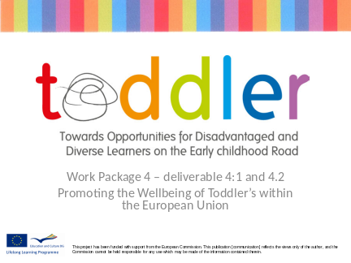
Slide 2 | 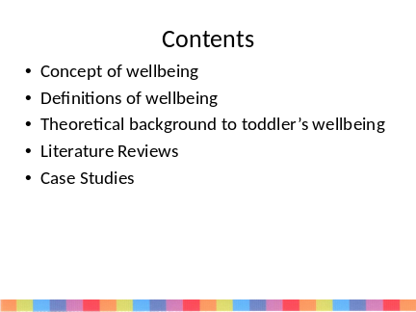 | Guidance notes to lecturers  There are varies ways of using the report to support this PowerPoint.  One way is to photocopy the materials for each country as a separate pack so each group of early year’s practitioner works with one country comparing and contrasting with their own country’s provision.
Slide 3 | 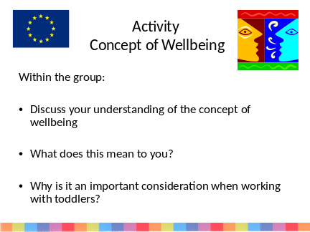 | Guidance notes to lecturers  - This activity is designed for the early years practitioners to explore their understanding of the concept (their thinking) of wellbeing
Slide 4 | 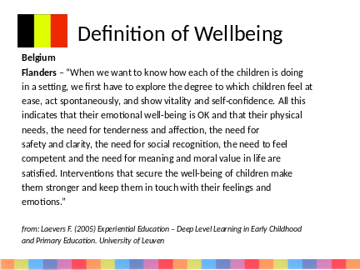 | Go through each country’s definition with the students
Slide 5 | 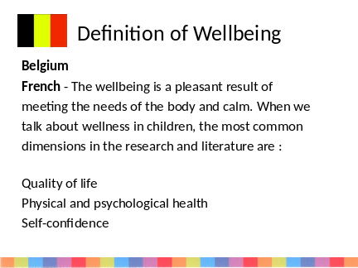
Slide 6 | 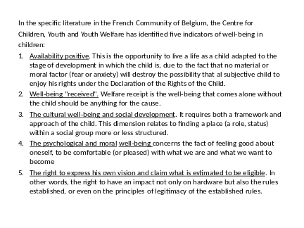
Slide 7 | 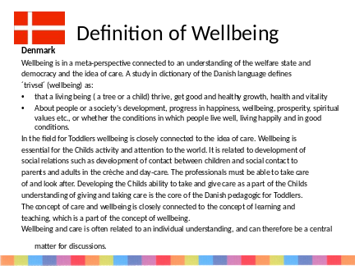
Slide 8 | 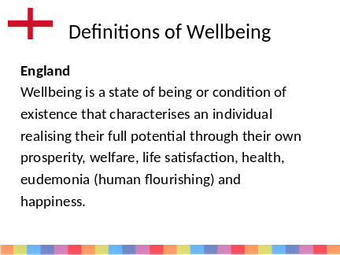
Slide 9 | 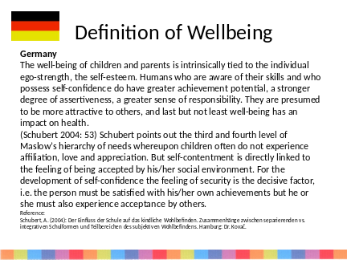
Slide 10 | 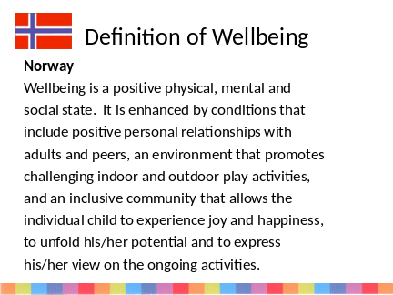
Slide 11 | 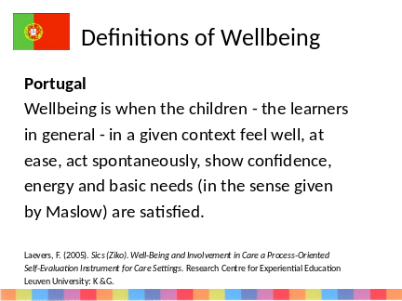
Slide 12 | 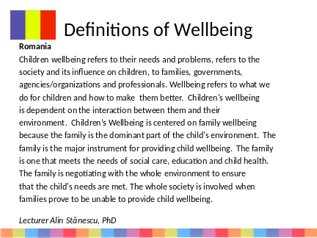
Slide 13 | 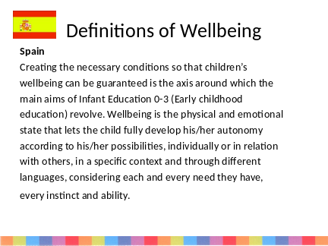
Slide 14 | 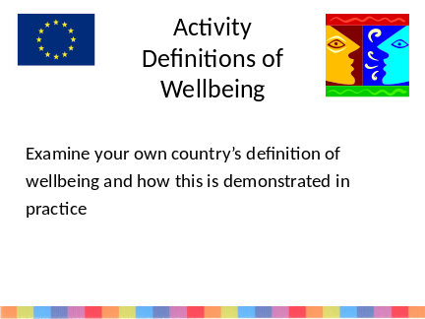 | Guidance notes to lecturers  - Reflect on how this is demonstrated in practice
Slide 15 | 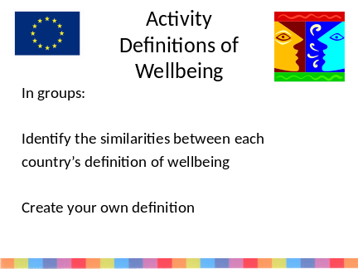 | Guidance notes to lecturers  - Identify the similarities between each country’s definition of wellbeing  - What does this tell us about each country’s perspectives on wellbeing?  - Early Years practitioner can then create their own definition to share with peers
Slide 16 | 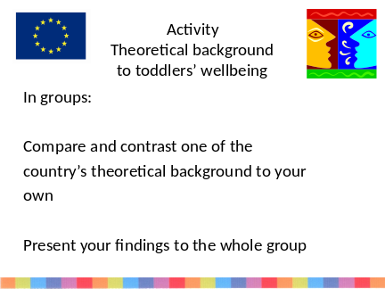 | Guidance notes to lecturers  - Compare and contrast own country with another using the materials in the report  - Present to the whole group
Slide 17 | 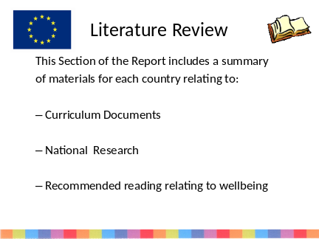 | Guidance notes to lecturers  - Use the materials from the report to support this
Slide 18 | 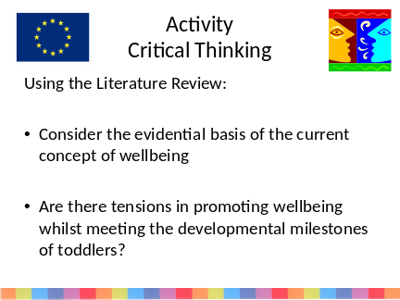 | Guidance notes to lecturers  Using the materials in the report:  - Early Years practitioners in groups or individually answer the questions posed  - Evidential basis – consider the current key research highlighted in the report to critically analyse the evidential basis of the current concept of wellbeing (one country or all countries)  - Early Years practitioners to identify any tensions which arise when trying to promote toddlers learning and development and also promote wellbeing
Slide 19 | 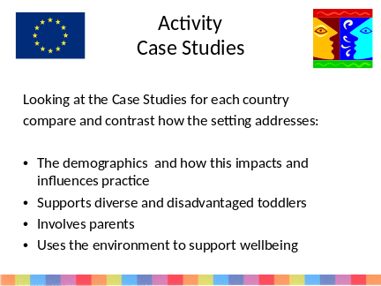 | Guidance notes to lecturers  Using the Case Studies:  - Early Years practitioners to compare and contrast in groups or individually
Slide 20 | 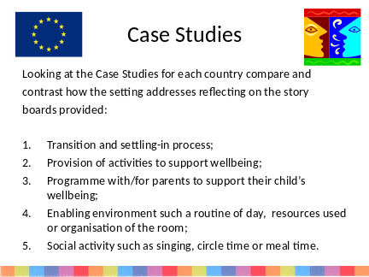 | Guidance notes to lecturers  Using the Case Studies:  - Early Years practitioners to reflect on the story boards for one or all countries
Slide 21 | 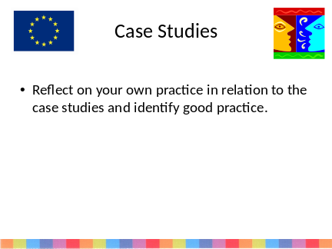 | Guidance notes to lecturers  Using work package 2 – State of the Art to support student comparisons of practice  Things to consider when comparing and contrasting:  - Cultural differences and how these could translate to own country’s practice  - Variations of provision for toddlers – government funded initiatives, voluntary funded and privately funded  - Eurydice document - EURYDICE (2009) Early Childhood Education and Care in Europe: Tackling Social and Cultural Inequalities. European Commission
Slide 22 | 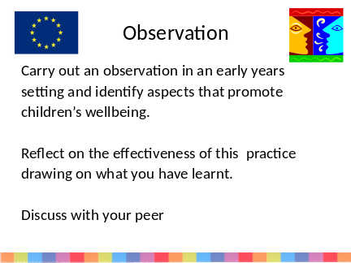 | Guidance notes to lecturers  Set the observation for the early years practitioners:  - This for early years practitioners to go away and carry out.  - Set up a discussion board on the Virtual Learning Environment so that they can then discuss their reflections together
Slide 23 | 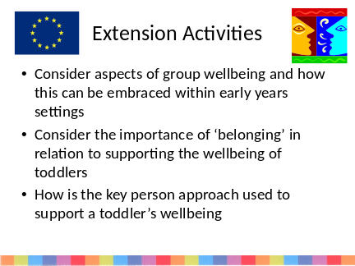 | Guidance notes to lecturers  To further continue this activity the group can explore the concept of group wellbeing and how this can be embraced to support the individual toddler  The group can explore the concept of ‘belonging’ and how the key person approach supports this

http://english.sm.dk/ministryofsocialwelfare/legislation/interior_legislation/day-care-facilities-act/Sider/Start.aspx
http://www.sm.dk/temaer/sociale-omraader/boern-unge-og-familie/dagtilbudsomraadet/dagtilbud/paedagogiske-laereplaner/Sider/Start.aspx
The population of Denmark (august 2011): 5.566.856

