In Silico Design of Bioisosteric Modifications of a Drug for the Treatment of Diabetes

Guillaume Vink1,2, Jean-Christophe Nebel1, Stephen P. Wren3*

1 School of Computer Science & Mathematics, Faculty of Science, Engineering and Computing, Kingston University London, Penryhn Road, Surrey, KT12EE

2 Department of Bioengineering, Nice Sophia Antipolis University Engineering School, Templiers Campus, 06410 Biot, France

3 Department of Chemical and Pharmaceutical Sciences, Faculty of Science, Engineering and Computing, Kingston University London, Penryhn Road, Surrey, KT12EE.

*Author for correspondence: s.wren@kingston.ac.uk

**Supplementary Information**

**Table of Contents**

**TAK-875 bioisosteres structures**  …………………………………………………………………………………………..………….**2**

**GW9508 bioisosteres structures** ……………………………………………………………………………………………………….**4**

**Table S1: TAK-875 bioisosteres corresponding numbers and pKa values**…………………………………………**.6**

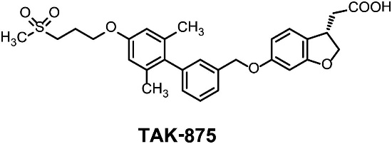**Figure S1: TAK-875 bioisosteres structures**



1

2

3, 4

5

6

7

8

9

10

11, 12

13, 14

15

**Figure S1 (continued)**

**Figure S2: GW9508 bioisosteres structures**

|  |  |  |  |
| --- | --- | --- | --- |
| **GW9508** | | | |
| 20 |  | 21 |  |
| 22,  23 |  | 24 |  |
| 25 |  | 26 |  |
| 27 |  | 28 |  |
| 29 |  | 30,  31 |  |
| 32,  33 |  | 34 |  |
| 35 |  | 36,37,38 |  |

**Table S1: TAK-875 bioisosteres corresponding numbers and pKa values**



**References**:

[1] Ballatore C, Huryn DM, Smith AB. Carboxylic acid (bio)isosteres in drug design. *ChemMedChem*. 8(3), 385–395 (2013)

[2]Hans Reich's Collection. Bordwell pKa Table.

[3] *Bioisosteric motifs cited in* - Lassalas P, Gay B, Lasfargeas C, *et al.* Structure Property Relationships of Carboxylic Acid Isosteres. *J. Med. Chem.* 59(7), 3183–3203 (2016).