In Silico Design of Bioisosteric Modifications of Drugs for the Treatment of Diabetes

Guillaume Vink^{1,2}, Jean-Christophe Nebel¹, Stephen P. Wren^{3*}

¹ School of Computer Science & Mathematics, Faculty of Science, Engineering and Computing, Kingston University London, Penryhn Road, Surrey, KT12EE.
² Department of Bioengineering, Nice Sophia Antipolis University Engineering School, Templiers Campus, 06410 Biot, France.
³ Department of Chemical and Pharmaceutical Sciences, Faculty of Science, Engineering and Computing, Kingston University London, Penryhn Road, Surrey, KT12EE.

*Author for correspondence: s.wren@kingston.ac.uk

Aim: To identify virtual bioisosteric replacements of two GPR40 agonists. Materials & Methods: Bioinformatic docking of candidate molecules featuring a wide range of carboxylic acid bioisosteres into complex with GPR40 was performed using TAK-875 and GW9508 templates. Results: This study suggests that 2,6-difluorophenol and squaric acid motifs are the preferred bioisosteric groups for conferring GPR40 affinity. Conclusion: This study suggests that compounds 10 and 20 are worthy synthetic targets.
Abstract: GPR40 agonists have been associated with the treatment of type 2 diabetes by decreasing the risk of hypoglycaemia. Lead GPR40 agonists GW9508 and TAK-875 exhibit propensity for β-oxidation and hepatotoxicity, respectively. Bioisosteric replacement offers the potential to attenuate toxicity and alter drug pharmacokinetics. Here, we report the use of bioinformatic tools to dock candidate molecules featuring a wide range of carboxylic acid bioisosteres into complex with GPR40 using TAK-875 and GW9508 templates. This study suggests that a 2,6-difluorophenoland squaric acid are the bioisosteric groups exhibit the best GPR40 affinity. These preliminary results should be augmented by other studies such as testing synthesised molecules like 10 and 20 for GPR40 binding and in vitro ADME profiling before considering new leads.
Keywords: docking, bioisosteres, drug design, type 2 diabetes, GPR40 agonist.

The World Health Organisation reported that diabetes is affecting an estimated 422 million adults globally, a nearly four-fold increase from 108 million cases in 1980. In 2016, diabetes alone caused 1.6 million deaths worldwide [1]. Type 2 diabetes (T2D) accounts for around 90% of all diabetes cases and is associated with a ten-year-shorter life expectancy in the UK [2]. In 2019, diabetes was associated with an astounding $760 billion USD in health expenditures worldwide [3]. These figures motivate the urgent need for global policy solutions to reduce the burden of diabetes, including prevention, diagnosis, and treatment [4].

T2D involves a wide range of genetic and environmental factors. Most cases of diabetes involve many genes, each of them increasing slightly the probability of becoming affected by the condition. Although more than 38 genes have been found that contribute to the risk of T2D [5,6], the major factors driving T2D are obesity, poor diet, and sedentary lifestyle. Formerly, this type of diabetes was seen only in adults, but it is now also occurring increasingly frequently in children. T2D is associated with insulin resistance (IR). IR occurs when the cells fail to respond adequately to insulin. Consequently, β-cells produce more insulin in order to cope with the loss of its sensitivity. Insulin level increases up to a point where β-cells have reached their peak secretion, but the total amount of released insulin cannot counteract IR. Therefore, glucose cannot enter cells and remains in the blood. The presence of high levels of glucose in the blood for extended periods of time that defines the disease [7]. The first-line therapy is exercise and dietary changes as most cases can be prevented with physical activity and appropriate nutrition [3]. The two main drugs or drug classes currently on the market are metformin and sulfonylureas. Metformin reduces insulin resistance whereas sulfonylureas enhances insulin secretion [8]. However, these medicaments have side effects: gastrointestinal disorder for metformin, and hypoglycaemia for sulfonylureas [8]. Promising drug targets have been targeted for the treatment of diabetes, like the GLP-1 and GPR40 receptors [9]. The GPR40 receptor is the subject of this study.

GPR40 belongs to the G-protein coupled receptor family. Its other name, FFA1 (Free Fatty Acid receptor 1), comes from its endogenous ligands discovered in 2003: free fatty acids [10]. GPR40 is located in the β-pancreatic cells in the Islets of Langerhans, but also in the brain [11]. Like other GPCRs, GPR40 is involved in the inositol triphosphate (IP3) pathway. The main advantage of this target is that the IP3 pathway induces insulin secretion only when glucose levels are high (one may use the term: glucose stimulated insulin secretion) [12]. Thus, there is no risk of hypoglycaemia unlike the uptake of sulfonylurea or insulin injections. Another asset of this target is that its ligands are orally bioavailable [13]. Previous studies on replacing the carboxylic acid function in GPR40 agonists have demonstrated that potency can be maintained [13]. GW9508 and TAK-975 are examples of GPR40 agonists based on free fatty acid templates but here, in this paper, we explore novel molecules.

GW9508: This molecule, developed by GlaxoSmithKline, belongs to the early GPR40 agonists with high lipophilicity. Unfortunately, this feature can cause off-target effects on the central nervous system. Another drawback of GW9508 is its propensity for β-oxidation [13,14,15].

TAK-875: To date, Takeda’s TAK-875 remains the GPR40 agonist that has progressed the furthest into clinical development [11]. Compared to GW9508, a hydrophilic sulfonylpropoxyl sidechain was introduced to decrease lipophilicity and improve the PK profile. Moreover, the β-position of the carboxylic acid was cyclised onto the phenyl ring in order to prevent β-oxidation [13,17]. Preclinical studies in isolated rodent and human islets established that TAK-875 stimulated insulin secretion in a glucose and GPR40-dependent manner [18]. Unfortunately, the clinical development was terminated late in phase III trials due to liver safety concerns. Mechanistic investigation showed that the acyl glucuronide (AG) metabolites of TAK-875 are the dominant cause of its hepatotoxicity [19,20]. The formation of AG metabolites is directly linked with the carboxylic acid functional group born by TAK-875 and other GPR40 agonists [21].

Bioisosteric replacement of carboxylic acids
Bioisosterism is a concept defined by how a set of molecules exhibits physical and chemical similarities in relation to their biological interactions [22]. For example, the replacement of a functional group with another group offers the potential to attenuate toxicity, and/or alter pharmacokinetics.

Bioisosteres of carboxylic acids have been well studied [23,24]. TAK-875 and GW9508 are lead compounds that already possess pharmacological activity but may nevertheless have suboptimal potency and toxicity profiles [16,25,26]. We intended to explore the virtual construction of new analogues of these molecules based on predicted affinity for the GPR40 receptor. The release( in 2014) of a 3D structure of TAK-875 linked to GPR40 in the RCSB repository (PDB ID: 4PHU) [27], precious information has become available about the binding site and the interactions between the ligand and the receptor. This information provides a useful starting point for structure-based drug design.

Experimental

Design of bioisosteric replacement for the carboxylic acid function
The carboxylic acid bioisosteres were chosen from the library assembled by Ballatore et al. [23]. The candidate molecules were constructed using Pymol [28]. Chemsketch [29], a freeware developed by ACD/Labs, was used to check that the molecules’ structure obeyed the valence rules and corresponded to the chosen bioisosteres. Attention was paid to stereochemistry, bond order, bond length and partial charges. For the bioisosteric group with a pKa in the range of 7.4±1, a protonated form was proposed for docking (i.e. for compounds 10, 16 and 17). The complete assembly of the 38 candidate molecules is available in the Supplementary Material (Figures S1 and S2).

Ligand Docking using AutoDock Vina
In this study, molecular docking was conducted using the latest version of the open-source software AutoDock, i.e. AutoDock Vina, which is developed by the Scripps Research Institute [30]. Not only has this tool been extremely popular with over 12,000 citations, but it has continuously supported state-of-the-art research as exemplified by its contribution to recent discoveries of potential SARS-CoV-2 therapeutic strategies [31,32]. Among the strengths of AutoDock Vina is its ability to offer docking where both the ligand and the receptor are flexible. While docking can be operated in rigid mode, i.e. only the ligand is flexible, such functionality is important because flexible docking is more accurate as it is able to simulate better the conformational adjustments, or induced-fit, occurring during the binding process. However, since flexibility of whole receptors would lead to prohibitive docking times, Autodock Vina enables users to set as flexible only the residues that are expected to change conformation during the docking process [30,33].

Consequently, all simulations reported in this paper were performed using flexible docking where four amino acids of GPR40 were set as flexible, i.e. Y91, R183, Y240 and R258, as defined in the 4PHU PDB structure. Those residues were selected since they have been shown to be important for GPR40 agonist recognition [34]. Indeed, they anchor the ligand into the binding pocket through polar interactions with the carboxylic acid. This includes the involvement of the arginines in basic interactions [27].

As specified by AutoDock Vina’s guidelines [30], structures of the receptor and putative ligands need to be preprocessed before docking can be performed. In order to prepare the receptor, ligands and water molecules were removed from the initial PDB file, then Kollman charges (i.e. template values for each amino acid that were derived from the corresponding electrostatic potential using quantum mechanics) and polar hydrogens were added. Finally, the AutoDock Tools were applied to assign to each atom an AutoDock4 type, which includes, if relevant, involvement in a hydrogen bond as a donor or an acceptor. The preparation of the ligands required specifying their bond rotatability: while all single bonds were set as rotatable, with the exception of the amide bonds because of their high rotational energy barrier [35], double and aromatic bonds were set as immobile.

Finally, the size of the docking search space and the search exhaustiveness were specified so that AutoDock Vina could focus on exploring the putative binding area. The search space was defined by a box able to contain both the binding site location suggested by the 3D structure release paper [27] and the ligand of interest. The following grid boxes were used, respectively, for the TAK-875 and GW9508 bioisosteres: size (30, 16, 16) centred on (-45.9, -2, 59) and size (26, 16, 16) centred on (-43.5, -2, 58.5), respectively. It should be noted that the values are in Angstrom. In terms of exhaustiveness, the default value of 8 was increased to 20 to enhance the search precision while maintaining a practical running time. As, on a standard PC, around 1 hour was required in order to dock a ligand, it was decided that conducting each experiment three times was a good compromise between reproducibility and processing capability. The outcome generated by AutoDock Vina for each experiment was the 3D structure of the best binding configurations, their corresponding affinities and the root mean square of atomic deviation (RMSD) between them. While further 3D analysis and visualisation were performed using Pymol [28], the freeware, Ligplot+ [36], developed by EMBL-EBI, was used to generate 2D ligand-protein interactions diagrams.

Results & Discussion

Docking tool evaluation
Before attempting to dock new compounds, the accuracy of AutoDock Vina on GPR40 using flexible docking was accessed using a ligand for which the molecular binding interaction is known. Thus, TAK-875 was docked without any bioisosteric replacement, and the outcome was then compared with the configuration of the original PDB structure (4PHU); see Figure 1.

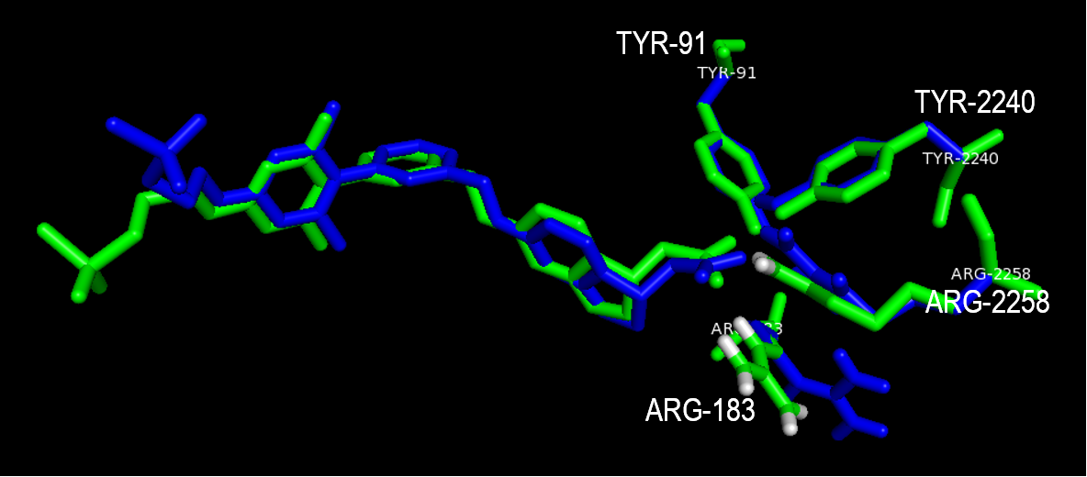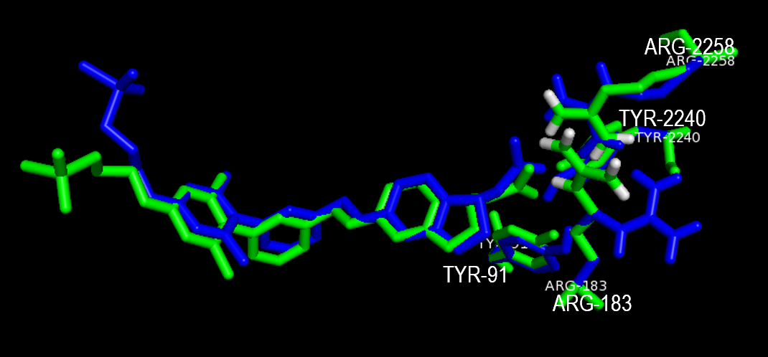
Figure 1 : Comparisons between the conformation of TAK-875 in the original X-ray structure (green), and Autodock Vina’s best prediction (blue). The figure displays two different views of TAK-875 and highlights the four residues chosen for sidechain flexibility.
The RMSD value between the original and the predicted docked structure was 2.321 Å (without any fitting and for all the 83 atoms). While discrepancies can be noticed at the tail of the molecules, they can be explained by the fact that the tail of TAK-875 is outside the binding pocket. Therefore, the tail is not constrained by TAK-875 bonding with GPR40, which gives it more degrees of freedom. This statement is confirmed by the β-factor of the original PDB structure (Figure 3). By taking into account the divergence of the positions of TAK-875’s tail, the calculated RMSD value stood for a good superimposition of the two structures [37, 38].

As expected, due to their numerous hydrophobic interactions, the overlapping of the aromatic rings was excellent. Focusing on the amino acids made flexible, three out of the four adopted their correct position in spite of the multiple alternatives they could have had. Although the arginine-183 residue was pointing towards another direction, this did not affect the rest of the structure. While the conformations of the molecules themselves were useful to compare the docked structure with the one resolved by X-ray crystallography, analysis of the individual interactions between the agonist and the receptor provided additional information to assess docking accuracy. As shown on the Ligplot+ diagram (Figure 2), the previously mentioned shift of R183 prevented from taking part in a hydrogen bond interaction. However, all the other interactions were conserved compared with the original TAK-875 X-ray structure (4PHU).
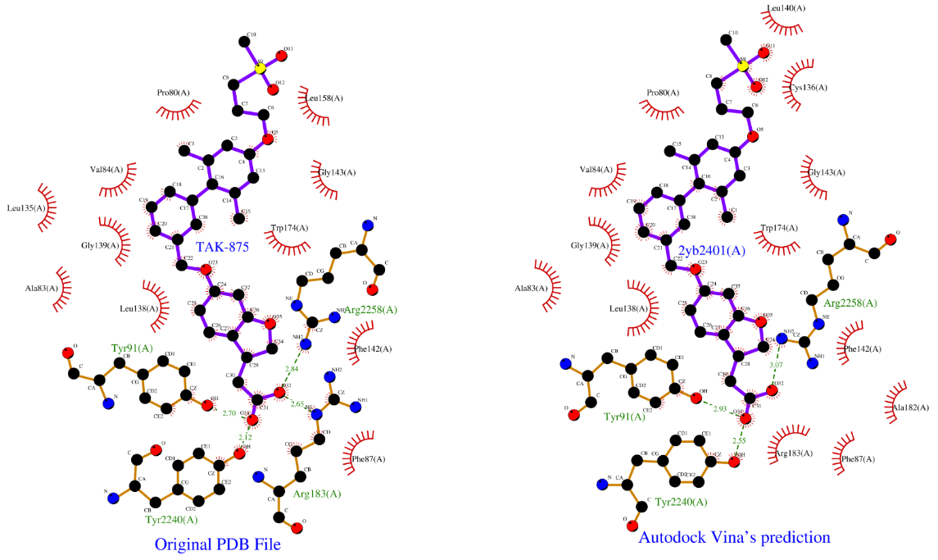
Figure 2: Ligand-protein interactions diagram of TAK-875 (Ligplot+): Comparison between the original PDB file, and Autodock Vina’s prediction. The H-bonds are represented with doted green lines. The hydrophobic interactions are represented by the red-fringed semicircles.

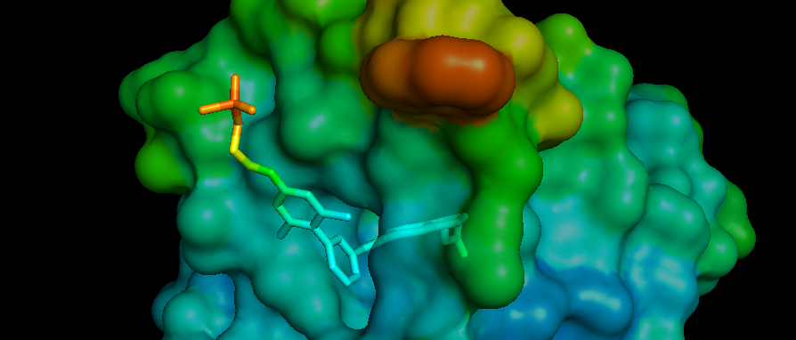
Figure 3: 4PHU X-Ray Structure coloured by β-factor with transparency. The tail of TAK-875 is coloured in red, showing the weaker stability on this part of the molecule. The diagram shows that the rest of the molecule is dug into the binding pocket.

Even though GW9508 has not been subjected to X-ray crystallography, it was still deemed relevant to compare it with TAK-875 in the 4PHU PDB file. We were also interested in this template due to the relative ease of preparing synthetic derivatives of this molecule.

Figure 4: Original X-ray structure of TAK-875 (green) compared to Autodock Vina’s best orientation prediction for GW9508 (magenta)

Autodock Vina’s prediction revealed a similar binding mode for GW9508, even if it is a smaller ligand than TAK-875 (Figure 4). Indeed, GW9508’s carboxylic acid group was anchored at the bottom of the binding pocket like in the case of TAK-875. Although the aromatic rings of TAK-875 and GW9508 do not superimpose perfectly - TAK-875 has four, while GW9508 has only three - GW9508’s rings are positioned in similar areas and remain under the effects of hydrophobic interactions. These results enabled us to be confident in the validity and accuracy of Vina for conducting the docking of GPR40 agonist bioisosteres to GPR40.

Bioisosteres evaluation
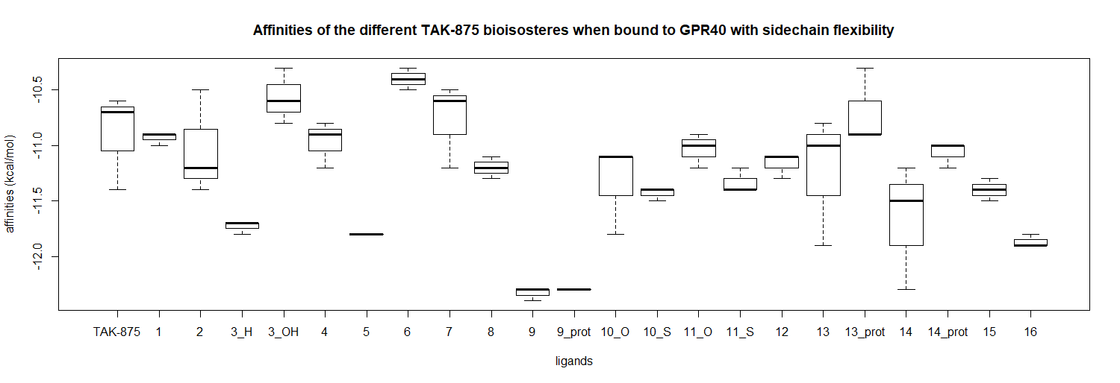
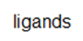
Following the individual docking of all the bioisosteres of interest using the approach previously described, their respective binding affinity (kcal/mol), as estimated by Vina, was compared with their parent compounds, i.e. TAK-875 and GW9508 (Figure 5).
1 2 3 4 5 6 7 8 9 10 10_prot 11 12 13 14 15 16 16_prot 17 17_prot 18 19

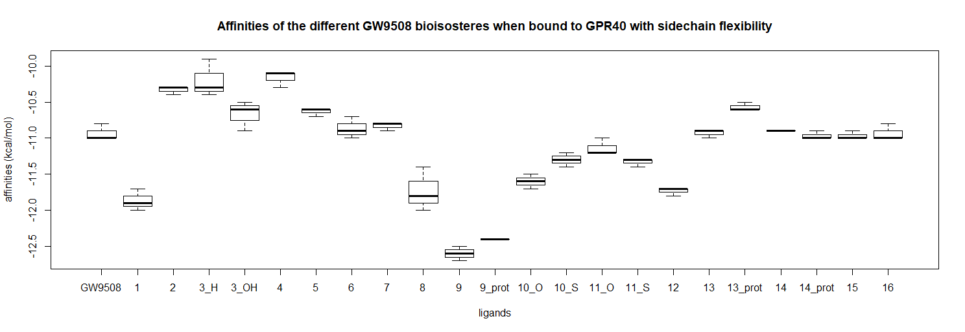
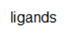
20 21 22 23 24 25 26 27 28 29 29_prot 30 31 32 33 34 35 35_prot 36 36_prot 37 38
Figure 5: Affinities of the parent compounds and their bioisosteres during flexible docking (boxplots). The experiments were run in triplicate. “Prot” stands for the protonated form of the ligand. The more negative the affinity is, the more stable the ligand-receptor complex.

The affinities of TAK-875 and GW9508 were used as control values. Although the affinities given by Autodock Vina are linked to some extent to the chemical dissociation constants of the ligands, there is no equation that links them together and the tool cannot provide absolute values. However, as relative affinities are expressed, this enables comparisons to be made between the receptor’s affinity for bioisosteres, TAK-875 and GW9508.
As TAK-875 is a larger molecule than GW9508, it displays a greater number of torsion angles, which lead to a larger number of possible configurations. Consequently, the thrice repetition of docking experiments with TAK-875 bioisosteres showed more variability than with the GW9508 bioisosteres. Most of the bioisosteres exhibited affinities values similar to their parent compounds. However, some bioisosteres showed enhanced affinity. For TAK-875, the three best bioisosteric groups were identified as 2,6-difluorophenol(10), cyclopentane 1,3-diones (19), and sulfonic acid (6) based on their predicted affinities for the receptor. It should be noted that the tetramic acid derivative (17) was not further considered due to the excessive variability in its results. For GW9508, the four best bioisosteric groups were the 2,6-difluorophenol (29), squaric acid (20), tetrazole (28) and oxadiazol-5(4H)-one (34) motifs.

Analysis of binding interactions
For the most promising bioisosteres, we studied the relationship between their binding affinities, as estimated by Autodock Vina, with the conformation of the molecules and their interactions. Predicted affinities and the number of H-Bond based interactions between GPR40 and the most promising TAK-875 and GW9508 bioisosteres are shown in Tables 1 and 2 respectively.

Table 1: Affinity and number of H-Bond based interactions between GPR40 and each of the 3 most promising TAK-875 bioisosteres. Values associated with TAK-875 are provided as reference.
Ligand | TAK-875 | 2,6-Difluorophenol (10) (deprotonated) | Cyclopentane 1,3-diones (19) | Sulfonic acid (6)
Mean affinity (SD) (kcal/mol) | -10.90 (0.43) | -12.33 (0.06) | -11.86 (0.06) | -11.80 (0)
Number of H-bonds (structure with best affinity, 3.35 Å max) | 3 | 3 | 1 | 1

Table 2 Affinity and number of H-Bond based interactions between GPR40 and each of the 4 most promising GW9508 bioisosteres. Values associated with GW9508 are provided as reference.

Ligand | GW9508 | 2,6-Difluorophenol (29) (deprotonated) | Squaric acid (20) | Tetrazole (28) | Oxadiazole-5(4H)-one (34)
Mean affinity (SD) (kcal/mol) | -10.93 (0.12) | -12.60 (0.10) | -11.86 (0.15) | -11.73 (0.31) | -11.73 (0.05)
Number of H-bonds (structure with best affinity, 3.35 Å max) | 1 | 0 | 1 | 0 | 0

Only the 2,6-difluorophenol (10) in Table 1 and the Squaric acid (20) in Table 2 got involved in as much H-bond interactions as their parent compound. These results show that a good affinity value does not always correlate with a high number of H-bonds. This confirms that the affinity value alone does not allow the drawing of firm conclusions for promising ligands. The chemical realism needs to be assessed as well as the agonist recognition. For this reason, the interactions of the two ligands mentioned before were analysed with the help of Ligplot+ diagrams (Figure 6). The other bioisosteres were not selected because of their lower number of H-bonds.
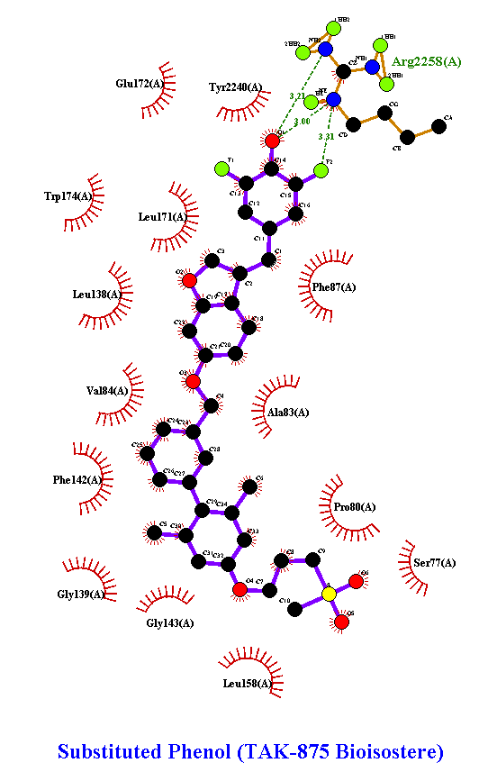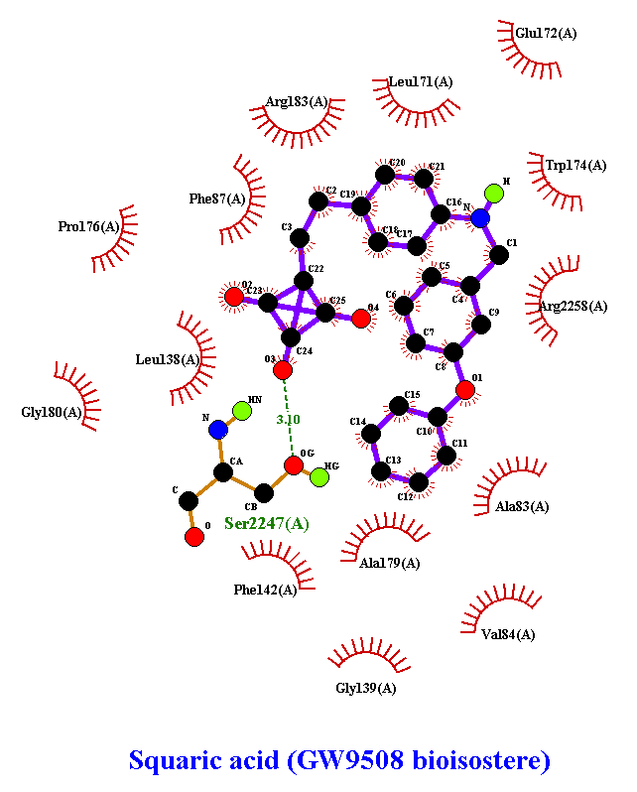
Figure 6: Ligplot+ diagrams of proteins interactions between two bioisosteres after flexible docking. The 2,6-difluorophenol (10) is derived from the TAK-875 template and the squaric acid (20) is derived from the GW9508 template.

The TAK-875 bioisostere is anchored at the bottom of the binding pocket through 3 H-bonds with arginine-258. On the right-hand side of Figure 6, it can be seen that squaric acid (20) has a more compact form with only 1 H-bond involving Serine-247, but also a lot of hydrophobic interactions to stabilise the compound. These representations show favourable interactions towards agonist recognition for both bioisosteres.

Conclusions
Autodock Vina proved to be a useful and accurate software for the docking of TAK-875 and GW9508 bioisosteres. So far, the optimal bioisosteric group seemed to feature either the 2,6-difluorophenol (10) for TAK-875 or the squaric acid (20) for GW9508. They both exhibited a good affinity value as well as a good interaction profile.
We plan to synthesise these virtual molecules and test them in relevant assay systems. It would be interesting to determine if replacement of the carboxylic acid function using these bioisosteric groups could help to prevent the formation of AG metabolites and/or drug hepatotoxicity (without significant loss of affinity for the GPR40 receptor).
Future perspective
This study has identified a limited number of carboxylic acid bioisosteres for us to target synthetically, in order to facilitate our efforts to discover novel GPR40 agonists. Preliminary investigations into the assembly of novel building blocks featuring thiazolidinedione (TZD) replacements for carboxylic acids have been reported [39]. We will build on this work by initially targeting the synthesis of compounds 10 and 20, both of which were found to be novel based on a scifinder-n search. [40] Many other parameters need to be considered in the course of drug discovery and, should we demonstrate binding affinity for the GPR40 receptor, we plan to profile our synthetic analogues for functional activity, their in vitro ADME properties, lipophilicity (logP), and other molecular properties. In 2018, Ho et al emphasised the localisation of an allosteric binding site on GPR40. The activation of this allosteric site is thought to act synergistically with the active site of GPR40 [41]. This structural knowledge could point to an interesting approach to potentiate the effectiveness of TAK-875/GW9508-derived agonists.

Acknowledgments
The authors would like to acknowledge the support of the Erasmus+ programme of the European Union, which has allowed Guillaume Vink to undertake an internship at Kingston University, London.

Supplementary Information
See attached file for chemical structures of our virtual molecules.

Financial & competing interests disclosure
The authors have no other relevant affiliations or financial involvement with any organisation or entity with a financial interest or financial conflict with the subject matter or materials discussed in the manuscript apart from those disclosed. No writing assistance was utilised in the production of this manuscript.

Summary Points

Experimental section
• Carboxylic acid bioisosteres molecules were constructed using Pymol.
• AutoDock Vina was used for the docking work described herein.
Results & discussion
• Autodock Vina’s prediction revealed a similar binding mode for GW9508 and TAK-875 at the GPR40 receptor.
• Affinities and the number of H-Bond based interactions between GPR40 and the most promising TAK-875 and GW9508 bioisosteres (10 and 20 respectively) were predicted.
Conclusion
• This study paves the way for synthesis of 10 and 20 ahead of biological testing.

References
1. Roglic G, World Health Organization, editors. Global report on diabetes. World Health Organization, Geneva, Switzerland (2016)
2. Diabetes UK, Diabetes in the UK 2010: Key statistics on diabetes, (2010)
3. Williams R, Karuranga S, Malanda B, et al. Global and regional estimates and projections of diabetes-related health expenditure: Results from the International Diabetes Federation Diabetes Atlas, 9th edition. Diabetes Research and Clinical Practice (2020).
4. Hu FB, Satija A, Manson JE. Curbing the Diabetes Pandemic: The Need for Global Policy Solutions. JAMA. 313(23), 2319–2320 (2015).
5. Kharroubi, A.T., and Darwish, H.M. (2015). Diabetes mellitus: The epidemic of the century. World J Diabetes 6, 850–867.
6. Ali O. Genetics of type 2 diabetes. World J Diabetes. 4(4), 114–123 (2013).
7. Chatterjee S, Khunti K, Davies MJ. Type 2 diabetes. The Lancet. 389(10085), 2239–2251 (2017).
8. Bolen S, Feldman L, Vassy J, et al. Systematic review: comparative effectiveness and safety of oral medications for type 2 diabetes mellitus. Ann. Intern. Med. 147(6), 386–399 (2007). ** This is an excellent review of diabetes therapeutics.
9. Nadkarni P, Chepurny OG, Holz GG. Regulation of Glucose Homeostasis by GLP-1. Prog. Mol. Biol. Transl. Sci. 121, 23–65 (2014).
10. Itoh Y, Kawamata Y, Harada M, et al. Free fatty acids regulate insulin secretion from pancreatic β cells through GPR40. Nature. 422(6928), 173–176 (2003).
11. Nakamoto K, Nishinaka T, Matsumoto K, et al. Involvement of the long-chain fatty acid receptor GPR40 as a novel pain regulatory system. Brain Research. 1432, 74–83 (2012).
12. Ferdaoussi M, Bergeron V, Zarrouki B, et al. G protein-coupled receptor (GPR)40-dependent potentiation of insulin secretion in mouse islets is mediated by protein kinase D1. Diabetologia. 55(10), 2682–2692 (2012).
13. Chen C, Li H, Long Y-Q. GPR40 agonists for the treatment of type 2 diabetes mellitus: The biological characteristics and the chemical space. Bioorg. Med. Chem. Lett. 26(23), 5603–5612 (2016).
14. Mikami S, Kitamura S, Negoro N, et al. Discovery of Phenylpropanoic Acid Derivatives Containing Polar Functionalities as Potent and Orally Bioavailable G Protein-Coupled Receptor 40 Agonists for the Treatment of Type 2 Diabetes. J. Med. Chem. 55(8), 3756–3776 (2012).
15. Li Z, Chen Y, Zhang Y, et al. Structure-based design of free fatty acid receptor 1 agonists bearing non-biphenyl scaffold. Bioorg Chem. 80, 296–302 (2018).
16. Mancini AD, Poitout V. GPR40 agonists for the treatment of type 2 diabetes: life after “TAKing” a hit. Diabetes Obes. Metab. 17(7), 622–629 (2015).
17. Negoro N, Sasaki S, Mikami S, et al. Discovery of TAK-875: A Potent, Selective, and Orally Bioavailable GPR40 Agonist. ACS Med. Chem. Lett. 1(6), 290–294 (2010). * The authors feel this work is a significant contribution to the field of drug discovery.
18. Yashiro H, Tsujihata Y, Takeuchi K, Hazama M, Johnson PRV, Rorsman P. The effects of TAK-875, a selective G protein-coupled receptor 40/free fatty acid 1 agonist, on insulin and glucagon secretion in isolated rat and human islets. J. Pharmacol. Exp. Ther. 340(2), 483–489 (2012). * An important medicinal chemistry contribution.
19. Kaku K, Enya K, Nakaya R, Ohira T, Matsuno R. Efficacy and safety of Fasiglifam (TAK-875), a G protein-coupled receptor 40 agonist, in Japanese patients with type 2 diabetes inadequately controlled by diet and exercise: a randomized, double-blind, placebo-controlled, phase III trial. Diabetes Obes Metab. 17(7), 675–681 (2015).
20. Otieno MA, Snoeys J, Lam W, et al. Fasiglifam (TAK-875): Mechanistic Investigation and Retrospective Identification of Hazards for Drug Induced Liver Injury. Toxicol Sci. 163(2), 374–384 (2018).
21. Ackerson T, Amberg A, Atzrodt J, et al. Mechanistic investigations of the liver toxicity of the free fatty acid receptor 1 agonist Fasiglifam (TAK875) and its primary metabolites. J. Biochem. Mol. Toxicol. , e22345 (2019).
22. Ali G, Islam NUI, Subhan F, Khan I. Input of Isosteric and Bioisosteric Approach in Drug Design. J. Chem. Soc. Pak., 36(5), 1-20 (2014).
23. Ballatore C, Huryn DM, Smith AB. Carboxylic acid (bio)isosteres in drug design. ChemMedChem. 8(3), 385–395 (2013).
24. Ballatore C, Lassalas P, Gay B, Lasfargeas C, et al. Structure Property Relationships of Carboxylic Acid Isosteres. J. Med. Chem. 59(7), 3183–3203 (2016).
25. Meanwell NA. Synopsis of Some Recent Tactical Application of Bioisosteres in Drug Design. J. Med. Chem. 54(8), 2529–2591 (2011).
26. Seeliger D, de Groot BL. Ligand docking and binding site analysis with PyMOL and Autodock/Vina. J Comput. Aided Mol. Des. 24(5), 417–422 (2010).
27. Srivastava A, Yano J, Hirozane Y, et al. High-resolution structure of the human GPR40 receptor bound to allosteric agonist TAK-875. Nature. 513(7516), 124–127 (2014).
28. The PyMOL Molecular Graphics System, Version 2.0 Schrödinger, LLC.
29. ACD/ChemSketch, version 2019.1.1, Advanced Chemistry Development, Inc., Toronto, ON, Canada, www.acdlabs.com, 2019.
30. Trott O, Olson AJ. AutoDock Vina: improving the speed and accuracy of docking with a new scoring function, efficient optimization and multithreading. J Comput Chem. 31(2), 455–461 (2010). * A key molecular modelling reference.
31. Dwarka D, Agoni C, Mellem JJ, Soliman ME, Baijnath H. Identification of potential SARS-CoV-2 inhibitors from South African medicinal plant extracts using molecular modelling approaches. South African Journal of Botany (2020)
32. Sarkar M, Saha S. Structural insight into the role of novel SARS-CoV-2 E protein: A potential target for vaccine development and other therapeutic strategies. PLoS One. 15(8) (2020)
33. Wong CF. Flexible receptor docking for drug discovery. Expert Opin. Drug Discov. 10(11), 1189–1200 (2015).
34. Sum CS, Tikhonova IG, Neumann S, et al. Identification of residues important for agonist recognition and activation in GPR40. J. Biol. Chem. 282(40), 29248–29255 (2007).
35. Veber DF, Johnson SR, Cheng H-Y, Smith BR, Ward KW, Kopple KD. Molecular Properties That Influence the Oral Bioavailability of Drug Candidates. J. Med. Chem. 45(12), 2615–2623 (2002).
36. Laskowski RA, Swindells MB. LigPlot+: multiple ligand-protein interaction diagrams for drug discovery. J Chem Inf Model. 51(10), 2778–2786 (2011).
37. Castro-Alvarez A, Costa AM, Vilarrasa J. The Performance of Several Docking Programs at Reproducing Protein–Macrolide-Like Crystal Structures. Molecules. 22(1), 136 (2017).
38. Kufareva I, Abagyan R. Methods of protein structure comparison. Methods Mol Biol. 857, 231–257 (2012).
39. Scanlon JJ, Wren S. Unearthing novel thiazolidinone building blocks as carboxylic acid bioisosteres. Future Med. Chem.12(20),1855-1864 (2020).
40. Scifinder-n exact structure searches were performed 06/12/2020 (https://scifinder-n.cas.org/) and zero hits were found.
41. Ho JD, Chau B, Rodgers L, et al. Structural basis for GPR40 allosteric agonism and incretin stimulation. Nat Commun. 9(1), 1645 (2018).
42. 1. Meng X-Y, Zhang H-X, Mezei M, Cui M. Molecular Docking: A powerful approach for structure-based drug discovery. Curr. Comput. Aided Drug Des. 7(2), 146–157 (2011).
43. Marcinak JF, Munsaka MS, Watkins PB, Ohira T, Smith N. Liver Safety of Fasiglifam (TAK-875) in Patients with Type 2 Diabetes: Review of the Global Clinical Trial Experience. Drug Saf. 41(6), 625–640 (2018).

