Inter-Regional Migration in Transition Economies:
The Case of Poland

By

Subrata Ghatak+

Alan Mulhern+

John Watson+

+School of Economics, Kingston University, UK.

We thank Vince Daly for helpful comments on an earlier version of this paper. The usual disclaimer applies.

Abstract

In this paper, we modify the Harris-Todaro model of migration to incorporate the impact of human capital, housing stock and the availability of publicly provided goods like health care and road provision in order to analyse the determinants of migration in different regions of Poland. We apply the Seemingly Unrelated Regression Equation [SURE] model to investigate the data. Our results show that GDP per capita, unemployment and distance have a strong effect on regional migration in this country. Human capital is also an important explanatory factor as is the provision of key publicly provided facilities such as roads. The lack of housing in Poland is important in explaining the low levels of internal migration.

JEL Classification: F 22, O15, J61.
Keywords: regional migration; Harris Todaro model; transition economies; Poland; SURE Model .
1. Introduction

In their seminal contributions to the economic literature, Todaro (1969) and Harris and Todaro (1970) identified real wage gaps and the probability of finding employment as the major factors behind migration. In the light of such models, it is easy to understand why strong migration pressures exist in some transition economies (Fassman and Munz, 1994; Ghatak et alia, 1996; Levine, 1999: Ghatak and Sassoon, 2001; Hatton and Williamson, 1998; Straubhaar and Zimmermann, 1992). Migration has become one of the most important factors affecting economic development in the 21st century (Hatton, 2001; Sheilds and Wheatley Price, 1998; Wheatley Price, 2001). On the other hand such models should also help explain why some economies have low or declining inter-regional migration. Traditional economic models can be inadequate in explaining current regional migration in transition economies as they ignore the role of a number of important factors like human capital, housing and the availability of publicly provided goods such as health care and transport infrastructure.

This paper focuses on the major economic causes of internal migration within Poland. Similar to other transition economies, Poland exhibits a polarisation of its economy with growing gaps between regions as well as increasing rates of unemployment (see figs 3 and 4). In view of traditional migration models it would be expected that internal mobility would reduce such gaps with migrants moving from depressed areas to more advanced regions. However, this is not happening as Poland shows very low rates of internal migration (Fidrmuc 2003 and Bornhorst and Commander 2004). The understanding of the migration dynamics of countries such as Poland , which have recently entered the EU, is a part of
the complex overall picture of intra-European migration and labour mobility.

The paper will address three specific issues. First, we will examine the role of conventional factors like wage and unemployment differentials in the context of the Harris-Todaro (H-T) model to explain regional migration within Poland. We also include distance as an explanatory variable. Next, the role of other factors is incorporated. We examine the role of infrastructure provision (mostly publicly provided goods) in a region in terms of housing, health care and road provision. These factors are of particular relevance in understanding the inter-regional dynamics of migration in European transition economies (Deichmann and Henderson, 1996; Andrienko and Guriev, 2003).

Economic theory suggests significant gains from free factor movements as long as labour markets clear. A study by Hamilton and Whalley (1984) suggests that at a world-wide level free labour mobility would bring about huge efficiency gains. However at the opposite extreme Brecher and Choudhri (1987) show that if real wages are fixed then the optimal degree of labour migration is zero. These contrasting results highlight the importance of assessing the welfare economics of migration models with properly specified and estimated labour markets. In the next section, we will develop models of different types of labour market behaviour that are characterised by wage–gaps, different marginal labour productivities and different employment probabilities. Thirdly, we modify the standard H-T model to incorporate the impact of human capital (the educational level of the migrant) to analyse the migration decision. Section 2 of this paper provides the theoretical model. In section 3, we describe the data, sources and key background literature. In section 4, we apply the Seemingly Unrelated Regression Model [SURE] to examine the data. Section 5 concludes.
2. A theoretical model of migration
Our theoretical model of migration is based on the H-T model of rural-urban migration. The future expected income from migration is given by
$\int{\left[{\text{PW}}_{u}+(1−P)W_{b}\right]e^{−\text{rt}}\text{dt}−C=\frac{1}{r}}\left[{\text{PW}}_{u}+(1−P)W_{b}\right]−C$ (2.1)
where C is the direct cost of migration, r is the migrants’ discount rate, P is the probability of employment at real wage W_{u} and W_{b} is the real income received if unemployed or employed in the informal sector. The would-be migrants compare (2.1) with the future income from remaining in the rural sector.
$\int{W_{r}e^{−\text{rt}}}\text{dt}=\frac{1}{r}W_{r}$ (2.2)
If employment is a certain prospect (i.e. P=1) then migration takes place only if there are gains from moving, i.e., only if
$\frac{1}{r}W_{u}−C>\frac{1}{r}W_{r} \text{or} W_{u}−W_{r}>\text{rC}$ (2.3)
Under conditions of uncertainty, the probability of obtaining employment is given by
$P=\frac{\overset{}{L_{u}}}{N_{u}}=\frac{\overset{}{L_{u}}}{{\overset{}{L}}_{u}+M\overset{}{N_{r}}}$ (2.4)
where L is population employed, N is total population and M is the rate of migrants coming from the rural region and the subscript u refers to urban regions while r refers to rural areas. Equation (2.4) assumes that migrants compete on equal terms with the incumbent urban employed population. Thus as M rises, P falls and migration continues only until the returns from (2.1) and (2.2) are exactly equal. Hence, the equilibrium migration rate M is given by
${\text{PW}}_{u}+(1−P)W_{b}−W_{r}=\text{rC}$ (2.5)
with P given by (2.4). Substituting (2.4) into (2.5) and solving for M gives the equilibrium migration rate. Equation 2.5 is derived assuming equality holds in 2.3.
$M=\left[\frac{W_{u}−W_{r}−\text{rC}}{\text{rC}−W_{b}+W_{r}}\right]\frac{\overset{}{L_{u}}}{\overset{}{N_{u}}}$ (2.6)
We require that Wb-Wr<rC for M>0 which implies there is no incentive to leave rural areas for urban unemployment.
From (2.6), we get the familiar results
$\frac{∂M}{∂W_{u}}>0;\frac{∂M}{∂W_{r}}<0;\frac{∂M}{∂\overset{}{L_{U}}}>0;\frac{∂M}{∂C}<0$ (2.7)
Inequalities (2.7) state that any marginal increase in urban wage (W_{u}) or decrease in the rural wage (W_{r}) will increase migration. Paradoxically, any policy to increase employment in the advanced urban sector will raise the migration rate and may increase urban unemployment. Hence, as predicted in the H-T models, a policy of creating more employment opportunities in the advanced regions may only enlarge the migration from the backward region. Also, any decrease in the cost of migration will increase M. Clearly, the H-T model ignores the impact of human capital, availability of public goods like health care, housing stock and road infrastructure in migration decisions. Later, we extend the H-T model to include the impact of such factors.

Figure 1 explains the gains and losses of migration. The benefits and costs of such migration will be clearly identified from the point of view of both the host and the donor regions. In fig 1, we show the pre and post-migration labour market in different regions of an economy. Due to the access to superior technology, better organisation and human capital, the marginal productivity of labour (MPL) in the advanced (“urban”) region is higher than in the backward (“rural”) region as shown by the positions of MPLW (marginal productivity of labour in the advanced region, W_{U}) and MPLE (marginal productivity in the poorer region, W_{R}). Real wages are higher in the advanced region (W_{U}) in comparison with backward region (W_{R}) as shown on the vertical axis of fig. 1 with employment at A (measured on the horizontal axis). In fig. 1 we show that after migration of labour from the backward to the advanced region, the equilibrium real wage will be W. The welfare gains are equal to ≡ KED (advanced) + EDCJ (migrants); loss for backward region ≡ FGJ = EJC. Thus the net overall gain = EKDC. Incidentally, Hamilton and Whalley (1986) estimate this area for global perfect labour mobility. Clearly, the size of the gain will depend on the degree of labour mobility, nature and quality of labour, substitutability or complementarity between different types of labour and the degree of labour absorption in the labour market given by the real wage flexibility. Inter alia, the greater the wage flexibility in the host country, the greater would be the welfare gain (Ghatak et alia. 1996; Levine, 1999).

It is known that in the original H-T model, uneducated labour has as much chance of getting a job as educated. Clearly, this is unrealistic. Hence, we now introduce two new assumptions in the H-T model. First, the probability of finding a job is also a function of the endowment of human capital (HC),
B
W_{U}
W
W_{R}
L
P
M
F
G
E
K
J
D
C
A
H
Real Wage
Employment
Figure 1: Employment and Real Wage alter Migration
MPLE
MPLW
$P=P\left(\text{HC},\frac{\overline{L_{u}}}{\overline{L_{u}}+M\overline{N_{r}}}\right) \text{with} \frac{∂P}{∂\text{HC}}>0$ (2.8)
thus individuals with a higher endowment of human capital will find a job more easily. Let HC be normalised in the interval (0,1). Then the probability of obtaining employment is assumed to be:
$P=\text{HC}\frac{\overline{L_{u}}}{\overline{L_{u}}+M\overline{N_{r}}}$ (2.9)
Both Bencivenga and Smith (1997) and Chaudhuri (2000) have developed models providing further modification of the H-T model, showing how urban unemployment and the informal sector can be understood within an H-T type model.

The second assumption is that the utility of finding a house is H. Would-be migrants face a new uncertainty. If they stay in the rural sector they are certain about having a house available, but after migration, migrants may face a shortage of houses. The probability of finding a house Ph is given by
$\text{Ph}=\frac{D}{\overline{L_{u}}+M\overline{N_{r}}}$ (2.10)
where D is the total amount of dwellings in the urban sector.
Finally, let PG be a vector of quantities of n publicly provided goods such as health care and road infrastructure. Formally,
$\text{PG}=\left\{{\text{PG}}_{1},{\text{PG}}_{2},\text{.}\text{.}\text{.},{\text{PG}}_{n}\right\}$. (2.11)
The utility of publicly provided goods, Ug is independent on all other variables in the utility function. It is given by,
$\text{Ug}=\text{Ug}(\text{PG}) \text{with} \frac{∂\text{UG}}{∂{\text{PG}}_{k}}>0 ∀ k=1,2,\text{.}\text{.}\text{.},n$ (2.12)
With these new conditions, the expected utility of migration becomes
$\int{\left[{\text{PW}}_{u}+(1−P)W_{b}+\text{PhH}+\text{Ug}({\text{PG}}^{u})\right]e^{−\text{rt}}\text{dt}−C=\frac{1}{r}}\left[{\text{PW}}_{u}+(1−P)W_{b}+\text{PhH}+\text{Ug}({\text{PG}}^{u})\right]−C$ (2.13)
and the utility of staying in the rural sector is
$\int{(W_{r}+H+\text{Ug}({\text{PG}}^{r}))e^{−\text{rt}}}\text{dt}=\frac{1}{r}(W_{r}+H+\text{Ug}({\text{PG}}^{r}))$, (2.14)
where the superscripts r and u refers to publicly provided goods in the rural and urban sector respectively.
Equilibrium will be achieved when (2.13) equals (2.14). Solving for M in equilibrium results in
$M=\frac{\overline{L_{u}}\left[\text{HC}(W_{u}−W_{b})−{rΔ}_{b}\right]+H(D)}{\overline{N_{r}}\left[{rΔ}_{b}\right]}$, (2.15)
where Δ_{b} is the difference in utility between staying in the rural sector and migrating for unemployment without a house, this is
$Δ=\frac{1}{r}\left[W_{r}+H+{\text{Ug}}^{r}−W_{b}−{\text{Ug}}^{u}\right]+C$ (2.16)

We require that individuals prefer to stay in the rural sector rather than to migrate for unemployment without a house, such that Δ_{b} > 0, a sufficient condition for M>0 in (2.15) is
$\text{HC}(W_{u}−W_{b})>{rΔ}_{b}$, (2.17)
which implies that the difference between wages in the formal and informal sector, corrected for human capital should be greater than Δ_{b.} Think about two extreme cases. First, if HC is the minimum possible, zero, migration will hardly take place because the probability of obtaining employment is zero. Second, if HC is the maximum value, one, then migration will take place if the plain difference between wages in the formal and informal sector is larger than the utility difference of staying and leaving for the informal sector without a house. If inequality (2.17) does not hold, then M >
0 only if there are enough dwellings available in the urban sector to compensate.

The effect of changes in housing, human capital and publicly provided goods on migration is given by the following derivatives:
$\frac{∂M}{∂D}=\frac{H}{\overline{N_{r}}\left[{rΔ}_{b}\right]}$ (2.18)
$\frac{∂M}{∂\text{HC}}=\frac{\overline{L_{u}}(W_{u}−W_{b})}{\overline{N_{r}}\left[{rΔ}_{b}\right]}$ (2.19)
$\frac{∂M}{∂{\text{PG}}^{u_{k}}}=\left[\frac{\overline{L_{u}}}{\overline{N_{r}}\left[{rΔ}_{b}\right]}+\frac{M}{{rΔ}_{b}}\right]\frac{∂\text{Ug}}{∂{\text{PG}}^{u_{k}}}$ (2.20)
$\frac{∂M}{∂{\text{PG}}^{r}}=−\left[\frac{\overline{L_{u}}}{\overline{N_{r}}\left[{rΔ}_{b}\right]}+\frac{M}{{rΔ}_{b}}\right]\frac{∂\text{Ug}}{∂{\text{PG}}^{r_{k}}}$ (2.21)
It follows that if Δ_{b} > 0 and wages in the formal sector are higher than in the informal sector, then (2.18), (2.19) and (2.20) are positive, while (2.21) is negative. Therefore any marginal increase in dwellings, human capital or in any publicly provided good in the urban sector will increase migration; while any marginal increase in publicly provided goods in the rural sector will deter migration.
3. Background and data sources.

There has been growing polarisation of the Polish economic space since the start of the Transitional Programme in 1989 with some regions growing much faster than others (Ghatak et al. 2004). However the pattern of inter-regional migration within Poland throughout the same period only faintly reflects this polarisation. Clearly, the lack of labour mobility from the low-productivity to high-productivity regions adversely affects efficiency and gains in output and employment. This has been explained in Fig.1.

Firstly, we locate our model of migration within the developing themes in the literature. Thus we test the extent to which inter-regional migration flows are correlated with:

- relative economic opportunity, measured by regional differences in wage rates and unemployment - the Harris and Todaro (1970) hypothesis. In the case of Poland there is a lack of regional data on wages for the time period we are studying. Wages therefore proxied by GDP per capita in our model.
- regional facilities (particularly publicly provided facilities) - the Tiebout (1956) hypothesis. In our model we test for road infrastructure, health and housing facilities. In the faster growing regions these factors act as agglomeration economies thus increasing regional productivity, raising wage rates and attracting inward migration.
- the relative distance migrants have to travel - the Hatton-Williams (1998) hypothesis. This proxies for the cost of migration.
- the impact of human capital on migration patterns (Dustmann 1995).

The theory behind these views of migration, the choice of our model and the choice of variables has been built on previous research in this area as well as our developing understanding of the forces of inter-regional migration.

Secondly, we locate our paper within the specific and limited research on inter-regional migration within Poland. Deichmann and Henderson (1996) clearly emphasize low internal migration as a serious problem in impeding efficiency and economic growth within Poland. They indicate that regional migration declined in the first half of the 1990s (especially rural-urban migration) and that population levels seemed frozen at sub-optimal urbanization levels. They also indicate that migration patterns within the country did not appear to respond to unemployment differentials and point to the housing shortage as the most likely candidate for explanation. Bornhorst and Commander (2004) also recognise the efficiency lost due to the low migration rates within Poland and point to the poor housing market as its cause. Our paper complements some of their research, for example the continuing decline of internal migration in the second half of the 1990s (see fig.2 in Appendix); the importance of the Polish housing situation as a block to regional migration; the low priority of health decisions in the migration pattern. Other studies of transitional economies have noted similar trends of low migration and differing regional growth rates (e.g. Fidrmuc 2003). With the aid of a rigorous econometric method of testing for the explanatory variables of inter-regional migration and with the availability of key data since 1995-1996, we are now able to test more deeply for the causes of migration within Poland and obtain results based on robust econometrics.

In accord with the theory elucidated in section 2 and also in accord with other countries' experience we expect that within Poland regional migration is correlated positively with GDP per capita (our proxy for wages) and negatively with unemployment in the faster growing regions. These regions therefore pull in workers from the slower growing regions. We expect that general infrastructure facilities in the faster growing regions act as magnets for migration, being expressions of agglomerations economies in these areas. Thus we expect that housing and road transport facilities will be positively signed on their coefficients. Health facilities are our only doubt. While consistency would demand we give it the same sign and expectation as the previous two variables, prior research (Deichmann and Henderson, 1996) indicates that migration was accompanied by worsening health statistics in the first half of the 1990s in Poland. By implication therefore Polish workers were moving to industrial areas in spite of the health hazards. Our inclusion of the variable of infant health (proxying for health facilities) remains open therefore as to expectation of sign. Distance to be travelled by the migrant, as proxy for the cost of migration, is assumed to be negatively signed. Human capital, as explained in Section 2, is expected to be positively correlated with migration.

All data has been drawn from the web site of the Polish Central Statistical Office (Glowny Urzad Statystyczny, GUS: www.stat.gov.pl) This data comprises regional data on the following: migration, unemployment, GDP per capita, housing, secondary school education, infant mortality, road provision and population numbers.
4. Empirical specification and results

For empirical estimation we follow
$M_{\text{ijt}}=δ_{i}+γ_{j}+{βX}_{\text{ijt}}+ε_{\text{ijt}} \text{with} i,j=1\text{.}\text{.}\text{.}\text{16} i≠j$ (4.1)
where M_{ijt} is the natural logarithm of migration from province i to province j; δ_{i} and γ_{j} are fixed effects for donor and destination provinces respectively, used to catch spatial heterogeneity; and X is a vector of explanatory variables which are as follows:
Y_{jt} (Y_{it}): natural logarithm of GDP per capita (proxy for wages) in destination province (donor province).
U_{jt} (U_{it}): natural logarithm of unemployment in destination province (donor province).
DW_{t}: natural logarithm of the number of dwellings per thousand population in destination region.
HC_{t}: is the natural logarithm of the number of students enrolled in secondary schools including vocational, basic and especial schools per thousand population in donor province.
D: is the road distance in kilometres between the capitals of provinces i to j, which we proxy for migration costs.
RD_{jt} (RD_{it}): natural logarithm of density of road length in destination province (donor province).
IM_{jt} (IM_{it}): rate of infant mortality in destination province (donor province).

The latter two variables are used to test the incidence of publicly provided goods. RD is a proxy for infrastructure and IM for health care. Three different models are estimated, the first does not take into account publicly provided goods, the second only infrastructure while the third uses all variables.

Some migration studies use symmetrical models, in which explanatory variables such as unemployment and GDP per capita are ratios or differences between donor and destination provinces. This may imply strong assumptions such as perfect information. Migrants may not react equally to changes in labour markets in far provinces compared to those in home region for which more information is available (Taylor and Martin 2001). Furthermore Bornhorst and Commander (2004) suggests that lack of information about job opportunities in other regions may be a cause of the low rates of migration in transition economies. Therefore, equation (4.1) uses the less restrictive asymmetrical specification.

The data used for estimation of equation (4.1), consists of 16 Polish provinces (voidvodships) with observations from 1995 to 2001. Each cross section comprises one single destination province. Therefore, there are 16 cross sections and 105 observations in each, which totals 1640 observations.
OLS estimates following the LSDV method were first used. Tests for groupwise heteroskedasticity and serial correlation were carried out and results indicate that these hypotheses cannot be rejected. Thus OLS estimators remained unbiased, but were not efficient. For this reason and in interest of brevity these are not reported here. Given these results, Zellner’s (1962) Seemingly Unrelated Regression Equations (SURE) were used.

Two different estimators of SURE are shown. Table 1 shows Feasible Generalised Least Squares (FGLS). Estimators in this table are obtained by estimating the variance-covariance matrix of errors by OLS and then using these estimates to compute GLS estimators of the model. Table 2 shows Maximum Likelihood estimator (ML), in which case, the process of obtaining estimates of the variance-covariance matrix is iterated until convergence. Both estimators are asymptotically equivalent and are reported for comparison purposes. Table 2 contains our preferred model (model 3).

Results are very similar across the two different estimators, the main difference being that in the second unemployment in the donor region (Uni) now becomes significant at the 5% level while road infrastructure for destination region (RDj) from being insignificant in Table 1 just approaches the 5% significance range in Table 2 - for all practical purposes however we can say that with a t-statistic of 1.99 it is a significant variable. However road infrastructure in donor regions (Rdi) in both tables proved insignificant. Our health variable proved insignificant - not unexpected given the evidence of previous research. Health issues do not seem to be part of the migrants’ decision making process. For the sake of brevity we shall comment on the results of Table 2 since these are our preferred results. All variables in Table 2 (except for health which we left open) have the expected signs.

Y_{i}, U_{j} and D are highly significant. Yj and U_{i} also prove significant though somewhat less so. Thus our results for Poland generally confirm traditional theory that internal migration follows the incentives and disincentives of relative regional opportunity and cost of migration. In explaining migration decisions specifically in Poland however, GDP in the destination province is important but not as much as in the donor province. Unemployment in the donor province is also significant though less so than the unemployment situation in the destination province. Distance is a very important explanatory variable for migration thus lending support to gravity type models. Housing facilities in the destination region (DW) and the educational background of the migrant (HC) are both highly significant with both SURE estimators. Finally, road provision (RD) is significant only for destinations regions in our preferred Table 2. Health, proxied by infant mortality in our model (IM) is not significant - thus indicating that workers are moving for principally narrower economic motives.

It follows from equation (4.1) that coefficients estimated are elasticities of migration with respect to their variables. Almost all elasticities are stable across the different models and estimators. Elasticity of migration with respect to GDP per capita in destination province is about 0.3, while with respect to GDP per capita in source province it is about -0.7. Thus the effect of GDP per capita in home regions is much stronger than in destination regions. The elasticity of unemployment in destination regions is about -0.3; while in source province it is close to zero. The elasticity of distance is about -1.7 and the elasticity of human capital is about 0.3.

The elasticity of migration with respect to housing is the largest reported at around 9 i.e. a 1% increase in available dwellings will increase migration by about 9%. Given the low levels of internal migration observed in Poland and given these results, it seems that housing is a key factor deterring inter-regional migration. An increase in the number of dwellings is the most effective way to boost migration.

After housing, the largest elasticity is that of distance. Migration to more distanced areas is discouraged. This effect is weaker than that of housing but is stronger than that of traditional factors such as unemployment and GDP per capita.
5. Conclusions

Our paper expands the traditional studies of inter-regional migration with a theoretical model and its empirical analysis with the integration of new variables. In addition to GDP per capita and unemployment in source and destination provinces, as well as distance between provinces, the effect of housing, human capital and publicly provided goods are also studied in our model in the light of the special characteristics of the transitional economies.

Polish regional migration is low by international standards - a feature noted in other transitional economies. However the migration that does exist follows economic patterns being influenced by relative regional economic opportunities and costs. Evidence shows that GDP per capita and unemployment have a strong effect on internal migration. However, GDP per capita in the donor province has a stronger influence than in the destination province. Unemployment has a stronger impact on migration in destination rather than donor provinces. Such asymmetry reinforces the assumption of imperfect information.

In accord with the gravity model migration is negatively affected by distance. We have found evidence that such migration is also influenced by regional facilities, which we have measured in terms of road infrastructure, health and housing. Lack of housing in particular has proved to be a major explanation for the low levels of migration. Health has not played an important role in migration decisions in Poland. Road infrastructure in the destination region does play a part in the story. Finally the human capital quality of the migrant plays an important role in migration since provinces with increased education tend to provide more migration.

It follows from these findings that in order to encourage greater labour mobility for reaping efficiency gains an important policy decision for the Polish government is to provide more practical housing for key workers in those regions with growth potential. Regional facilities can also be improved thus providing the infrastructure necessary for increased employment. Finally greater educational provision helps migration. The better educated migrant is more equipped to find work, long term employment and a higher wage.
APPENDIX
Table 1. SURE - FGLS
i = donor province
j = destination province
 | Model 1 |  | Model 2 |  | Model 3
Variable | Coefficient | t-Statistic | Coefficient | t-Statistic | Coefficient | t-Statistic
Yj | 0.312270 | 2.204338 | 0.283441 | 1.958233 | 0.351483 | 2.395126
 |  | (0.0276) |  | (0.0504) |  | (0.0167)
Yi | -0.689939 | -5.946880 | -0.663047 | -5.518536 | -0.603709 | -4.994133
 |  | (0.0000) |  | (0.0000) |  | (0.0000)
Unj | -0.200051 | -4.126762 | -0.192704 | -3.905802 | -0.200564 | -4.048255
 |  | (0.0000) |  | (0.0001) |  | (0.0001)
Uni | -0.024531 | -0.562529 | -0.016497 | -0.373800 | -0.007922 | -0.184010
 |  | (0.5738) |  | (0.7086) |  | (0.8540)
DW | 7.124814 | 4.524636 | 7.068580 | 4.482521 | 6.843659 | 4.345957
 |  | (0.0000) |  | (0.0000) |  | (0.0000)
DS | -1.722519 | -108.6755 | -1.722305 | -108.7082 | -1.723011 | -108.7631
 |  | (0.0000) |  | (0.0000) |  | (0.0000)
HC | 0.311662 | 4.361559 | 0.332297 | 4.497642 | 0.329944 | 4.569111
 |  | (0.0000) |  | (0.0000) |  | (0.0000)
RDj |  |  | 0.301865 | 1.477836 | 0.251654 | 1.197591
 |  |  |  | (0.1396) |  | (0.2312)
RDi |  |  | 0.028936 | 0.172410 | 0.003887 | 0.023974
 |  |  |  | (0.8631) |  | (0.9809)
Imj |  |  |  |  | -0.023297 | -0.318641
 |  |  |  |  |  | (0.7500)
Imi |  |  |  |  | 0.198778 | 3.070004
 |  |  |  |  |  | (0.0022)
Fixed Effects - Source Province
DOLNOŚLĄSKIE | 0.190405 |  | 0.185237 |  | 0.146874
KUJAWSKO-POMORSKIE | -0.640570 |  | -0.643759 |  | -0.665893
LUBELSKIE | -0.374125 |  | -0.367494 |  | -0.361241
LUBUSKIE | -0.842822 |  | -0.839607 |  | -0.844056
ŁÓDZKIE | -0.641518 |  | -0.639110 |  | -0.631225
MAŁOPOLSKIE | -0.640473 |  | -0.648831 |  | -0.622243
MAZOWIECKIE | 0.550000 |  | 0.537892 |  | 0.519472
OPOLSKIE | -1.223800 |  | -1.221608 |  | -1.196914
PODKARPACKIE | -0.658238 |  | -0.650306 |  | -0.621883
PODLASKIE | -0.891696 |  | -0.879221 |  | -0.862830
POMORSKIE | -0.026862 |  | -0.026955 |  | -0.026388
ŚLĄSKIE | 0.523797 |  | 0.503987 |  | 0.472633
ŚWIĘTOKRZYSKIE | -1.159413 |  | -1.157513 |  | -1.142957
WARMIŃSKO-MAZURSKIE | -0.451975 |  | -0.444951 |  | -0.420941
WIELKOPOLSKIE | -0.358056 |  | -0.361799 |  | -0.359762
ZACHODNIOPOMORSKIE | 0.438344 |  | 0.444181 |  | 0.409796
Fixed Effects - Destination Province
DOLNOŚLĄSKIE | -21.92823 |  | -21.78174 |  | -22.06415
KUJAWSKO-POMORSKIE | -22.31163 |  | -22.18542 |  | -22.46861
LUBELSKIE | -22.24050 |  | -22.08464 |  | -22.36138
LUBUSKIE | -22.44127 |  | -22.21896 |  | -22.52255
ŁÓDZKIE | -23.38518 |  | -23.23097 |  | -23.49031
MAŁOPOLSKIE | -21.65999 |  | -21.62388 |  | -21.91237
MAZOWIECKIE | -21.85682 |  | -21.71024 |  | -22.00965
OPOLSKIE | -22.79659 |  | -22.65274 |  | -22.94522
PODKARPACKIE | -21.49236 |  | -21.30968 |  | -21.62373
PODLASKIE | -22.87722 |  | -22.64980 |  | -22.93493
POMORSKIE | -21.33457 |  | -21.15893 |  | -21.46637
ŚLĄSKIE | -22.01903 |  | -22.00502 |  | -22.26250
ŚWIĘTOKRZYSKIE | -22.98776 |  | -22.85167 |  | -23.13089
WARMIŃSKO-MAZURSKIE | -21.82948 |  | -21.61962 |  | -21.92002
WIELKOPOLSKIE | -21.60433 |  | -21.45942 |  | -21.77009
ZACHODNIOPOMORSKIE | -21.30883 |  | -21.05067 |  | -21.36034
R-squared | 0.873970 |  | 0.873922 |  | 0.874159
Note: Probabillity of t-Statistics in parenthesis

Table 2. SURE - ML
i = donor province
j = destination province

 | Model 1 |  | Model 2 |  | Model 3
Variable | Coefficient | t-Statistic | Coefficient | t-Statistic | Coefficient | t-Statistic
Yj | 0.315091 | 2.674913 | 0.284040 | 2.364447 | 0.316233 | 2.611109
 |  | (0.0075) |  | (0.0182) |  | (0.0091)
Yi | -0.783222 | -7.399060 | -0.751399 | -6.829158 | -0.698041 | -6.367656
 |  | (0.0000) |  | (0.0000) |  | (0.0000)
Unj | -0.245196 | -5.738220 | -0.251447 | -5.891795 | -0.263271 | -6.137353
 |  | (0.0000) |  | (0.0000) |  | (0.0000)
Uni | 0.069504 | 1.863415 | 0.088506 | 2.322145 | 0.093815 | 2.519503
 |  | (0.0626) |  | (0.0203) |  | (0.0118)
DW | 9.473241 | 7.361655 | 9.071592 | 6.916685 | 8.562876 | 6.474561
 |  | (0.0000) |  | (0.0000) |  | (0.0000)
DS | -1.749548 | -113.2608 | -1.740803 | -113.6154 | -1.748879 | -114.1249
 |  | (0.0000) |  | (0.0000) |  | (0.0000)
HC | 0.329481 | 5.544738 | 0.330199 | 5.359525 | 0.324837 | 5.314442
 |  | (0.0000) |  | (0.0000) |  | (0.0000)
RDj |  |  | 0.549256 | 2.676696 | 0.416990 | 1.987408
 |  |  |  | (0.0075) |  | (0.0470)
RDi |  |  | -0.098132 | -0.726289 | -0.121829 | -0.923166
 |  |  |  | (0.4678) |  | (0.3561)
Imj |  |  |  |  | -0.072393 | -1.022795
 |  |  |  |  |  | (0.3066)
Imi |  |  |  |  | 0.168409 | 3.243366
 |  |  |  |  |  | (0.0012)
Fixed Effects - Source Province
DOLNOŚLĄSKIE | -0.182196 |  | -0.178630 |  | -0.225668
KUJAWSKO-POMORSKIE | -0.561674 |  | -0.543967 |  | -0.574108
LUBELSKIE | -0.333992 |  | -0.300385 |  | -0.332056
LUBUSKIE | -0.830078 |  | -0.826570 |  | -0.850330
ŁÓDZKIE | -0.696986 |  | -0.669829 |  | -0.692912
MAŁOPOLSKIE | -0.597929 |  | -0.537452 |  | -0.521118
MAZOWIECKIE | 0.664438 |  | 0.650911 |  | 0.673788
OPOLSKIE | -1.325446 |  | -1.234080 |  | -1.253529
PODKARPACKIE | -0.714359 |  | -0.700899 |  | -0.690114
PODLASKIE | -0.694006 |  | -0.705221 |  | -0.686227
POMORSKIE | 0.065693 |  | 0.071352 |  | 0.062009
ŚLĄSKIE | 0.319078 |  | 0.340986 |  | 0.340356
ŚWIĘTOKRZYSKIE | -1.042017 |  | -0.993264 |  | -1.017642
WARMIŃSKO-MAZURSKIE | -0.338240 |  | -0.342880 |  | -0.307392
WIELKOPOLSKIE | -0.353065 |  | -0.316501 |  | -0.351074
ZACHODNIOPOMORSKIE | 0.612002 |  | 0.583797 |  | 0.551136
Fixed Effects - Destination Province
DOLNOŚLĄSKIE | -34.61984 |  | -32.52596 |  | -30.49414
KUJAWSKO-POMORSKIE | -34.88830 |  | -32.84256 |  | -30.82420
LUBELSKIE | -34.83407 |  | -32.73575 |  | -30.73450
LUBUSKIE | -34.99786 |  | -32.77779 |  | -30.81480
ŁÓDZKIE | -36.29590 |  | -34.15867 |  | -32.09604
MAŁOPOLSKIE | -34.10316 |  | -32.24794 |  | -30.24128
MAZOWIECKIE | -34.64666 |  | -32.55524 |  | -30.51882
OPOLSKIE | -35.36269 |  | -33.28548 |  | -31.29931
PODKARPACKIE | -33.78765 |  | -31.67575 |  | -29.75932
PODLASKIE | -35.52784 |  | -33.29105 |  | -31.30599
POMORSKIE | -33.83384 |  | -31.71215 |  | -29.74363
ŚLĄSKIE | -34.83542 |  | -32.97744 |  | -30.86273
ŚWIĘTOKRZYSKIE | -35.54686 |  | -33.48045 |  | -31.47959
WARMIŃSKO-MAZURSKIE | -34.27180 |  | -32.07850 |  | -30.13073
WIELKOPOLSKIE | -34.08789 |  | -32.02785 |  | -30.06180
ZACHODNIOPOMORSKIE | -33.85749 |  | -31.57277 |  | -29.61117
R-squared | 0.854439 |  | 0.853509 |  | 0.853638
Note: Probabillity of t-Statistics in parenthesis

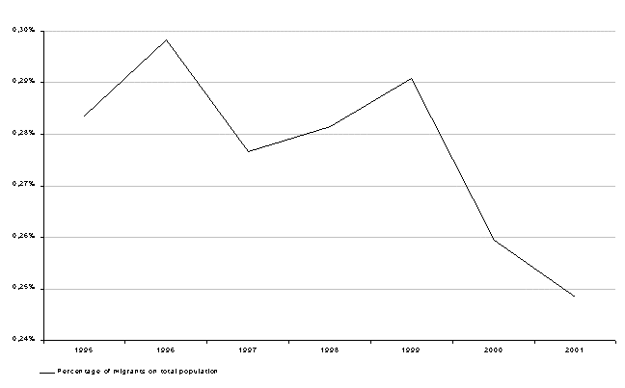
Fig.2. Declining inter-regional inward migration in Poland: 1995-2001

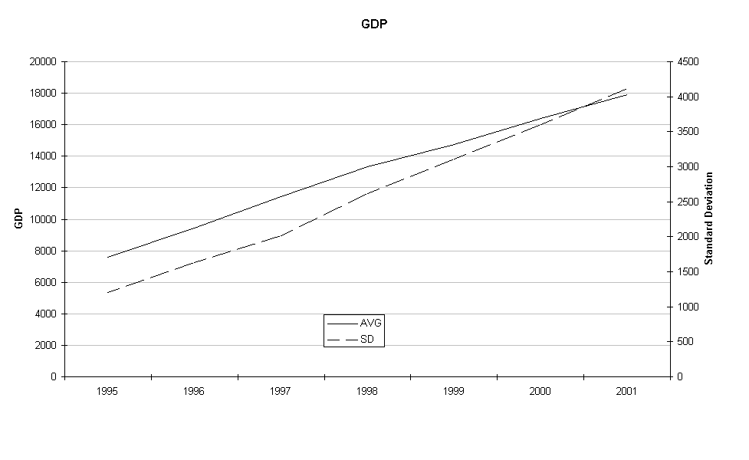
Fig 3. GDP in Polish regions: 1995-2001

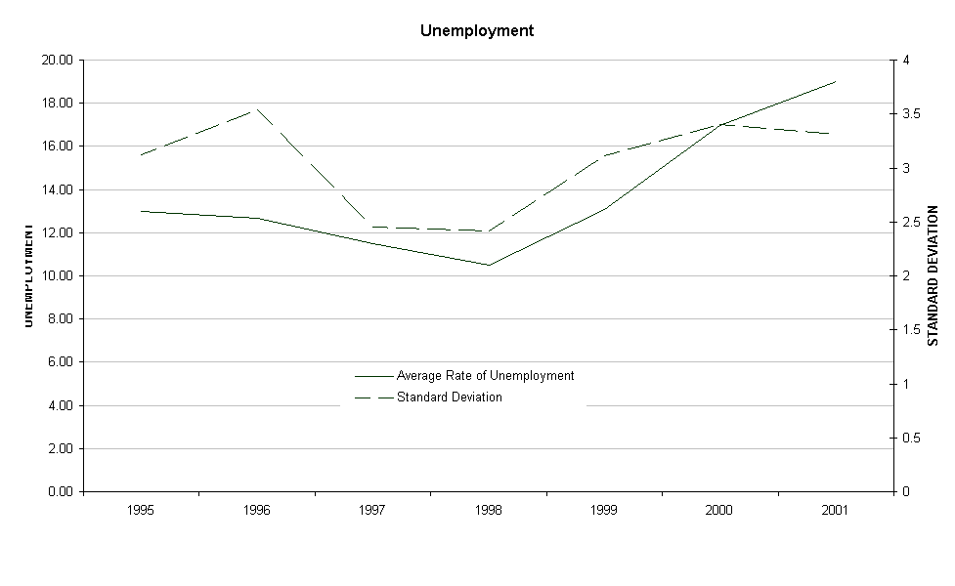
Fig 4. Unemployment in Polish regions

References

Andrienko, Y., and S. Guriev (2004) Determinants of interregional mobility in Russia, The Economics of Transition, 12 (1): 1-27.

Bencivenga, V.R., and B.D. Smith (1997) Unemployment, Migration, and Growth, The Journal of Political Economy, 105 (3), pp. 582-608.

Bornhorst, F. and Commander, S. (2004), Regional Unemployment and its Persistence in Transition Economies. Discussion Paper 1074, IZA. Institute for the Study of Labour, Bonn, Germany.

Brecher,R. and Choudhri,E. (1987) "International Migration versus Foreign Investment in the Presence of Unemployment". Journal of International Economics.

Cameron,G. and Muellbauer,J. (1999) Earnings, Unemployment, and Housing Evidence from a Panel of British Regions. CEPR paper. London.

Chaudhuri, S. (2000) "Rural-urban migration, the informal sector, urban unemployment, and development policies: A theoretical analysis". Review of Development Economics 4 (3), pp. 353-364

Deichmann,U. and Henderson,J.V. (1996) Urban and Regional Dynamics in Poland. World Bank.Washington DC.

Dustmann,C. (1995), Human Capital Accumulation And Earnings Assimilation of Migrants. CEPR paper. London.

Fassman,F. and Munz,S. (1994), Migration Focus, OECD.

Fidrmuc,J. (2003) Migration and Regional Adjustment to Asymmetric Shocks in Transition Economies. CEPR paper. London

Ghatak,S. (2003, 4th Edition), An Introduction to Development Economics. Routledge.

Ghatak,S., Levine,P. and Wheatley Price,S. (1996). "Migration Theories and Evidence: An Assessment". Journal of Economic Surveys, 10:2: pp.159-198.

Ghatak,S and Sassoon,A. eds. (2001). Migration and Mobility: The European Perspective, Palgrave.

Ghatak,S. Mulhern,A. and Stewart,C (2004), Regional development of Small Firms in Poland. Kingston University, Economics Discussion Paper.

Hamilton,B.and Whalley,J. (1984). "Efficiency and Distribution Implications of Global Restrictions on Labour Mobility". Journal of Development Economics,14: 61-75.

Hatton, T. and Williams,J.(1998), The Age of Mass Migration, OUP.

Hazans, M. (2001) Determinants of Inter-Regional Migration in the Baltic Countries. University of Latvia and BICEPS.

Harris, J. and Todaro, M. (1970). "Migration, Unemployment and Development: A Two-Sector Analysis". American Economic Review, 126-142.

Levine,P.(1999). "The Welfare Economics of Immigration Control". Journal of Population Economics, 12 : 23-43.

Mayo.S. and Stein, J (1988), Housing and Labor Market Distortions in Poland: Linkages and Policy Implications. Policy Planning and Research Staff Report INU 25, World Bank, Washington, D.C.

Sheilds,M and Wheatley Price,S. (1998). "The Earnings of Male Immigrants in Britain". Applied Economics: 30: 1157-68.

Straubhaar T. and Zimmermann K. (1992). Towards a European Migration Policy. Discussion Paper 641. CEPR:London.

Taylor, J. and Martin, P. (2001) Human Capital: Migration and Rural Population Change. Handbook of Agricultural Economics, Eds. Bruce L Gardner and Gordon C. Rausser. North-Holland, Ch 10.

Tiebout, C.M. (1956). ‘A Pure Theory of Local Expenditures’, Journal of Political Economy,
64 (5), pp. 416-24.

Todaro, M. P. “A Model of Labor Migration in Less Developed Countries.” American Economic Review, March 1969, 59(1), pp. 138-148.

Wheatley Price, S. (2001). "The Employment Adjustments of Male Immigrants in England". Journal of Population Economics: 14: 193-220.

Zellner,A.(1962) "An efficient method of estimating seemingly unrelated regressions and tests of aggregation bias". Journal of the American Statistical Association, 57(297):348–368.

By regions in Poland we refer to the structure of 16 voivodships that comprise the economy.
Official inter-regional migration figures greatly understate the amount of "temporary economic migration" (spending the working week in one region while returning home at weekends) that is taking place in Poland
Other studies of Poland had indicated already this housing shortage (Mayo 1988). Studies in other counties also confirm the importance of this variable. For example Cameron and Muellbauer (1999) with reference to UK regional migration note " The housing market therefore has an important impact on regional convergence".
Hazans (2001) shows with regard to Estonia, Latvia and Lithuania that while registered internal migration has been declining in the post -Soviet era, nevertheless the existing migration patterns follow traditional explanations: regional unemployment, and wage differentials . He also notes the importance of human capital as a factor in the migration pattern. Much of this resembles the Polish experience described in this paper. Similarly in Russia internal migration is of low intensity but nevertheless is determined by economic factors (Andrienko and Guriev 2003).

