To the future or the past? Ligeti’s stylistic eclecticism in his Hamburg Concerto.
Mike Searby

György Ligeti’s Hamburg Concerto (1999 rev. 2002), his final significant work, has a curiously fragmented nature, and a surprising range of styles. The work is notable for its use of natural horns, both played by the soloist and the horn quartet in the chamber orchestra, making use of the upper harmonics lying outside of the equally tempered scale. His immediately preceding major work was the Violin Concerto (1989-93) which shares similar movement titles to the Hamburg Concerto, and some of its compositional techniques, but is much more substantial in scope. The former is in five movements lasting 28 minutes whereas the latter is in seven movements over 14 minutes. Therefore the Hamburg Concerto consists of much shorter movements, and even these are subdivided into 14 smaller sections (some superimposed or overlapping), whereas the Violin Concerto is divided into seven parts—its second movement is partitioned into ‘Aria, Hoquetus and Choral’. These latter titles are also used in the Hamburg Concerto as is ‘Praeludium’ and ‘Intermezzo’ from the Violin Concerto. There is also a lament-like section in both works, a common occurrence in Ligeti’s later music: in the final ‘Appassionato’ of the Violin Concerto and the sixth movement from bar 32 onwards in the Hamburg Concerto—fleeting but clearly identifiable.
The main difference between the two works is that the structure has been miniaturised in the Hamburg Concerto, as there are few extended sections of music. The listener is confronted with a bewildering array of musical sketches which are extremely divergent in nature and style. Ligeti is projecting his ideas in as economical manner as possible, and there is a breathless quality to the work. It is also much more experimental than its predecessor, which is largely achieved through the use of natural upper harmonics in the horns; the natural horn quartet is often pitched in different keys a semitone apart. This has the consequence that many of the horns’ pitches are not ‘in tune’ with the rest of the orchestra, creating a richer and more astringent harmonic result. The Violin Concerto similarly uses the scordatura of the solo violin and viola, but this has less obvious impact in the harmonies and aural result. As Ligeti puts it regarding the use of natural horns, “by providing each horn or group of horns with different fundamentals I was able to construct novel sound spectra from the resulting overtones. These harmonies, which had never been used before, sound ‘weird’ in relation to harmonic spectra.” In the score the overtones are shown by numbers, indicating the number of the harmonic series, and an indication of the approximate deviation from the equally tempered pitch. Ligeti had used the horn’s natural harmonics earlier in his career; the first example is in the Concerto Românesc (1951) which uses the flattened seventh overtone, but not again until his Horn Trio in 1982. The use of natural horn harmonics in the Hamburg Concerto has been taken much further and becomes the main feature for much of the work.
The Hamburg Concerto contains two contrasting types of music: slow-moving and primarily harmonic (although not tonal), exploring the natural horns’ tuning found in movements I, IIb, IV (solo), V, VII; and faster moving, rhythmic and more conventional music found in movements IIa, III,IV VI. The slower-moving music appears to be making a reference to Ligeti’s texturally-focused music of the 1960s but with the added feature of the horns’ harmonics and their distorted tunings. The faster-paced music is close to Ligeti’s later, more eclectic style, with elements of Bartók’s and Reich’s musical language apparent. The work mines Ligeti’s entire past for its materials, and so appears to function as a summary of his total compositional output.
I will now examine some of the movements in detail to explore the range of compositional techniques and styles used. The texture and approach of the opening ‘Praeludium’ is close to that of the static music which is a common feature in Ligeti’s mature music from the 1960s. Similar slow-moving textures can be found in Lontano (1967), movement one of Ten Pieces for wind quintet (1968), and the second movement of the Chamber Concerto (1969–70). Ligeti often ‘freezes’ the music through the long suspension on a tritone or octave in which complete stasis is achieved. The difference between the ‘Praeludium’ and these earlier examples, however, is the specific harmonies used, and the exploration of the natural horn’s tunings. The upper partials of the harmonic series are used as colouration of the harmony—a way of blurring or, in Ligeti’s words, ‘dirtying’ the harmony. When Ligeti talks about the Kyrie from his Requiem (1963–5) he says that “what you actually hear is not a chromatic scale, since the singers cannot help making mistakes in the intonation, which produces a kind of microtonality, dirty patches, and these ‘dirty patches’ are very important.” Other examples of this ‘dirtying’ of the harmony can be heard in the second movement of the Second String Quartet which does not use quartertones, but rather uses slight deviations from equal temperament, and these deviations are close to the effects that Ligeti creates with the natural horns in the Hamburg Concerto. Ligeti is not generating a completely new harmonic language, as he implied in the quotation above, but rather he is colouring and disturbing an existing harmonic language.
The harmony in ‘Praeludium’ at first unfolds in a similar way to that in the vocal work Lux Aeterna (1966) and Lontano, through expanding from a major second to create larger modal clusters. Figure 1 provides a harmonic reduction of part of the ‘Praeludium’ and shows how this cluster expands in a wedge-like

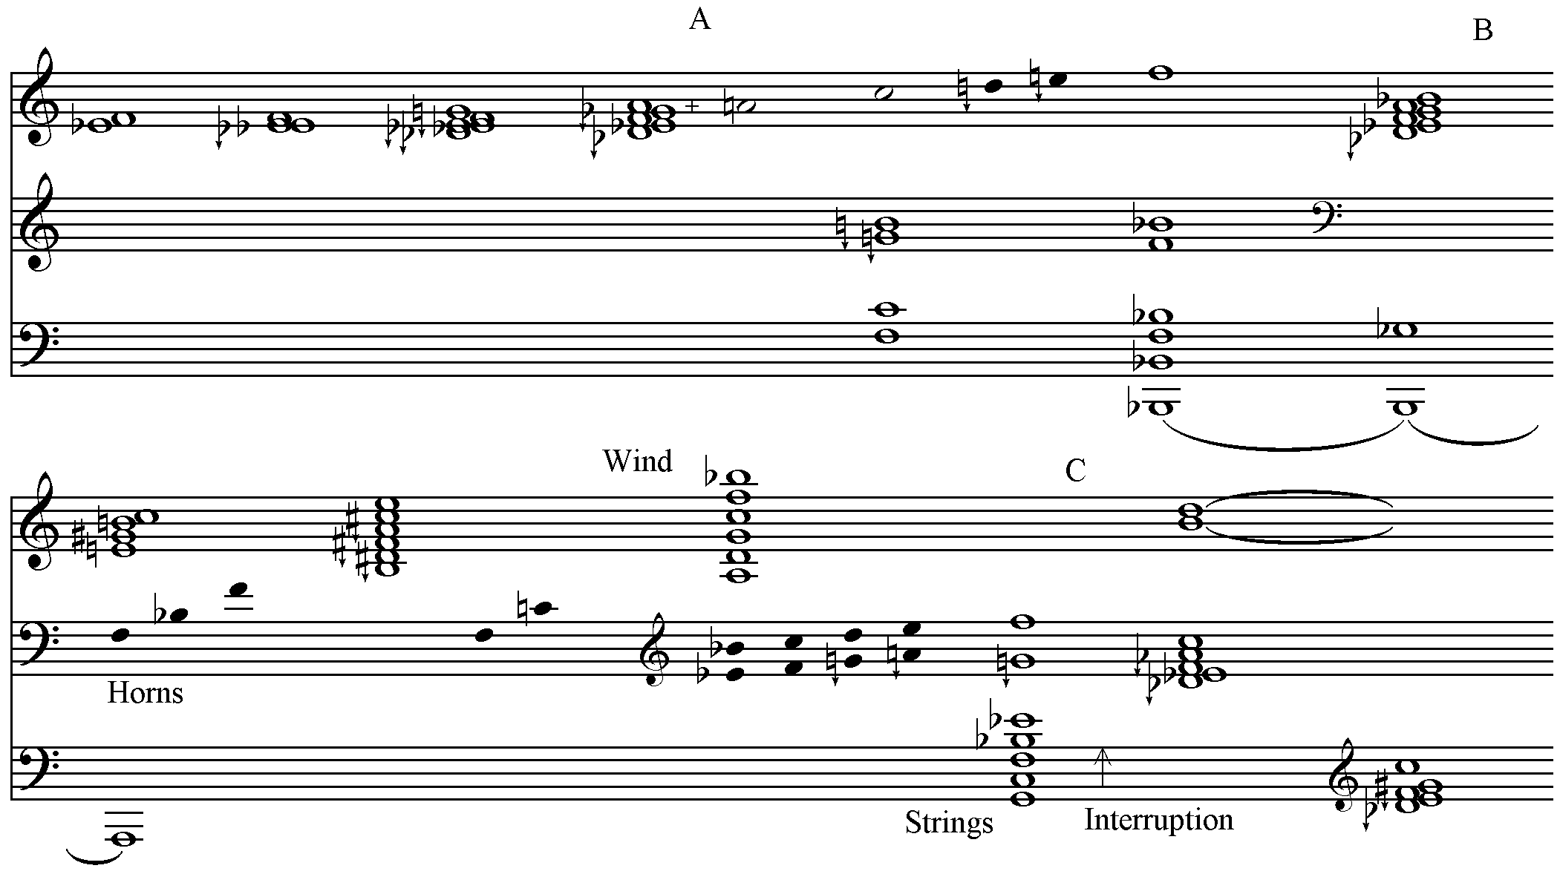
Figure 1
Harmonic Reduction of Hamburg Concerto: I: ‘Praeludium’
form – although it does not use Ligeti’s usual micropolyphony to generate the pitch material. The pentachord which appears just before letter ‘A’ is wholetone dominated, and built on a lowered Db; it is significant because it recurs throughout the movement in various forms. The harmony after letter ‘A’ is built on superimposed perfect fifths [F,C,G+B] which resolves at the third bar after letter ‘A’ with a pure fifth Bb/F§ to create one of Ligeti’s ‘frozen’ moments. An entry of a wholetone dominated hexachord cluster occurs just before letter ‘B’ (a variant of the chord before ‘A’) followed by two harmonies based on thirds in the wind and strings: E^{b6} and B¹¹, with the horns creating dissonance against these tonal allusions. Before letter ‘C’ two overlapping superimposed fourth chords appear in the woodwinds and strings built up on the bass notes A and G. This is followed at letter ‘C’ by a structural interruption with unrelated material which is largely generated from trichords made up of augmented fourths and major thirds, but not consistently so. As this material accelerates towards the movement’s climax, the intervals gradually become smaller. The final two chords of the movement are variants of the wholetone chord, which seems to be the defining sonority in this movement. In Ligeti’s music of the 1960s he would have avoided using superimposed fourth and triadic harmony types, but otherwise the overall textural and timbral effect is quite similar in the ‘Praeludium’. Ligeti is revisiting his past in this movement, but with some subtle transformations to the detail of the harmony.
The last section of the tripartite second movement of the Hamburg Concerto stands out because of Ligeti’s innovative exploration of harmony using the natural horns pitched in F, E, Eb, and D to create a choral using the horn’s upper harmonics from these four fundamentals. The harmonic result is quite startling, and is reminiscent of Stravinsky’s chorales in his L’Histoire du Soldat (1918). The parallels are that both Stravinsky and Ligeti take a chorale-like melody but harmonise it in an idiosyncratic and non-tonal fashion, without functional harmony. In the Hamburg Concerto the main chorale melody is in the second horn’s part in E which is not always the highest pitch, but is predominant through the use of differentiated dynamics. The chorale line is divided into five irregular phrases with each ending in a quasi-cadence. The nature of the deformed harmonies used is that they relate to traditional tonal chords but are not ‘tonal’ in terms of the progressions used, and also make extensive use of the harmonic partials which do not fit the equal tempered scale. The chords resemble the ‘non-atonal’ harmonies Ligeti uses in his opera Le Grand Macabre (1974–77 rev. 1996), particularly those used in the ‘Finale Passacaglia’. He distorts the nature of the chords in both examples by juxtaposing tonally distant harmonies, and avoiding any traditional harmonic progressions. The harmonies in the Hamburg Concerto operate independently of each other, as if they are separate slices of harmonic material, and it is only the chorale theme that binds the chords together. These chords are generated from a combination of pitches that fit within the equal tempered scale, and the natural harmonics that do not. As Charles Corey points out, in places the distortion of the tuning can be as much as a quartertone (13th partial) which considerably unsettles the aural result. It is this combination of equally tempered notes and pitches outside this tuning that creates such a distinctive harmonic and timbral result. It is helpful to treat these chords as functioning much more as a series of contrasting timbres than as harmonic progressions, as is the case with Messiaen’s approach to harmony.
There are several ways of describing these harmonies, because of their inherent ambiguity, but their main characteristic is an avoidance of strong tonal implications between chords. This is achieved by having harmonies juxtaposed that are not tonally related, or at least there is considerable tonal space between them. For example bars 16–17 (see Figure 2) consist of a progression of D^{b7}, E^{b}m⁹, C^{M7}, A⁷, B^{M7}, E^{bM7}, Aº7 which demonstrates little harmonic logic in terms of its tonal syntax, and tends to

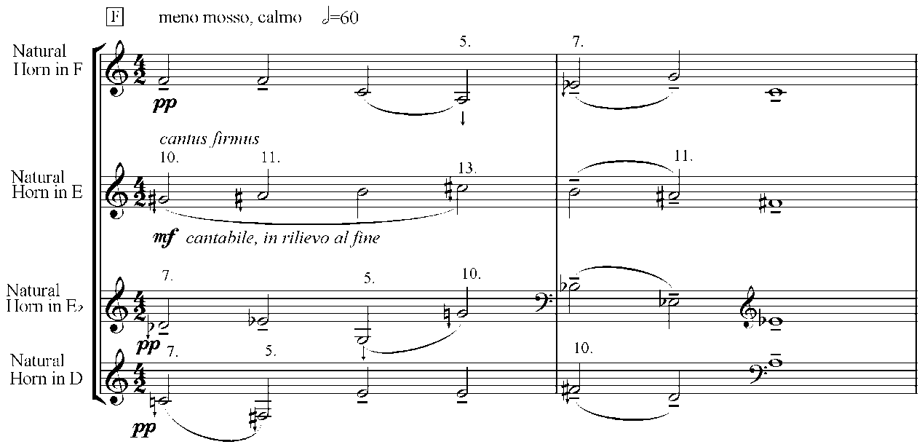
Figure 2
Hamburg Concerto: II: bars 16-17 © 2002 Schott Music GmbH & Co. KG, Mainz, Germany. Reproduced by permission. All rights reserved.
confuse the listener to undermine their sense of key. One characteristic of the progressions is a tendency to end each phrase on a relatively straight forward tonally-related and consonant chord, which provides a resolution in tension. Each successive phrase ends with the following chords: Dim⁷/A; B⁷; C^{M7}; B^{b7}; B^{b9/13}.The final chord of the movement is very Stravinskian in its rich structure and is built up from an E major triad but also can be viewed as a superimposed fourth chord (see figure 3).

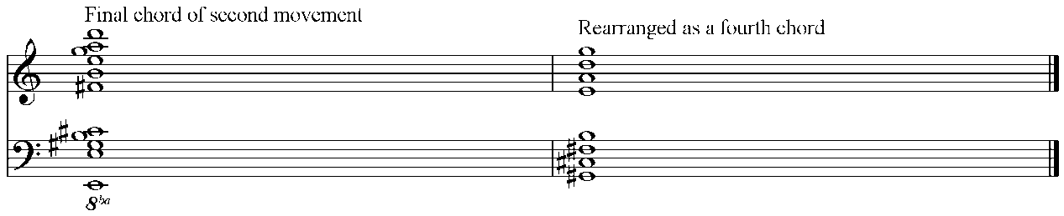
Figure 3
Hamburg Concerto: II: Final chord
Kris Shaffer has carried out statistical research on the use of triads by Ligeti which suggests that there is a relationship between Ligeti’s use of harmony in his later music, and traditional tonal syntax in terms of the harmonic motion he chooses to use. It is true that Ligeti does not create progressions in which the harmonies are very distant from those they are adjacent to, however, the resulting progressions are rarely comprehensible as tonal, or else they are very fleeting and the tonal effect is soon cancelled out. An implication of Shaffer’s research is that Ligeti’s choice of harmony is not arbitrary, but of course this choice is often primarily driven by a linear feature, such as the chorale line or a passacaglia structure. Like Stravinsky in his chorales from L’Histoire du Soldat, Ligeti both hints at, and distorts traditional harmonic progressions. The result is both fundamentally non-tonal in effect but with allusions to tonal constructions, deformed in the Hamburg Concerto by the use of the horn’s upper harmonics. It is a continuation and evolution of the ambiguous harmonic language first found in Ligeti’s opera Le Grand Macabre, particularly that in the ‘Finale Passacaglia’.
Within the fourth movement of the Hamburg Concerto is contained the longest section of music; the ‘Kanon’ which starts at letter ‘W’ and continues until the end of the movement. It contrasts with the rest of the concerto in the manner in which it uses a clearly defined structure and compositional process. It seems to use a mixture of techniques from Ligeti’s Melodien (1971) with its multilayered melodies, and Steve Reich’s rigorous and mechanical minimalist processes. The initial five pitch pattern is quite Reichian in its modality [E,C,B,F,G] but this is deceptive as the initial melody gradually reveals itself to be a segment from a twelve-note pattern. One only hears the row in its entirety towards the end of the movement at letter ‘t’, and most of the movement, consists of a five note window gradually moving across the row, so as one drops out, a new note is added from the ‘parent’ row. For example at letter ‘b’ the Db is added to create a six-note pattern at which the first note of the initial pattern disappears (see Figure 4 which shows the flute and piccolo). At letter ‘c’ the Eb is added and the note C disappears, and so on. This means that the resulting

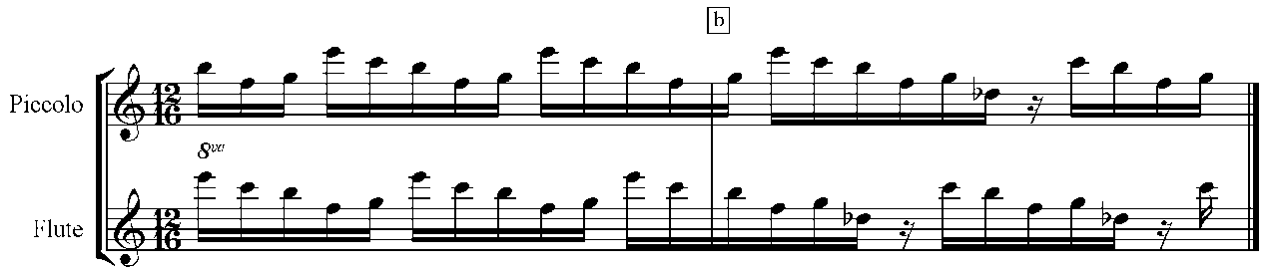
Figure 4
Hamburg Concerto: IV: bars 80-1 © 2002 Schott Music GmbH & Co. KG, Mainz, Germany. Reproduced by permission. All rights reserved.
harmony and melody is continually but gradually shifting, in a similar fashion to a minimalist composition, especially those by Reich from the 1980s which use phase-shifting and canon. Figure 5 demonstrates how the pattern of pitches evolves and their ‘parent’ twelve note row.

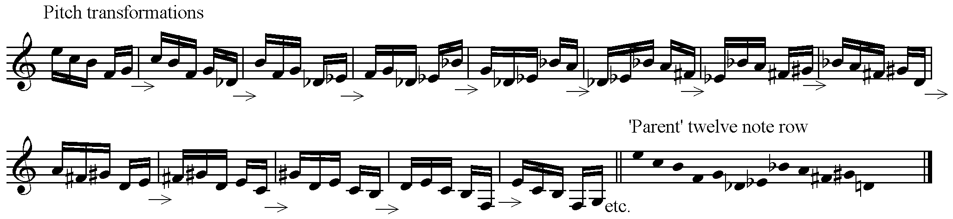
Figure 5
Pitch transformations in the Kanon of movement IV of the Hamburg Concerto
The entries of each pattern are staggered so each instrument starts at a different point in the ‘row’. Semiquaver rests are inserted which allow for breathing by the wind players, but also to avoid instruments being on the same beat with the same note, especially as the five semiquaver pattern grows to six semiquavers when a new note is added. As more instruments are added, the number of rests grows to prevent pitch collisions (where more than one instrument plays the same note), so once there are seven lines, the patterns grow to seven semiquavers including a quaver rest (see letter ‘q’). Timbral variety is created by changing the instrumentation in parallel to the changes in pitch.
After letter ‘o’ the patterns expand, revealing more of the underlying twelve-note row until it is complete at letter ‘t’. The pattern of semiquavers then shortens and starts to disintegrate as if the ‘machine’ is finally breaking down. The pitch residue after the ‘breakdown’ consists of chains of descending thirds which leave behind a sustained and expanded Ligeti ‘signal’ chord (F4,E5,C6) at the end of the movement in the lower strings. The compositional technique of this section owes much to Steve Reich’s phase compositions from the 1980s such as Vermont Counterpoint (1982) and Electric Counterpoint (1987) with their complex and evolving canons. Ligeti’s earlier micropolyphonic technique, which is also canonic, is non-rhythmic, and therefore makes the music’s pulse practically inaudible. In his later music, however, Ligeti makes use of more traditional canons, for example in ‘Wenn aus der Ferne’ from Drei Phantasien (1982) which begins with an eight-part canon. ‘Abendphantasie’ also from Drei Phantasien is also concerned with canon but in this case each one of the 14 entries moves up a semitone from bar four. Hence although Ligeti had stopped using his micropolyphonic technique by the late 1970s, he still had an interest in canon as a convenient method of creating complex, multilayered counterpoint.
In the Violin Concerto’s ‘Intermezzo’ there is a canonic layer in the strings which consists of fast-moving chromatic scales that are staggered and gradually expand their range. This continues for the whole movement and gradually dominates the entire texture, overwhelming the solo violin. The aural effect is quite different to that in the Hamburg Concerto but the technique is almost identical. Therefore in the latter work Ligeti references both Reich’s and his own music, with the result being the creation of a new compositional technique which combines elements of both.
In the examples explored above, Ligeti’s Hamburg Concerto demonstrates two significant characteristics. One is the re-examination of elements from his past compositions, albeit with some transformation of technique. The other characteristic is to expand his approach to microtonality through the use of upper harmonics in the natural horn to create a new kind of harmony. This harmony, however, still has a relationship to the harmonies used in his works from the post-micropolyphonic period. Thus even this apparently new musical concept is still rooted in his existing musical language. The Hamburg Concerto may be backward looking in many respects, but it still explores new and surprising sonic phenomena. The concerto is neither looking to the future nor the past, but rather creates music which forges the two together to create a fascinating and bewitching hybrid.

The work consists of a concerto for solo horn (doubling natural horn), natural horn quartet, and small chamber orchestra.
For a detailed explanation see Steinitz, R. (2003) György Ligeti: Music of the Imagination. London: Faber and Faber, 294-99.
Ibid. 357.
There also natural harmonics used in the horns in the Violin Concerto.
Ligeti, G. (2003) liner notes to The Ligeti Project IV: Hamburg Concerto, Double Concerto, Ramifications, Requiem, Teldec Classics 8573-88263-2, 4.
Similarly used by Benjamin Britten in his Serenade for Tenor, Horn and Strings (1943).
Although there are examples of works which explore microtonal tunings in the intervening period such as String Quartet no. 2 (1968) and Ramifications for string orchestra (1968-69).
For example letter H in Lontano.
Ligeti, G. (1983) György Ligeti in Conversation with Péter Várnai, Josef Häusler, Claude Samuel and Himself. London: Eulenburg, 53.
For related discussion on microtonality see: Cuciurean, J. (2011) Bridging the Stylistic Divide: Correlating Spatial Voice-Leading and Harmonic Design in Ligeti's Middle- and Late-Period Works. Manuscript submitted for publication. (An early version of this paper was presented at the annual meeting of the Society for Music Theory, Seattle, WA, November 2004.). Bernard, J. (1999). Ligeti’s restoration of interval and its significance for his later works. Music Theory Spectrum, 21(1), 1-31. Roig-Francoli, M. (1995). Harmonic and formal processes in Ligeti’s net-structure compositions. Music Theory Spectrum, 17(2), 242-267.
See Searby, M. (2010) Ligeti’s Stylistic Crisis: Transformation in His Musical Style 1974-1985. Lanham, MD: Scarecrow Press, 54.
Corey, C. (2011). Pitch and Harmony in György Ligeti’s Hamburg Concerto. Unpublished doctoral dissertation, Pittsburgh University, 55-66.
Shaffer, K. (2011). “Neither Tonal nor Atonal”?: Harmony and Harmonic Syntax in György Ligeti’s Late Triadic Works. Unpublished doctoral dissertation, Yale University.
The concept of machines and their eventual malfunction is one that Ligeti used many times in his earlier music.
As discussed in more detail in Jane Clendinning’s article elsewhere in this issue.
John Cuciurean’s article elsewhere in this issue discusses the use of canon in Ligeti’s Bewegung which is a non-microcanonic work.

