Do Emerging Markets Matter in the World Oil Pricing System?
Evidence of Imported Crude by China and India on Brent Prices

Hong Li & Sharon Xiaowen Lin*
This revised version 1st March 2011

Abstract: This paper provides empirical evidence on the changing structure of world oil price system by identifying an additional driver – emerging market factor. We choose China and India as a representative of emerging markets to examine if the quantity of crude oil imported by China and India is significant in the existing oil pricing system (Kaufmann et.al. (2004). Our data starts from January 2002 and ends in March 2010 which includes the oil shock of 2007-2008. We utilize cointegration and Error-Correction-Model framework developed by Engle-Granger (1987) and Gregory-Hansen (1996) in the analysis. Our results indicate that demand from emerging market has become a significant factor in the world oil pricing system since 2003. This result is significant as it lends empirical support to the widely held conjecture that the oil shock of 2007-2008 is a demand-led shock (Hamilton, 2009). Our result also has significant policy implications that go beyond the oil shock. The emerging market factor is there to stay and reflects the changing power between emerging and developed economies in the world economic system as a result of decades of fast economic development in the former. It will certainly influence policy issues related to oil and beyond.
Keyword: Cointegration, Oil market modelling, Oil imports by China and India

1. Introduction
World oil markets have experienced rapid changes of record prices during the oil shock of 2007-2008. Various conjectures have been put forward to explain this phenomenon. One popular explanation stems from demand shocks (Hamilton 2009). It is argued that in the short run, when supply infrastructure does not have any chances to adjust to demand changes, unexpected increases in demand could cause supply – demand imbalances, and if demand outpaces supply to a large extent, record prices could be reached as a result. If the supply is lagging behind demand for a period of time, the supply – demand imbalances could sustain over a period of time and a series of record prices could be reached.

In the case of emerging market demand, there may be a prolonged short term demand – supplying imbalances caused by the lag of expectation on true demand for imported oil from emerging economies, such as China and India. The unprecedented growth in China and India for the last twenty years has led to rapidly increased demand for imported oil, competing for its share in a pool of steady world oil supplies for the last 10 years. Market expectations of demand for crude oil from emerging economies may have consistently lagged behind actual demand, suggesting that planned supplies are not sufficient to meet actual demand. This possible demand-supply imbalance may well be exacerbated by one of the longest post-war economic booms during the period from 2004 to 2008. As oil supply capacities take years to build up, the increased demand from China and India on imported oil may have tilted market demand-supply balance over time and contributed to record oil prices.

A closer look at the demand for imported oil from China and India has revealed that China started to import crude oil since 1996 after decades of self-sufficiency on this primary commodity and its volume of oil imports accelerated since. Similarly the volume of crude imported by India has increased rapidly since late 1990s. The increased demand for imported oil from both countries are fuelled by their fast economic development in recent decades and have increasingly become an significant factor in the competition for limited resources in the world oil market. Their competition for imported oil in the world markets can be illustrated in Figure 1. OECD share of total world imported oil has decreased for the period under investigation from 79% to 70% while the share of China and India (Chindia) out of total world imported oil has increased from 9% to 19%. Figure 2 displays the actual volume of Chindia imports, together with OECD imports and total world oil imports (million barrels per day). The imports of oil by China and India have increased with the total world demand for imported oil while OECD total imported oil has decreased during the period under investigation.

…………………… Insert Figure 1 here ………………………..
…………………… Insert Figure 2 here ………………………..

This study attempts to provide empirical evidence on the impact of crude oil imports by China and India on world oil prices for the period during 2002-2010. This is the first attempt, to the best knowledge of our knowledge that such empirical analyses have been carried out to cover the time span of the oil shock of 2007-2008. The result will shed some light on conjectures whether the oil shock is caused by demand shocks (Hamilton, 2009) or other factors such as speculation (Kaufman, 2011),

Our empirical investigation is underpinned by the price rule set out by Kaufman el at. (2004) and carried out in the framework of the residual-based cointegration analysis originally proposed by Engle and Graner (1987) and subsequently extended by Gregory and Hansen (1996) to control for the structural break in the series. Not only our results would help provide empirical evidence on recent oil price shock, it would also uncover whether emerging markets’ demand for oil in the world oil markets is a significant factor in oil pricing. The implication of the latter, if found significant, would go far beyond the oil shock and have profound economic implications which may affect future policies.

The rest of the paper is organized as follows: Section 2 gives a brief review on the literature on factors influencing world oil prices and the China and India phenomenon; Section 3 discusses methodologies adopted; Section 4 introduces the data; Section 5 examines empirical findings; and finally Section 6 concludes.

2. Literature Review
2.1 Factors driving world oil prices
OPEC is the biggest single supplier of crude oil in international oil markets, hence a clear oil price driver. A large volume of research has devoted to how OPEC behaves and how it influences oil prices. The literature in this area is abundant and we only indicatively mention some of them. Hypotheses are being tested on whether OPEC behaves as a Cartel (Loderer, 1985; Gülen, 1996; Alhajji & Huettner, 2000), a dominant producer, or a fringe producer (Griffin, 1985). Despite a lot of research output, there is no consensus as how OPEC behaves (Kaufman et al., 2004). This may be due to the intricacy of OPEC behaviour given the hugely complex oil markets. It may also be due to the underlying fundamentals that have been evolving over time. For example the reliance on imported OPEC crude has been reducing over the years after the two oil shocks in the 70s. Non-OPEC energy production has increased substantially due to energy security concern, technology innovations, and high oil prices which make additional investments in production viable.

Despite there is no consensus on OPEC behaviour, there is evidence that OPEC impacts world oil prices and this influence may be time-varying and price-dependent (Lin and Tamvakis 2010). More specifically, influences of OPEC on oil prices can be further broken down to its production capacity, capacity utilization, production quotas and the degree of which OPEC production exceeds these quotas, or Cheat (Kaufman et al., 2004).
The time-varying and price-dependent influence from OPEC suggests that there are other factors driving oil prices. Since the oil shocks in the 70s, vast majority of the oil exports are designated to OECD countries with USA at the top of league table for imported crude. Their collective demand for oil imports has been modelled in the oil pricing system of Kaufman et al. (2004). As underlying OECD countries’ oil consumptions fluctuate with their individual economic cycles and their domestic oil productions, their collective demand for imported oil also fluctuate over time. This time-varying demand for imported oil may interact with the relative stable oil supply and causing oil price to fluctuate.

More factors have been put forward to explain the rise of oil prices in recent years. Kaufman et al. (2008) identifies the role of US refinery and nonlinear plays in the world oil pricing system up till 2006. Speculation is another factor being put forward to explain high oil prices following the rapid growth of financial markets for oil-based financial derivatives, branded as New Asset Class (Geman 2005). Kaufmann and Ullman (2009) find a turning point at Sept 2004 using the difference between spot and futures prices as proxy for speculation. Direct measure of speculation using CFTC data so far does not draw clear conclusions as whether speculation exists or whether it has a destabilizing impact on market prices (Wang, 2003; He et al., 2009).

Research on causes of oil shock of 2007-2008 record oil prices is ongoing. Recent work in the area includes the “demand shock” argument by Hamilton (2009) and “speculation” argument by Kaufman (2011). None of the paper provides substantial empirical evidence to support their argument. Our paper would fill in this gap in this area by providing empirical evidence on demand shock argument. More specifically, we are testing an additional factor in the oil pricing system, i.e. emerging market factor represented by China and India. Unlike the temporary nature of factors such as US refinery, non-linearity and speculation mentioned above, which disappear after the shock, the emerging market demand is there to stay and is of more permanent nature. It may generate significant implications for policy makers around the world.

2.2 China crude oil import phenomenon
Research on the relationship between oil price and Chinese oil demand has largely focused on the need of Chinese energy imports and its impact on its economy. Zhao and Wu (2007) examine the determinants of China’s energy imports and find that in the long run, growth of industrial production and expansion of transport sectors affect China’s oil imports. As the Chinese economy industrializes and the automotive sector expands, China’s oil imports are likely to increase despite the substitution effect from China’s domestic oil production. It is anticipated that China will be more dependent on overseas oil supply regardless of the world oil prices. By analysing trends of various transport modes, such as growth in air, waterway, highway, railway and freight, Skeer and Wang (2007) project China’s transport energy uses under different transport growth scenarios and forecast China’s need to import to be between 52% to 68% of its oil demand in 2020. Korhonen and Ledyaeve (2010) examine the effects of oil prices shocks on oil producing and consuming countries and find that China is one of the worst affected economies, highlighting the negative impact of high oil prices on Chinese economy.

While high oil prices would generate negative impact on Chinese economy, Chinese demand on imported oil also help accelerate world oil prices. This complete cycle may have policy implication for Chinese policy makers. Most of research so far has been focused on how elevated oil prices would impact on Chinese economy. How to decouple the growth of GDP from the growth of imported oil, and ultimately energy consumption is a challenging issue.

3. Methodology
3.1 The empirical model and the Engle-Granger cointegration analysis
Following the price rule set out by Kaufman et al. (2004), we start with our model by including Days, Quota, Cheat, Caputil, in the world oil pricing system.
$\text{Pr}{\text{ice}}_{t}=β_{0}+β_{1}{\text{Days}}_{t}+β_{2}{\text{Quota}}_{t}+β_{3}{\text{Cheat}}_{t}+β_{4}{\text{Caputil}}_{t}+μ_{t}$ (1)
Price is the Real Brent price averaged on a monthly basis. Days is days of forward consumption of OECD crude oil stocks. Quota is the OPEC production quota (million barrels per day). Cheat is the difference between OPEC production and OPEC quotas. Caputil is the capacity utilisation by OPEC, which is calculated by dividing OPEC production (mbd) by OPEC capacity (mbd). This price rule takes into account key supply variables - OPEC capacity, production, quota, actual production (Griffin,1985) and demand variables (OECD consumption, stock level) that influence world oil prices. This pricing rule is originally used to provide evidence to identify OPEC behavior – competitive v. co-operative, as well as being applied to include simultaneous estimation of the variables within the system (Dees et al. 2007). We use this price rule as a benchmark model and our purpose of this study is to detect the impact of emerging market oil demand which is previously excluded from this world oil pricing system.

Given the growing demand for imported crude oil by China and India, we add the “Chindia factor”, into this framework. It is computed as the combined share of imported crude by China and India in total world crude volume. With this extra factor, equation (1) is extended as follows.
$\text{Pr}{\text{ice}}_{t}=β_{0}+β_{1}{\text{Days}}_{t}+β_{2}{\text{Quota}}_{t}+β_{3}{\text{Cheat}}_{t}+β_{4}{\text{Caputil}}_{t}+β_{5}{\text{Chindia}}_{t}+μ_{t}$ (2)
Or in a shorter form
$y_{t}=β_{0}+\sum_{i=1}^{5}{β_{i}x_{i,t}}+μ_{t}$
$y_{t}$is real Brent price at time t, and $x_{i,t}$ is the right-hand side explanatory variables listed above or drivers of real oil prices.

Equation (2) captures the long-run relationship between the dependent variable and the explanatory variables underpinned by the price rule (Kaufman et al., 2004) only if all the variables are stationary. Thus all the variables under study will be subject to unit root test by the Augmented Dickey-Fuller (ADF) approach. If the variables are non-stationary or integrated of order one, equation (2) can still capture the long-run relationship as long as the residuals of equation (2) are stationary according to Engle and Granger (1987). The stationary residuals will indicate that the variables are cointegrated and equation (2) is therefore known as a cointegrating regression, capturing the long-run relationship between the real oil price and the included variables on the right-hand side of equation (2). Hence, the residuals, as presented in equation (3), of equation (2) will be subject to the ADF unit root test, with critical values prepared by Davison and MacKinnon (1993).
$μ_{t}=y_{t}−(β_{0}+\sum_{i=1}^{5}{β_{i}x_{i,t}})$ (3)

Once it is established that equation (2) is a cointegrating regression and the variables under study are cointegrated, there is a long-run, or equilibrium, relationship between the dependent variable and the explanatory variables on the right-hand side of equation (2). However, in the short run there may be disequilibrium. Therefore, we can treat the residuals (equation (3)) as the ‘equilibrium error’. We can use this error term to tie the short-run behavior of real oil price to its long-run value, i.e., we can correct disequilibrium through the error correction mechanism. Equation (4) is an error correction model proposed by Engle and Granger (1987).
${Δy}_{t}=α_{0}+\sum_{i=1}^{5}{α_{i}{Δx}_{i,t}}+α_{6}μ_{t−1}+ε_{t}$ (4)
Equation (4) states that the changes in the real oil price depend on the changes in the explanatory variables of equation (2) and the lagged equilibrium error term, μ_{t-1}. Given that our series is not very long and the number of explanatory variables is relatively large, we cannot afford to include too many lags in the error correction model. We will only include one lag. The absolute value of the equilibrium error term, $α_{6}$, describes how quickly the equilibrium is restored.

The above Engle-Granger cointegration analysis helps evaluate models which combine both long run and short run properties and overcome the danger of estimating a spurious regression because of the presence of stochastic or deterministic trends in the data. These serve well the purpose of our study, to detect the impact of emerging market oil demand which is previously excluded from the world oil pricing system. However, we do not prove that the relation in equation (2) is really a long run one using the Engle-Granger method. We have to have a strong belief in the long run equilibrium relationship between the variables that is supported by the pricing rule of Kaufman et al. (2004). More importantly, Engle-Granger cointegration test presumes that the cointegrating vector is time-invariant; the long-run equilibrium represents a stable underlying relationship. This is not appropriate if the relationship between the variables of interest experiences a structural break within the sample period. Leybourne and Newbold (2003) have shown that spurious rejection, indicating the presence of cointegration, can occur when structural breaks are neglected in the analysis. That is, using Engle-Grnger cointegration test may induce spurious cointegration in the presence of structural breaks. Thus in next step, we attempt Gregory-Hansen cointegration test which allows structural breaks in the cointegration relationship.

3.2 Gregory-Hansen (1996) cointegration test
Gregory and Hansen (1996) modify the Engle-Granger (1987) cointegration test by allowing the coefficients in the cointegration relationship to be subject to a structural break. That is, on the basis of Equation (2), the Gregory-Hansen procedure requires that we introduce a dummy variable to indicate the break date, which is (for t = 1, 2, …, n) given by:
$ϕ_{t}=\left\{\begin{matrix}0 & \text{if} & t≤\left[nτ\right] \\ 1 & \text{if} & t>\left[nτ\right]\end{matrix}\right. 0\text{.}\text{15}≤τ≤0\text{.}\text{85}$
This dummy variable can be used to model a variety of forms of structural break. We consider a level shift (LS) and a regime shift (RS) of the cointegrating equation as follows:
Model LS: $y_{t}=β_{0}+β_{0}ϕ_{t}+\sum_{i=1}^{5}{β_{i}}x_{i,t}+μ_{t}$ (5)
and
Model RS: $y_{t}=β_{0}+β_{0}ϕ_{t}+\sum_{i=1}^{5}{β_{i}}x_{i,t}+\sum_{i=1}^{5}{δ_{i}}ϕ_{t}x_{i,t}+μ_{t}$ (6)
Following the Gregory-Hansen procedure, we apply one of these models sequentially for all break dates within the permitted range of $\left[0\text{.}\text{15}n\right] ≤t≤\left[0\text{.}\text{85}n\right]$ and, for each such break date, we compute a statistic to test the null of no cointegration. Null hypothesis will be rejected in favour of cointegration with a structural break if the most extreme value obtained for the test statistic exceeds the Gregory-Hansen critical value (Gregory and Hansen, 1996). The advantage of this approach is that we can use data to determine if there is a break and when it occurs. Note that the Gregory-Hansen cointegration test allows four explanatory variables on the right-hand side of the equations (2), (5) and (6). During the estimation, the most statistically insignificant explanatory variable will be dropped. This is then confirmed by a restriction test.

4. Data
Monthly figures of import and export volumes and crude stocks are obtained from JODI database. The data period under study, between January 2002 and March 2010, covers the boom of oil prices where record prices are set as well as the bust of prices when the recent recession is taking place. The Chinese and Indian crude import statistics are computed as follows. We divide the volume imported by China and India by world total imports. The resulting statistic is the share of Chindia’s import volume. Brent crude oil prices, OPEC quota and OPEC production capacity data are downloaded from Bloomberg. We choose Brent prices as the benchmark world crude prices as it represents a large proportion of world crude trades. Brent prices are calculated as monthly average of Brent daily spot prices from Bloomberg. Real oil prices are calculated by deflating Brent spot prices by US CPI index. As mentioned in Section 2, Days is days of forward consumption of OECD crude oil stocks, Quota the OPEC production quota, Cheat the difference between OPEC production and OPEC quotas, and Caputil the capacity utilisation by OPEC.

Unit root tests are conducted for all variables and results are reported on Table 1. ADF tests indicate that all variables are non-stationary (there is a unit root presence) at level terms, but are stationary at their first difference (no unit root). Given that the series are integrated of order one, we can now pursue the cointegration analysis as discussed in Section 2.
…………………… Insert Table 1 here ………………………..

5. Empirical Results
5.1 Analysis of the price rule of Kaufman et al. (2004)
We firstly estimate the oil pricing rule (Equation (1)) using the Engle-Granger cointegration technique on data from January 2002 to March 2010. The result of the unit root test on the residuals of equation (1) during January 2002 and March 2010 reported on Table 2 shows that the residuals are non-stationary, implying that the long run relationship established in Kaufman’s study is not confirmed for the period between January 2002 and March 2010 in our study. This could be due to following two reasons. Firstly, different demand-supply fundamentals resulting from possible varied pricing impact from OPEC (Lin and Tamvakis 2010) and changing behaviour of oil importing countries may have changed the structure of the pricing rule. The conventional Engle-granger cointegration test may not be appropriate for the current period with a structural break. Secondly, the price rule of Kaufman et al. (2004) may have omitted a variable representing the role of emerging markets played in world oil markets in recent years. Following this reasoning, we proceed to apply the Gregory-Hansen cointegration test in this section first and then add the share of Chinese and India (Chindia) imports as a proxy for emerging markets statistics in equation (1) as represented by equation (2) in next section.
…………………… Insert Table 2 here ………………………..

According to Table 3, the Gregory-Hansen cointegration test does not provide any evidence of cointegration as the residuals from equation (1) remain non-stationary even though an effort is made to control for the potential structural changes, either as a level shift or regime shift, caused by the changes in the behaviour of the series. However, it is evident that there is a structural break in July 2003. We further re-estimate equation (1) using the period of August 2003 and March 2010, in order to avoid the structural break, and carry out the ADF test on the residuals. The result reported on Table 2 shows that the residuals of equation (1) during August 2003 and March 2010 are still non-stationary. These exercises confirm that it is insufficient to only control for the possible structural change in the long-run relationship between the real oil price and the explanatory variables as set out by Kaufman et al. (2004). We should attempt to investigate the possibility of omitting relevant variables from the price rule of Kaufman et al (2004).
…………………… Insert Table 3 here ………………………..

5.2 Effect of oil imports by China and India
We follow the Engle-Granger approach to estimate equation (2) by OLS using the period January 2002 and March 2010 and test the residuals of equation (2) for unit root. The oil imports by China and India are found statistically significant in explaining the variation in the oil price but the residuals of equation (2) during January 2002 and March 2010 are not stationary as reported on Table 2. Applying the Gregory-Hansen cointegration test to equation (2) using the period of January 2002 and March 2010, as reported on Table 3, we find that the oil imports by China and India are statistically significant while the variable, Days, is statistically insignificant and subsequently dropped from the equation. Although there is a structural break in July 2003, there is no evidence that there is a cointegration between the real oil price and the variables such as Quota, Cheat, Caputil and Chindia included in equation (2).

We reduce the sample to August 2003 and March 2010 in order to avoid the structural break and re-estimate equation (2). Once the sample size is adjusted, there is evidence of cointegration between real oil price and the explanatory variables including Quota, Cheat, Caputil, Days and Chindia. Given the evidence of stationarity of the residuals during August 2003 and March 2010 as reported on Table 2, equation (2) is a cointegrating regression and it captures the long-run relationship among the variables. The evidence that imports of China and India are significant in explaining the real oil prices during August 2003 and March 2010 supports the conjecture of Hamilton (2009) that the oil shock of 2007-2008 is caused by demand shock from countries such as China. Our result that imports of China and India did not influence the oil prices until August 2003 is consistent with the remark of Hamilton (2009) that China’s economy had only recently become big enough relative to the global economy to make a material difference even though it had been growing at a remarkable rate for a quarter century. According to Table 4, Chindia is a statistically significant and additional factor in the long run oil pricing rule. As expected, imported crude by China and India gained a greater share in the world oil market at the expenses of OECD (Figure 1) and became a significant factor in oil pricing rule. When imports by China and India increase by 1 unit, real oil prices tend to increase accordingly with the magnitude of 4.24. The 10% of increased share of imported oil from China and India between August 2003 and March 2010 (Figure 1) may have pushed the oil prices between $38 and $47/bbl. The other significant factor in equation (2) is Quota with magnitude of 0.00008. It is well documented that OPEC quota plays a vital role in oil price determination via its ability to adjust world oil supplies (e.g. Kaufman et al., 2004; Lin and Tamvakis, 2010). The positive magnitude seems to confirm the widely held perception that OPEC is a cooperative producer during the price peak period, indicating that the higher the real oil price, the higher quota OPEC sets to accommodate the demand increase.
…………………… Insert Table 4 here ………………………..

All other variables are insignificant but remain important to keep the long run relationship stationary. During our sample period when oil prices peaked, OPEC capacity utilization is expected to remain relatively high in line with the quota while cheat from OPEC is expected to be low. Cheat is expected to be associated with low oil prices. When oil prices are low, member countries are likely to seek ways to compensate their lost revenues due to low oil price, e.g., exporting extra oil. Therefore, given Quota is significant, it is not surprising to find neither capacity utilization nor cheat is significant. Furthermore OECD Days of stock is also insignificant as the share of OECD imports has declined rather than increased over the period (Figure 1). It however remains as an important factor in the long-run pricing relationship.

We further estimate equation (4), the Error Correction Model (ECM). Results are listed in Panel B of Table 4. Short term adjustments of real oil prices are reflected by the magnitude and sign of α₆ of equation (4). The coefficient of adjustment, α_{6,} from ECM estimation is negative (-0.16) and significant at 10%. This implies that the real oil price adjusts to the long term disequilibrium in the short run to maintain the long-run relationship. In other words, when imports from China and India increases unexpectedly in one period, the real oil price would adjust upwards to absorb this disequilibrium in the next period to track the long run equilibrium.

A word of caution is in place when one needs to utilize our results. Our data sample is relatively short and the joint influence of the emerging economies such as China and India is still in its early stage in terms of influencing world oil pricing system. Furthermore we are not ruling out other factors of temporary nature such as speculation that may have influenced the oil shock of 2007-2008, as discussed by Kaufman (2011). However they are not the focus of our study.

6. Conclusions
This study models the effects of increased imports of crude oil by emerging markets, in particular, China and India, on world oil prices within the framework of Engle-Granger (1987) cointegration and Error Correction Model. Following the oil price rule set out in Kaufman et al. (2004), we found Chindia (combined China and India) factor as an additional driver in the long run relationship from August 2003 to March 2010. Our empirical evidence supports theoretical hypothesis that increased oil imports by China and India act as a demand shock, driving world oil prices to elevated levels (Hamilton, 2009). These results would have important policy implications for policy makers in both developing and developed economies in terms of demand-supply projection, energy security and geopolitics. It will also help fill in the gap of how Chinese demand for imported oil might have impacted the growth of Chinese economy as most of research so far has been focused on how elevated oil prices would impact Chinese economy. These results may generate particular interests to Chinese policy makers.

References
Alhajji, A.F., Huettner, D. (2000), Opec and World Crude Oil Markets From 1973 to 1994: Cartel, Oligopoly, Or Competitive? Energy Journal, 21(3), 31-59.
Dees, S. & Karadeloglou, P. & Kaufmann, R. K. & Sanchez, M. (2007), "Modelling the world oil market: Assessment of a quarterly econometric model," Energy Policy, Elsevier, 35(1), 178-191.
Davidson, R. and MacKinnon, J. (1993), Estimation and inference in econometrics, Oxford University press
Dickey, D.C. and Fuller, W.A. (1979), “Distribution of the estimators for autoregressive time series with a unit root,” Journal of the American Statistical Association, 74, 427-431.
Engle, R.F. and Granger, C.W.J. (1987), ‘Cointegration and Error Correction: Representation, Estimation, and Testing’, Econometrica, 55, 251 - 276.
Geman, H. (2005), Commodities and commodity derivatives, John Wiley and Sons Inc
Gülen, S. G. (1996), Is Opec a Cartel? Evidence From Cointegration and Causality Tests. Energy Journal, 17(2), 43-57.
Griffin, J. (1985), “OPEC Behavior: a test of alternative hypothesis”, American Economic Review, 75(5), 954-963.
Gregory, A. and Hansen, B. (1996), Residual-based tests for cointegration in models with regime shifts, Journal of Econometrics, 70, 99-126
Hamilton, J (2009), Causes and consequences of the oil shock of 2007–2008, Brookings Papers on Economic Activity, 215–261.
He, L.Y., Fan, Y and Wei, Y.M. (2009), Impact of Speculator’s Expectations of Returns and time scales of investment on crude oil price behaviours, Energy Economics, 31, 77-84.
Kaufmann, R.K. (2011), The role of market fundamentals and speculation in recent price changes for crude oil, Energy Policy, 39, 105–115.
Kaufmann, R.K and Ullman, B. (2009), Oil prices, speculation, and fundamentals: Interpreting causal relations among spot and futures prices, Energy Economics, 31(4),550-558.
Kaufmann, R.K., Dees, S., Gasteuil, A., and Mann, M. (2008), The Role of Refinery Utilization, Futures Markets and Non-Linearities. Energy Economics, 30, 2609-2622.
Kaufmann, R.K., Dees, S., Karadeloglou, P., and Sanchez, M. (2004), Does OPEC Matter? An Econometric Analysis of Oil Prices. The Energy Journal, 25(4), 67-90.
Korhonen, I. and Ledyaeva, S. (2009), Impact of speculator's expectations of returns and time scales of investment on crude oil price behaviors, Energy Economics, 31, 77-84.
Leybourne, S. J. and Newbold, P. (2003) Spurious rejections by cointegration tests induced by structural breaks, Applied Economics, 35, 1117-1121
Lin, S. X. and Tamvakis, M. (2010), OPEC announcements and their effects on crude oil prices, Energy Policy, 38(2), 1010-1016.
Lin, S.X. and Tamvakis, M. (2001), Spillover Effects in Energy Futures Markets, Energy Economics, 23, 43-56.
Loderer, C. (1985), A Test of the Opec Cartel Hypothesis: 1974-1983. Journal of Finance, 40(3), 991-1006.
Skeer, J., and Wang, Y.J. (2007), China on the Move: Oil Price Explosion? Energy Policy, 35, 678-691.
Stock, J.H. and Watson, M.W. (1993), “A simple estimator of cointegrating vectors in higher order integrated systems”, Econometrica, 61, 783-820.
Wang, C. (2003), The behavior and performance of major types of futures trader, Journal of futures markets, 23(1), 1–31
Yuan, J.H., Kang, J.G., Zhao, C.H. and Hu, Z.G. (2008), “Energy consumption and economic growth: Evidence from China at both aggregated and disaggregated levels”, Energy Economics, 30, 3077–3094.
Zhao, X.Z., and Wu, Y.R.(2007), Determinants of China’s Energy Imports: An Empirical Analysis. Energy Policy, 35, 4235-4246.
Figure 1 Monthly OECD imported crude oil share v. combined share of China and India for imported crude oil.
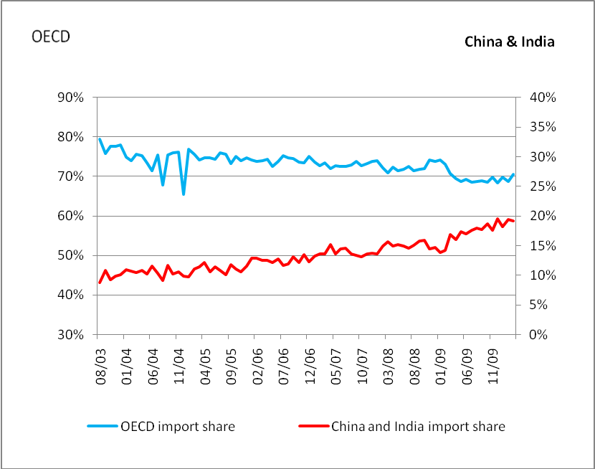

Figure 2 Chindia, OECD imports and total world oil imports.
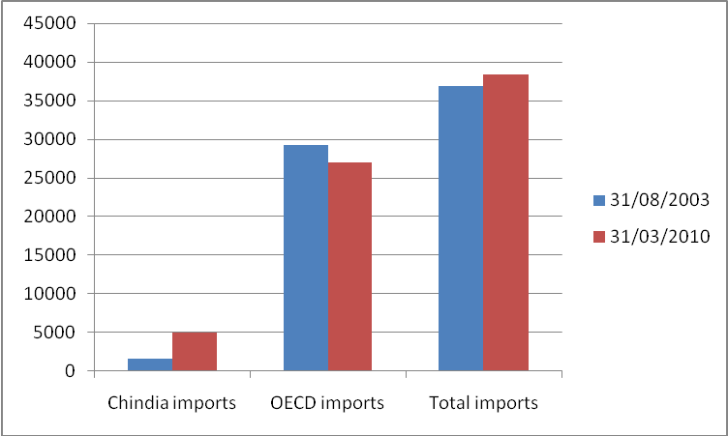

Figure 3. Brent oil prices

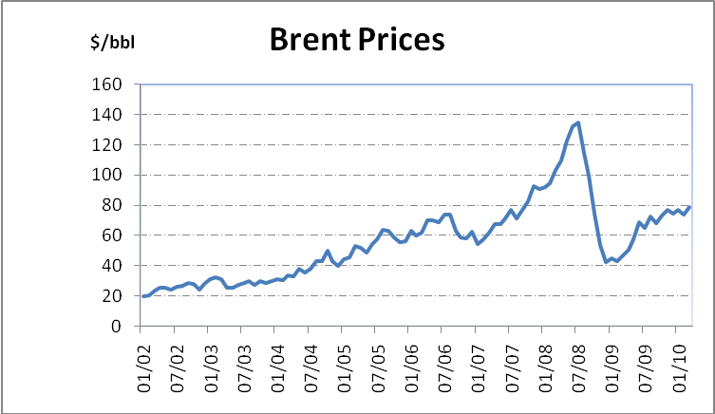

Table 1 unit root tests
 | January 2002 – March 2010 |  |  |  | August 2003-March 2010
 | Level |  | First difference |  | Level |  | First difference
 | Lag | ADF stat | Lag | ADF stat | lag | ADF Stat | lag | ADF Stat
Real Oil price | 1 | -2.123 | 0 | -6.386 | 1 | -2.304 | 0 | -5.727
Quota | 1 | -2.264 | 0 | -7.826 | 1 | -2.676 | 0 | -5.164
Cheat | 0 | -2.346 | 0 | -11.895 | 1 | -1.566 | 0 | -12.628
Caputil | 1 | -2.621 | 0 | -8.974 | 0 | -1.890 | 0 | -10.998
Days | 3 | 0.033 | 2 | -9.393 | 3 | -0.226 | 2 | -8.889
Chindia | 2 | 0.301 | 1 | -10.397 | 1 | -0.268 | 0 | -15.219
Critical values  (MacKinnon, 1996) | -3.399 at α=1%  -2.892 at α=5%  -2.583 at α=10% |  |  |  | -3.514 at α=1%  -2.898 at α=5%  -2.586 at α=10%

Table 2 Cointegration tests by the Engle-Granger approach
 | Equation (1) |  | Equation (2)
 | 2002.1–2010.3 | 2003.8-2010.3 | 2002.1-2010.3 | 2003.8-2010.3
ADF Stat | -3.75 | -3.948 | -3.752 | -4.74
Critical Value | -4.13 |  | -4.42
Note: The critical values are at α=10% level of significance and obtained from Davidson and McKinnon (1996), page 722.

Table 3 Cointegration tests by the Gregory-Hansen approach
Case | Test | Equation (1) |  | Equation (2) |  | Critical value  at α=10%
Case | Test | Statistic | Break date | Statistic | Break date | Critical value  at α=10%
Level Shift | ADF | -4.65 | July 2003 | -4.35 | July 2003 | -5.31
Level Shift | Za | -32.02 | July 2003 | -36.28 | July 2003 | -5.31
Level Shift | Zt | -55.71 | July 2003 | -57.84 | July 2003 | -54.38
Regime Shift | ADF | -4.57 | July 2003 | -5.36 | July 2003 | -6.17
Regime Shift | Za | -31.37 | July 2003 | -46.23 | July 2003 | -6.17
Regime Shift | Zt | -54.93 | July 2003 | -61.78 | July 2003 | -72.56
Note: Equation (2) has real price on LHS and Quota, Cheat, Caputil and Chindia on RHD. The critical values are obtained from Gregory and Hansen (1996), page 109.
Table 4. Estimated ECM model
Panel A: Long Run relationship, dependent variable RPRICE
(Equation 2)

 | Coefficient | Probability
Constant | -3.598245* | 0.0000
QUOTA | 0.00008* | 0.0002
CHEAT | -0.00003 | 0.1630
CAPUTIL | 1.364708 | 0.1501
DAYS | -0.00003 | 0.9965
CHINDIA | 4.256094* | 0.0002
Panel B: short term dynamics (Equation 4)

 | $$α_{6}$$ | Probability
Rprice | -0.16 | 0.08

School of Economics, Kingston University, UK. Email: h.li@kingston.ac.uk
* Corresponding author. Sharon Lin is a faculty of Finance at Cass Business School, City University, London, UK. Email: lin@city.ac.uk. The authors wish to thank Liu HongZhong, Shao Yu, Liang XiangLin and Gao Xiaomei for helpful support for the project; Yan Lin, Zhang Yanxun, Song Jun, Hillard Huntington, participants of CEA Annual Conference in Cambridge, IAEE Annual Conference in Istanbul for stimulating discussions and comments. Finally, funding by UK-China Research Excellence programme is gratefully acknowledged.
See JODI.org for details
JODI: Joint Oil Data Initiative, www.jodi.org. Six international organizations – APEC, Eurostat, IEA, OLADE, OPEC and UNSD launched the Joint Oil Data in April 2001. The primary goal was to raise the awareness of all oil market players of the need for more transparency in oil market data.
We use Brent as the oil benchmark despite its smaller trading basis compared to WTI. It is free from constraints/distortions that WTI might have to face due to their varied underlying delivery infrastructure. Furthermore as both benchmarks have high correlation and communicate to each other on a daily basis (Lin and Tamvakis), we use Brent prices as the representative of world oil prices.
JODI data are available from January 2002 from which we started our analyses from 2002. Following Gregory Hansen test discussed later, we then move our starting point to August 2003. The estimated results of equations (1) and (2) by OLS during January 2002 and March 2010 are not reported in order to save space, but they are available on request.
We tried variations of OLS regressions, e.g. DOLS as set out in Kaufman’s paper, non-stationarity of the residuals remains.
As a robustness check, we also repeat the above analyses using China data alone, the results are not significant.

