Enemy of the State: Framing the Political Assassin
By Shane O’Sullivan

Introduction
Michel Foucault notes, ‘the guilty person is only one of the targets of punishment. For punishment is directed above all at others, at all the potentially guilty’, using ‘obstacle-signs’ to deter repetition of crime:
So these obstacle-signs that are gradually engraved in the representation of the condemned man must therefore circulate rapidly and widely; they must be accepted and redistributed by all; they must shape the discourse that each individual has with others and by which crime is forbidden to all by all – the true coin that is substituted in people's minds for the false profits of crime.’
This essay will apply Foucault’s discussion of the political technologies of punishment to the case of Sirhan Sirhan, the convicted assassin of Democratic Presidential candidate Robert Kennedy in 1968, still incarcerated in San Diego.
Cinema has seldom addressed the RFK assassination. Bobby (Estevez) (2006) focused on the impact of the assassination on a fictionalised set of twenty-two characters at the Ambassador Hotel on the night Kennedy was shot; and two feature documentaries explore the conspiracy aspects of the case and set out a counter-narrative to the official story – The Second Gun (Alcan) (1973) and RFK Must Die (O’Sullivan) (2008).
Television has had a much greater impact in circulating the ‘obstacle-signs’ engraved in representations of Sirhan, framing the state narrative of the assassination and shaping public opinion and political memory. I will explore the crime and punishment of Sirhan by considering ‘television as scaffold’ – how US networks have mediated the punishing power of the state on the body, mind and soul of the once-condemned man from the aftermath of the crime to his recent parole hearings.
As director of RFK Must Die (2008) and author of Who Killed Bobby? (2008), I construct an evidentiary polemic that contests Sirhan’s conviction for the first-degree murder of Bobby Kennedy. Here, I will examine the state’s punishment of Sirhan and how the dynamics of his subjugation and the misuse of evidence contributed to his penal sentence, and shaped public reception of the state narrative of the assassination.
***

The Assassination
Shortly after midnight on 5 June 1968, Senator Robert Kennedy gave a victory speech to ecstatic supporters at the Ambassador Hotel in Los Angeles after winning the crucial California Democratic primary to keep his bid for the Presidency alive.
Moments later, as he shook hands with kitchen staff and supporters in a backstage pantry, twenty-four-year-old Palestinian Sirhan Sirhan pulled a gun from his waistband, pointed it at the senator and started firing.
The spontaneous execution of Lee Harvey Oswald live on television in the basement of Dallas police headquarters on the morning of President Kennedy’s funeral five years earlier so marked Bobby Kennedy’s closest advisors that as soon as the senator was shot, the cries went up, ‘Don’t kill him!’ ‘We don’t want another Oswald!’ yelled California Speaker Jesse Unruh, ‘If the system works at all, we are going to try this one!’
Oswald’s assassination by Jack Ruby was a unique subversion of the judicial process. Ruby claimed it was a retaliatory act of vengeance born of sympathy for the pain and loss of Mrs. Kennedy, reflecting what one report called a public ‘outpouring of rage and vindictiveness against the assassin…Only one out of three Americans felt Lee Harvey Oswald deserved a trial; one in five was pleased that Oswald had been murdered.’
While cameras were rolling in Dallas during the killings of both President Kennedy and his alleged assassin, there is no film or video record of the moment Bobby Kennedy was assassinated. The CBS camera team that had formed a security wedge in front of the senator throughout the campaign were left behind by a last-minute change of plan as he left the stage. By the time they caught up, he was lying prostrate on the pantry floor, his head cradled by busboy Juan Romero and a pool of blood forming by his right ear from the fatal shot that penetrated his brain.
Network cameras were covering the California primary at the hotel that evening but their looped replays of the assassination could only show the chaos in the pantry after the shooting and a wild-eyed young man almost lynched by the crowd as he was led by police through the lobby and downstairs to a patrol car as Unruh continued to shout ‘We don’t want another Oswald!’
While there’s no question Sirhan fired eight shots that evening, he has never been able to remember the shooting and audio recordings of Sirhan’s first hours in custody support defense claims that he was in a dissociated state at the time. Sirhan later told an incredulous Jack Perkins of NBC News that, in those first hours, he didn’t know what had happened or why he was there:
It all seemed like a nightmare to me, sir. It seemed unreal.
Did you ever ask [the police] what had happened?
No, sir. Nothing ever dawned on me to ask.
But you were being held in the middle of the night in a police station, with officers all around you and you were handcuffed, it must have occurred to you to ask, ‘Why am I here?’
I wish I could have, sir. I wish I could have.
Which, of course, makes it look like you knew why you were there.
I honestly did not, sir.
While the audiotapes of Sirhan in custody were played for the jury at trial, they have never been broadcast and were suppressed for twenty years until the belated release of the LAPD investigation files in 1988. So, at the first early-morning news conference after the shooting, police chief Thomas Reddin told a different story:
He was very cool, very calm, very stable, and quite lucid…and wanted to talk about just about everything except the events last night. If I were to judge him strictly on the basis of our conversation…I would say he was a gentleman.
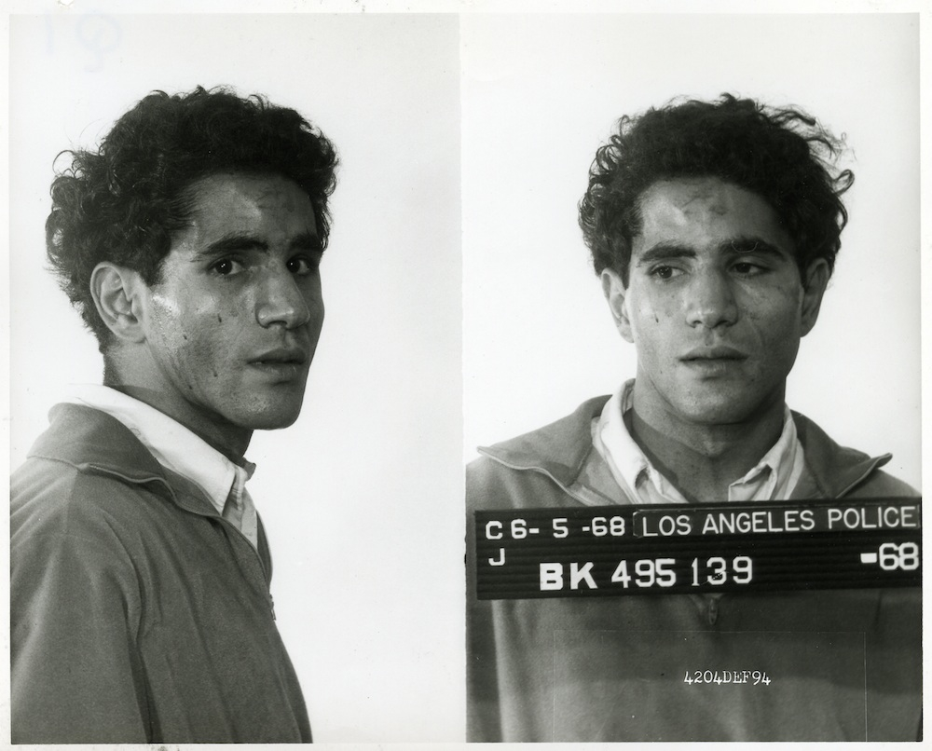
Arrest photos of Sirhan Sirhan (California State Archives)
The suspect wouldn’t give his name, so the police proceeded ‘on a John Doe basis’ and at first, it seemed an open-and-shut case. Sirhan was the only one seen firing at Kennedy; a newspaper clipping in his shirt pocket noted the hypocrisy of Kennedy’s campaign pledge to sell jet bombers to Israel; and a search of his room yielded notebooks containing strange repetitions of the phrase ‘Robert F. Kennedy must be assassinated’:
My determination to eliminate R.F.K. is becoming more the more of an unshakable obsession…R.F.K. must die – RFK must be killed...Robert F. Kennedy must be assassinated before 5 June 68…
Mayor Yorty was rebuked for discussing the incriminating notebooks with the press and calling the accused a ‘loner who…favored Communism of all types’, prejudicing a fair trial. Governor Reagan told a national television audience, ‘Two hundred million Americans did not do this. One young man did it, and not even for an American reason.’
While Kennedy was still fighting for his life, in a live televised address, a ‘shocked and dismayed’ President Johnson told his ‘fellow citizens’ he was ‘deeply disturbed…by lawlessness and violence in our country, of which this tragedy is the latest spectacular example’. But it didn’t mean ‘that our country itself is sick…[or] has lost its sense of direction, even its common decency’. He called on Congress to ‘pass laws to bring the insane traffic in guns to a halt’ and rushed in Secret Service protection to protect other candidates. He also appointed a National Commission on the Causes and Prevention of Violence to investigate the roots of assassination, murder, assault and violent public disorder:
Supported by the suggestions and recommendations of criminologists, sociologists, and psychologists…we hope to learn why we inflict such suffering on ourselves.
Bobby Kennedy died the next day and Sirhan was indicted for murder. The Public Defender requested that two psychiatrists examine his mental state at the time of shooting and a court order was issued barring witnesses from talking to the press and restricting discussion of the case to ensure a fair trial.
***
‘How can one extinguish the dubious glory of the criminal?’ Foucault asks. He argues that all crimes should ‘teach a lesson…[and] each punishment should be a fable’ - an ‘economy of publicity’ in which ‘only those obstacle-signs that arrest the desire to commit the crime by the calculated fear of punishment will circulate in men's discourse...’:
Filled with these terrible images and salutary ideas, each citizen will spread them through his family and there…his children gathered around him, will open up their young memories to receive, in imperishable lineaments, the notion of crime and punishment, the love of law and country, the respect and trust of the magistrature.
Two days after the assassination, a very poignant primetime special of Mister Rogers’ Neighborhood (1968) was aired to help parents explain the graphic news coverage to their children and begin to shape young memories.
Soberly dressed in a suit and tie, Mister Rogers describes ‘the unique ways in which children express their feelings through play…dramatizing some very violent…[and] callous things’ - how a little boy at a childcare center said he was grumpy because ‘somebody shot me in the head today.’ We then see a playground exchange between two puppets, Lady Elaine Fairchild and X the Owl:
I watched the whole thing again on TV. He got shot six times. Six times!
I saw it just once. I didn’t want to see it anymore.
It sure was neat the way they picked him up and everything and all those people were there and…say, why don’t you pretend that you’re the shooter, X, and you shoot me?
I don’t want to be the shooter.
Ah, go on…It’s just pretend. You shoot and then I’ll fall down and then you can fly away.
I don’t feel like being the shooter, Lady Elaine…
When Lady Elaine doesn’t want to play the shooter either, the parental figure of Rogers’ co-host Lady Aberlin appears and says ‘it’s too scary to play the shooter today’. She draws an interesting comparison between the wishful writing in Sirhan’s notebooks and the act of assassination itself:
Pretending and wishing can’t make things happen, can they?
You mean, that shooter that I saw didn’t wish to shoot the other man?
Well, he was angry, Lady Elaine. He was very angry but the wishing didn’t make the shooting happen.
What did?
His hand on the gun did the shooting. He could have wished all he wanted to but if he hadn’t picked up the gun, he would never have shot the other man.
Mister Rogers talks about the importance of self-control in managing anger and aggression and sings a song called ‘What do you do with the mad that you feel?’ In a final sketch, Daniel Striped Tiger asks Lady Aberlin to let the air out of a balloon and asks what assassination means. ‘It means somebody getting killed in a sort of surprise way…’ she says, ‘a lot of people are sad and scared about it’.
Regicide
While not quite regicide, assassinating a Kennedy running for the Presidency, five years after JFK’s death, came close in American culture at the time. Hundreds of thousands came out to see RFK on the streets of Los Angeles during his campaign and lined the tracks as his funeral train passed down the east coast to Arlington Cemetery.
In a matter of days, Sirhan was transformed from an unemployed jockey who liked to hypnotize himself alone in his room to an enemy of the state and, in his own words, an ‘infamous and hated’ assassin. The assassination was an attack on the social body, the democratic process and the votes of millions of Americans. As Foucault notes, Sirhan was ‘worse than an enemy, for it is from within society that he delivers his blows - he is nothing less than a traitor…’
As Foucault writes, the criminal ‘disqualifies himself as a citizen and emerges, bearing within him…a wild fragment of nature; he appears as a villain, a monster, a madman, perhaps, a sick and, before long, 'abnormal' individual. It is as such that, one day, he will belong to a scientific objectification and to the 'treatment' that is correlative to it.’
The psychiatric objectification of the ‘sick’ Sirhan was the most notable feature of his time in custody before trial. Sirhan has always said he cannot remember writing in his notebooks or the shooting itself. The story he told Jack Perkins in 1969 is the story he told at his most recent parole hearing. He drank four Tom Collins cocktails and was too drunk to drive home, so he went in search of coffee and met a pretty girl. He poured her a coffee and she led him into a dark place and the next thing he remembered, he was ‘almost choked to death’ on a steam table after the shooting. ‘And I wish they had,’ he told the parole board.
‘What did you think had happened?’ asked the Commissioner:
I didn’t know what the hell happened…the doctors said I was in a dissociated state. I must have been either too drunk, too hypnotized, too much out of my senses to be really be aware of what happened, and I’m not saying that to be dismissive of my responsibility but that is really what happened.
Where once the truth of a crime and confessions were extracted by torture - with the idea that ‘words extracted by pain had greater authenticity’ - now both sides of the case joined forces to recover the truth from Sirhan’s mind. His attorney Grant Cooper pursued a defense of diminished capacity that he hoped would ‘save the boy’s life’. He allowed both defense and prosecution psychiatrists access to Sirhan and in January 1969, they hypnotized him and asked him to reenact the crime.
These dramatic recordings support the gaps in Sirhan’s memory and the defense claim that he was in a hypnotic trance at the time of the shooting. They were later broadcast at length in my film but were never played to the jury and suppressed for twenty years.

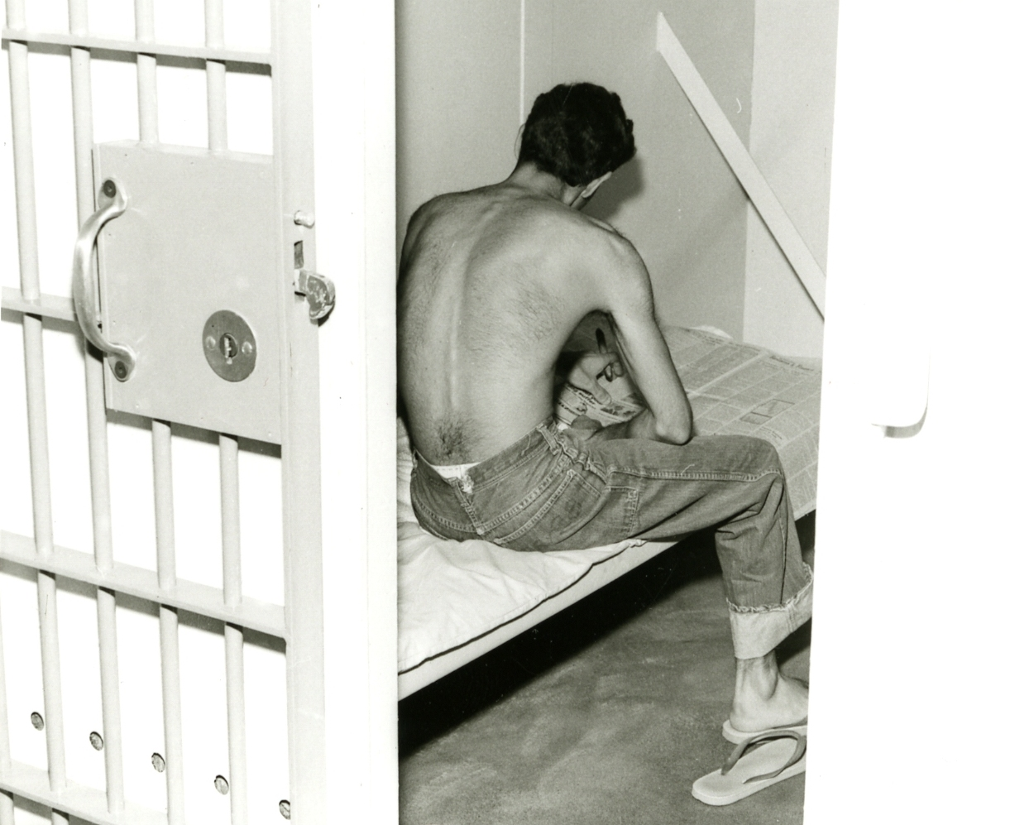
Sirhan in his cell, August 1968 (California State Archives)

Ritual and spectacle of the trial
Where once ‘the great terrifying ritual of the public execution’ marked what Foucault describes as ‘the physical confrontation between the sovereign and the condemned man’, now the state sought to establish the truth through reason and the human sciences in the court of law. The ‘contained anger of the people’ would confront the suspect in the twelve persons of the jury to decide the degree of guilt and punishment. Where once a political assassin was taken to the scaffold, now private execution in the gas chamber in San Quentin was the ultimate penalty awaiting the condemned.
But the trial nearly didn’t happen. Three days before the first witness was called, both sides agreed a plea of first-degree murder in return for a recommendation of life imprisonment to the jury, not the death penalty.
The prosecution psychiatrist had concluded Sirhan was psychotic, supporting the defense position of diminished capacity, so ‘we can’t conscientiously ask for the death penalty’, said L.A. County District Attorney Evelle Younger. As the outcome of the trial was ‘a foregone conclusion…are we justified in going through the motions of a very traumatic and expensive trial?’
As O’Sullivan (2008) notes, while Cooper felt Sirhan ‘was entitled to a charge of second-degree murder, the likelihood of obtaining such a verdict from the jury in such a high-profile case had to be weighed against the possibility of the jury ignoring the psychiatrists and returning a death sentence.’
To avert suspicion that ‘there was any hanky-panky going on,’ Younger promised to release the investigation files and psychiatrists’ reports, so ‘the second-guessers, and they will be legion…will have all the evidence’ but Judge Walker was having none of it:
I think you have got a very much-interested public…and they continually point to the Oswald matter, and they wonder what is going on because the fellow wasn’t tried.
When Cooper suggested putting on ‘a very skeleton outline of the case’, Walker rightly said, ‘Well, then they would say that it was all fixed.’ The jury should determine the outcome, not the psychiatrists, he declared, ‘so let’s go on with the trial’.
***
But how would the trial be represented to the public? In early December, the L.A. County Board of Supervisors endorsed a motion to change court rules to allow live television coverage of the trial, citing the public's ‘constitutional right’ under Article VI of the Bill of Rights:
In all criminal prosecutions, the accused shall enjoy the right to a speedy and public trial by an impartial jury…
One newspaper editorial argued bringing TV cameras into the courtroom ran the risk ‘of transforming a public trial into a trial by publicity’ and an ‘entertainment spectacle.'
Three years earlier, the Supreme Court had reversed Billie Sol Estes’ conviction for swindling by a Texas court, ruling he ‘was deprived of his right…to due process by the televising and broadcasting of his trial’ against his wishes. In his opinion, Clark criticized the disruption caused by the cameras, the ‘temptation offered by television to play to the public audience’ and its effect on the judge, jury, witnesses and the defendant himself:
Its presence is a form of mental - if not physical - harassment, resembling a police line-up or the third degree. The inevitable close-ups of his gestures and expressions during the ordeal of his trial might well transgress his personal sensibilities, his dignity, and his ability to concentrate on the proceedings before him - sometimes the difference between life and death…Trial by television is, therefore, foreign to our system…The television camera is a powerful weapon. Intentionally or inadvertently it can destroy an accused and his case in the eyes of the public…[and] strip the accused of a fair trial.

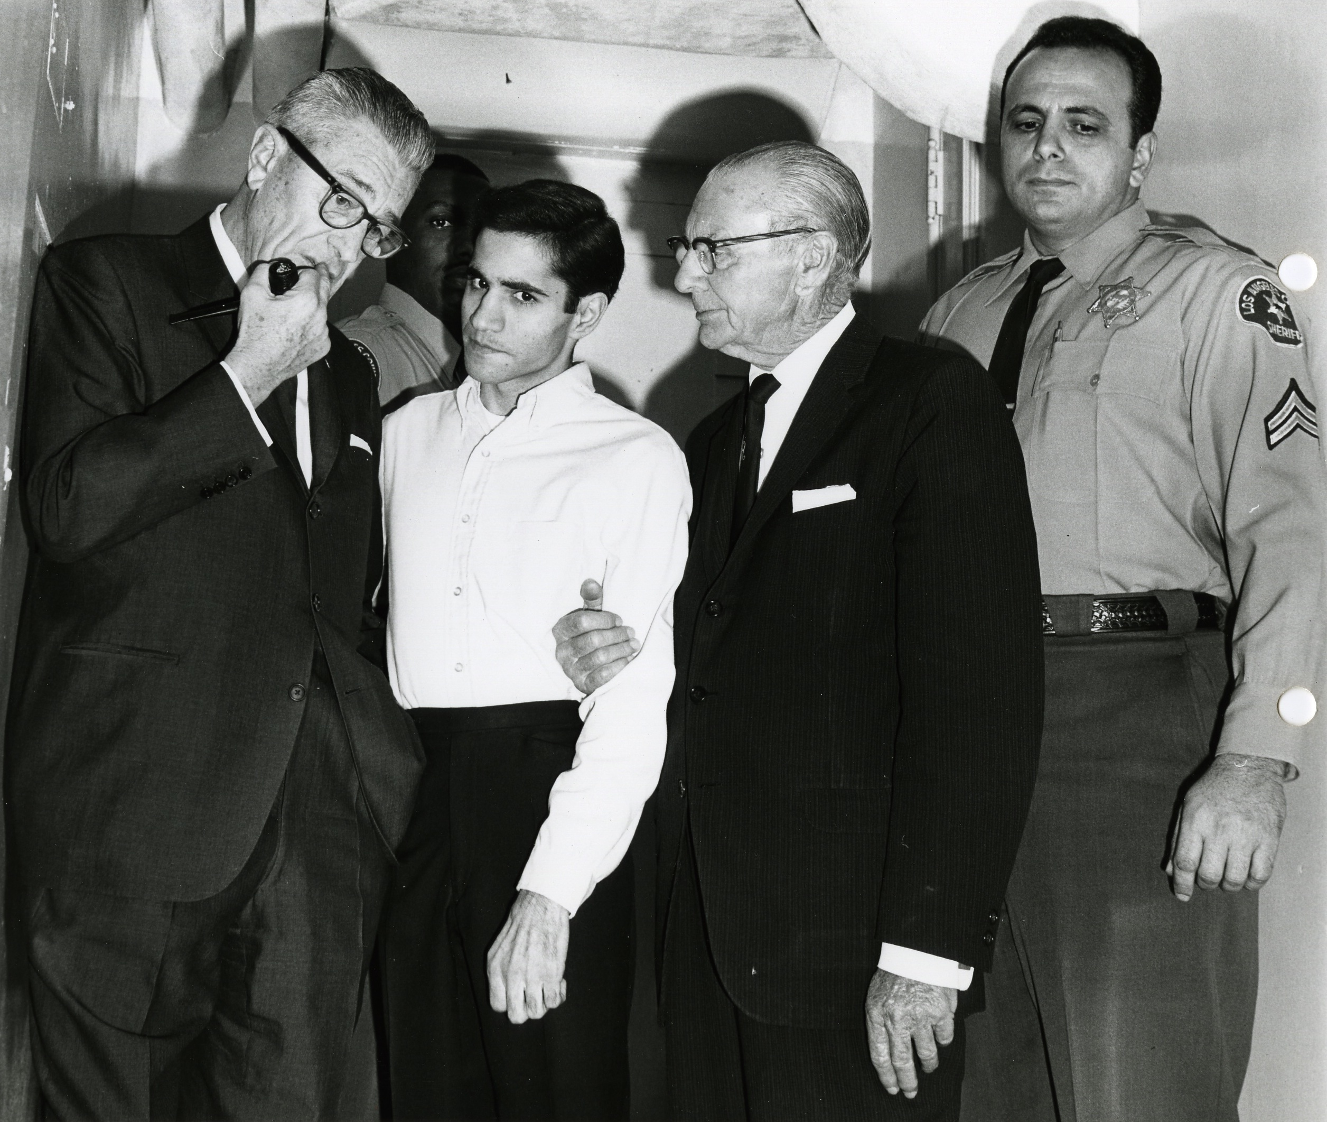
Sirhan with his attorneys, December 1968

The attempt to televise Sirhan’s trial failed, so the only filmed record shows a very shy accused emerge from his cell area with his attorneys on the first day. Due to overwhelming press interest, the trial was transmitted via closed-circuit television to an overflow pressroom by a camera hidden in an air-conditioning unit but no recording was allowed and television played a largely passive role during the trial, never questioning the inept display of Sirhan’s attorneys, whose defense of diminished capacity admitted their client’s guilt in an attempt to placate the jury and ‘save the boy’s life’.
Two-minute situationers on the nightly news summarized the day in court but the investigation files on which the trial was based - and the evidence they withheld - would stay closed until 1988. A senior psychologist at San Quentin later dubbed the psychiatric testimony at Sirhan’s trial ‘the psychiatric blunder of the century’:
The psychiatric-psychological team, largely made up of Jewish doctors, pooled their efforts to prove that Sirhan, the hated Arab, was guilty and insane…
A LIFE editorial agreed much of the psychiatric testimony was ‘a shambles’ and noted the uneasy threshold between medical opinion and moral and legal judgment. ‘The judge and the jury are the community’s representatives. It is for them to make the judgment, not us psychiatrists,’ said one.
On April 14, the trial ended and the jury retired to deliberate the degree of guilt or innocence. The options were manslaughter, carrying a penalty of one to fifteen years; second-degree murder (five years to life); or first-degree murder (life in prison or death in the gas chamber). Three days later, they chose the latter and the penalty phase of the trial began. The jury had to decide between life in prison or the death sentence - to slay the common enemy or rehabilitate him.
The Penalty
Vermeil imagined a ‘scene of absolute punishment’, a living torture, for ‘the most terrible of crimes’ like regicide:
The man found guilty of this crime would have his eyes put out; he would be put into an iron cage, suspended in the air, above a public square; he would be completely naked; he would be attached to the bars of the cage by an iron belt around his waist; to the end of his days, he would be fed on bread and water…
As Foucault notes, the punishment of the body manifest in the ritual of the scaffold was gradually replaced by a more humane ‘art of punishing’ which used ‘a whole technology of representation’ to code social behavior and reduce illegality in the minds of all:
What must be maximized is the representation of the penalty, not its corporal reality…In physical torture, the example was based on terror: physical fear, collective horror, images that must be engraved on the memories of the spectators…The example is now based on the lesson, the discourse, the decipherable sign, the representation of public morality…the reactivation of the code, the collective reinforcements of the link between the idea of crime and the idea of punishment…which seeks to control delinquency by a calculated economy of punishments.
Foucault argues that ‘the submission of bodies through the control of ideas…[using] the 'mind' as a surface of inscription for power…was much more effective than the ritual anatomy of torture and execution’. He cites the Enlightenment reformer Servan: ‘A stupid despot may constrain his slaves with iron chains; but a true politician binds them even more strongly by the chain of their own ideas...'
In calculating the penalty, Foucault notes the words of the Enlightenment criminologist Beccaria (a seminal influence on the Founding Fathers): ‘one must choose the means that will leave the most lasting impression on the minds of the people, and the least cruel on the body of the criminal.
Foucault argues that the penalty should be calculated ‘in terms not of the crime, but of its possible repetition’:
One must take into account not the past offence, but the future disorder. Things must be so arranged that the malefactor can have neither any desire to repeat his offence, nor any possibility of having imitators… One must punish exactly enough to prevent repetition.
On April 23, the jury brushed such progressive ideas aside and returned the death sentence by a vote of 10-2, choosing ‘an equivalence of horror’ and a ‘symmetry of vengeance’ between crime and punishment, a life for a life. Sirhan calmly chewed gum as he listened to the verdict. ‘It’s all right,’ he comforted his defense team, ‘even Jesus Christ couldn’t have saved me.’
On May 21, a letter from Senator Edward Kennedy to the D.A. was read into the record:
My brother was a man of love and sentiment and compassion. He would not have wanted his death to be a cause for the taking of another life.
Sirhan was stunned by what he later called ‘a supreme act of mercifulness’ but the judge was not swayed, formally sentencing him to death and remanding him to death row in San Quentin.
The next day, Jack Perkins interviewed Sirhan for the eighteen-minute NBC special, First Tuesday: The Mind of an Assassin (1969). It’s a fascinating distillation of the mysteries and conundrums of the trial, with Perkins often seeming slightly bewildered by Sirhan’s responses. An Associated Press reviewer was also confused ‘since Sirhan repeatedly voiced his affection for Kennedy, his sorrow about his death and his inability to realize the man died at his hand…[while] most of the time a half-smile played on his features.’
Perkins’ final question granted Sirhan three wishes - what would they be? ‘That Senator Kennedy were still alive’ Sirhan replied, before breaking down in tears and adding ‘and that there should be peace in the Middle East…’ Perkins closed by saying ‘it was our impression, the camera crew and I, that he looked on us as perhaps his last contact with the world outside prison.’
Once the interview was over, the body of the condemned man was transferred to death row in San Quentin and Sirhan disappeared from public view to await his moment in the apple-green gas chamber, pending appeal. The theatre and spectacle of the trial was over and the full weight of justice had been served.
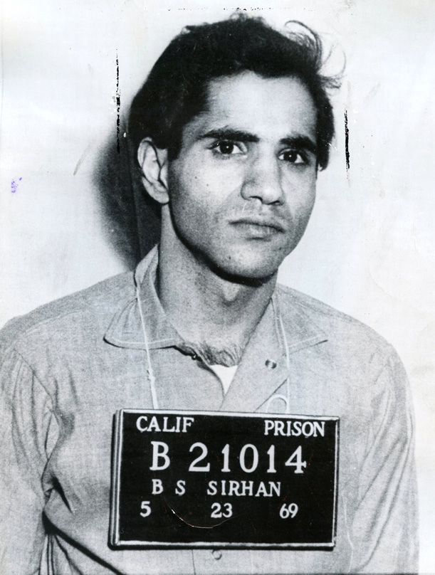
Prison handout of Sirhan after his trial (CDCR)
***
The final report of the National Commission on the Causes and Prevention of Violence was finally published under Nixon in December 1969:
Considering the high visibility, the substantial power, and the symbolic (as well as actual) importance of the American presidency, it is not surprising that Presidents are prime victims of assassination, or that conspiracy theories attend the event…What better target for those who wish to punish a nation, strike out at a symbol of great power, or simply draw the attention of the world and history to themselves?
It reflected on the fact that nearly one in four American presidents had ‘been the targets of assassins' bullets, and four died as a result.’ Such a high assassination rate was almost unique among developed democracies and it sought an explanation in ‘our frontier culture, the ready availability of guns, tensions among diverse groups, a low standard of political decorum.’
It found a comforting pattern in political assassins:
Presidential assassins typically have been white, male, and slightly built. Nearly all were loners and had difficulty making friends of either sex and especially in forming lasting normal relationships with women…Normal family relationships were absent or disrupted…All of the assassins were unable to work steadily during a period of one to three years before the assassination. All of the assassins tended to link themselves to a cause or a movement and to relate their crime to some political issue or philosophy.
We do not know why the assassin politicizes his private miseries or why he chooses to express himself through such a terrible crime. Perhaps he comes to blame his own failures on others…Once his own inner misery becomes identified with the misery of those whom he champions, he places the blame for both on the nation's foremost political figure…[and seeks] to accomplish - in one burst of directed energy - something of great worth to end his misery and assert his value as a human being.
The Commission also found comfort in the fact that ‘non-conspiratorial assassination has been the American pattern’:
Though an assassin is mentally deranged, the violent rhetoric of our politics and our constant flirtation with actual violence may be factors that bring him at least halfway to his distorted perception of what actions are right and legitimate…
***
In the months following Sirhan’s trial, the senior psychologist at San Quentin, Dr. Eduard Simson, saw him twenty times and they built up a strong rapport. Simson found no evidence to support prosecution claims that Sirhan was psychotic or paranoid schizophrenic and Sirhan asked Simson to use hypnosis to recover his memory of the shooting. But before they could start, Associate Warden James Park intervened, concerned that Simson was ‘making a career out of Sirhan’ and Simson resigned in protest.
Simson later told NBC News he felt the ‘full truth’ of the assassination remained locked in Sirhan’s mind. While the defense argued Sirhan had hypnotized himself to act out the writing in his notebooks and kill Kennedy, Simson saw him as the ideal ‘Manchurian candidate’: ‘He was easily influenced, had no real roots, and was looking for a cause. The Arab-Israeli conflict could easily have been used to motivate him.’
In 1972, the California Supreme Court ruled the death penalty unconstitutional and after three years on Death Row, Sirhan’s sentence was commuted to life imprisonment, with the possibility of parole. The vengeful impulse of the jury was tempered by the humanity of the Supreme Court and the ‘punitive theatre' of the scaffold, ‘where the body of the tortured criminal had been exposed to the ritually manifested force of the sovereign’, was replaced by sealed prison walls enclosing the ‘mysterious work of punishment’.
Parole
In 1975, the year Discipline and Punish was published, Sirhan was given a parole date. As Foucault argues, the function of a penalty is to transform and modify the prisoner:
The punishment should diminish as it produces its effects…a penalty that had no end would be contradictory – all the constraints that it imposes on the convict and of which, having become virtuous once more, he would never be able to take advantage, would be little better than torture; and the effort made to reform him would be so much trouble and expense lost by society…punishment can function only if it comes to an end...
The technology of parole has been designed to address this. Foucault quotes Vilan on the demotivating effect of a life sentence without end:
A life sentence throws them into despair; they become indifferent to the correction of their morals and to the spirit of work; they become concerned only with plans to escape and to rebel; and since the judgments that were passed on them did not deprive them of life, why should one seek to render it unbearable for them?
The California state legislature had this in mind in 1975 when they moved to introduce fixed sentences and give those on indeterminate life sentences ‘a date certain’ for their release. At his initial parole hearing, Sirhan was granted a parole date of February 23, 1986, later brought forward eighteen months for good behavior.
Prisoners convicted of first-degree murder had been freed, on average, after eleven years and given Sirhan’s record of good behavior, the parole board couldn’t justify giving him more time because of who he killed. The chairman of the panel told the press he was ‘proud as hell that [they] didn’t search for some bogus reason to deny him…This should prove we don’t have any political prisoners.’
In the post-Watergate era, amid newspaper exposes of CIA/Mafia assassination plots against foreign leaders and illegal domestic spying programs, the political assassinations of the sixties gained serious media currency. Ted Charach’s Golden Globe-nominated documentary The Second Gun (1973) presented the case for a second shooter in the Ambassador pantry and the Zapruder film was finally shown on television.
In 1975, CBS News launched investigations into the Kennedy and King assassinations in the award-winning series The American Assassins. The courts denied CBS access to the ‘still secret’ LAPD report on the Sirhan case but a joint petition with shooting victim Paul Schrade led to a re-examination of the ballistics evidence that proved inconclusive.
Host Dan Rather spent four and a half hours with Sirhan and found him to be ‘sensitive, intelligent…talkative and [with] a sense of humor.’ Sirhan didn’t want the interview recorded but said ‘he simply does not remember the shooting of Senator Robert Kennedy…[and] that if any other person influenced him in any way to do the shooting, he is not aware of it.’
A nationwide poll conducted by CBS News showed 53% of the public believed others were involved with Sirhan and 41% wanted the case reopened but while the House Select Committee on Assassinations reinvestigated the JFK and MLK killings and found conspiracy, a planned RFK investigation was dropped due to lack of funds.
Media coverage
As Foucault notes, ‘punishment must be regarded as a retribution that the guilty man makes to each of his fellow citizens, for the crime that has wronged them all – penalties that are constantly placed before citizens' eyes…’
The battle over Sirhan’s parole has been the main vehicle for this and Sirhan returned to public view in April 1982 when, after a vocal petition by L.A. County District Attorney John Van de Kamp, the Board of Prison Terms held ten days of hearings to consider rescinding Sirhan’s parole date. NBC won a court order to tape the hearings and on the final day, Sirhan broke a 13-year media silence to read a closing statement to the board:
When you’re on death row, you think a lot about death. In fact, that’s all you think about. As the psychiatrists and others have explained, I have time and again reflected on the taking of Robert Kennedy’s life and what that did to his wife and family, since I have seen my own brother murdered before my eyes as a child…and I have always experienced remorse at what I did…I sincerely believe that if Robert Kennedy were alive today he would not countenance singling me out for this kind of treatment. I think he would be among the first to say that no matter how horrible a deed I committed 14 years ago, that should not become the cause for denying me equal treatment under the laws of the country…
In response, Deputy District Attorney Larry Trapp said the 1975 board ‘made an improper assessment of the danger of political assassination to society’ and claimed Sirhan was still ‘deeply committed to the cause that sent him here’:
Sirhan took it upon himself to rewrite history…If we parole Mr. Sirhan, Californians will risk sending a message throughout the entire world to every misfit, fanatic and political crusader throughout the world that political assassination costs just 13 (sic) years…He might feel some remorse after this period of time but I really think he feels more sorry for himself than for his victim...
These comments became regular tropes in the discourse around Sirhan’s parole: his remorse (or lack thereof); equality before the law versus the cost of political assassination in the United States; and the message Sirhan’s punishment sends to the world and future political assassins. Two weeks later, Sirhan’s parole date was rescinded and Van de Kamp said, ‘The message must be sent out in clear and unmistakable terms that political assassination will not be tolerated in this society - and those who engage in it must pay the price.’
Central to the decision were two threatening letters written by Sirhan in the early seventies and not considered by the 1975 panel. The first was written to Grant Cooper, Sirhan's trial attorney, in 1971:
Hey Punk,
Tell your friend Robert Kaiser to keep mouthing off about me like he has been doing on radio and television. If he gets his brains splattered he will have asked for it like Bobby Kennedy did. Kennedy didn’t scare me, don’t think that you or Kaiser will - neither of you is beyond my reach…RBK must shut his trap, or die.
In the margin, Sirhan wrote a p.s. for Cooper: ‘Don’t ever forget, you dirty son of a bith [sic] that you cost me my life.’
The target, author and defense investigator Robert Kaiser, ‘took it as a piece of literary criticism - he didn’t like my book!’ He dismissed it as a temper tantrum and still feels Sirhan was hypnotically programmed to commit the assassination.
‘Consider the circumstances…’, a regretful Sirhan told David Frost in 1989:
You’re cooped up in a Death Row cell…pretty near twenty-four hours a day. You have no ability to communicate with anybody meaningfully. No telephone…really nothing. I was placed in total isolation up there. And the frustrations build up. I was young. I was still wild…every second of your thoughts and your mind and your being is threatened with death, so it didn’t seem that terrible a threat, really, to make. And it was more done out of frustration and venting steam rather than a deliberate one…
The second letter to a prison employee in 1975 concerned acute dental problems: 'When I panic at the loss of my teeth, I want you to rest assured that I'm going to kill you’…[and everyone else] 'responsible for my continued torture.’ Sirhan’s urgent need for dental care was being ignored, he told Frost, ‘and the only way that you could get more immediate attention was to really raise hell with the guards…that’s really what it boiled down to.’
Yet these isolated outbursts are still held against Sirhan by the punishing power forty years later as evidence of his anger, aggression and impulsivity; his determination to stand up for his rights showing a lack of obedience, discipline and submission.
While making RFK Must Die (2008), I ordered copies of NBC newscasts of Sirhan’s parole hearings and it’s interesting to analyse the editorial line they take on the story. The anchor lead-in to a report on the 1983 hearing notes that ‘after 15 years in prison…Sirhan’s animosity towards Israel seems undiminished’ before cutting to a clip of Sirhan discussing Robert Kennedy:
The man was a U.S. senator, sir, he had a lot of influence…he was becoming President. And as President, Commander-in-Chief…he can send nuclear bombs and the entire U.S. arsenal to Israel to kill my countrymen.
‘Sirhan insists he’s paid his debt to society and should be released…’ NBC reported. After serving more time than most first-degree murderers, he felt he ‘had been unfairly singled out for harsh treatment’:
You people are not judging me on my criminality, it’s on my political beliefs that you are punishing me for…If you are trying to ask me to renounce my devotion, my love for my countrymen, you’re not going to do that. I don’t care how long you keep me in this prison…
Jordan had offered Sirhan a return to the Arab world if paroled and ‘he said the Kennedy family could recommend that he be freed from prison and then deported’:
I’m not going to go out there and join some assassination squad. Terrorism, that’s not my interest, like I told you, I want to put all this behind me, try to get married and raise a family and live out my life as a normal person would…As much as you people hate me, as evidenced by your treatment of me, as eager as I am to leave this country, let’s part company, I say. Let me go back.
But again, Assistant D.A. Larry Trapp took a hard line:
Political assassination in America must never be rewarded by freedom…I think it’s an insult to all Americans that he would be released to a country where I think a large segment of the people would treat him as a hero.
Successive parole boards would question the sincerity of Sirhan’s remorse and, as he told reporters, the performative act of expressing remorse clearly got to him:
I do feel remorse, believe me, but 15 years after the event…I feel like as if I’m a parrot, you know, repeating the same refrain, that I am sorry, I do feel remorse but I can’t really express the same emotion in saying so now as I did early on…I genuinely do feel remorse for the loss of Robert Kennedy.
A poorly phrased NBC report described Sirhan entering his 1985 hearing ‘armed with a psychiatric report that called him an “exemplary inmate”.’ Dr. Hicks’ psychiatric evaluation found Sirhan to be ‘an exemplary prisoner with no predilection toward violence at this time’ but once again, he was turned down.
The parole board doubted Sirhan’s remorse and ‘partial amnesia’ and panel chairman Rudolph Castro called the 1968 assassination ‘an attack on the democratic system of government (which) with three shots disenfranchised millions of people. Sirhan still does not accept the enormity of his crime…[and] needs to develop a marketable skill and participate in self-help programs to prepare him for future release’ - almost word for word, what the parole board concluded at his most recent parole hearing in 2011.
The secret nature of parole board deliberations was undermined by the board’s own incompetence at the 1985 hearing. The press were allowed to watch the open hearing via closed-circuit television. When the panel retired, the camera was switched off but the microphone was left on, exposing the true nature of parole board decision-making. Reporters listened in as after three minutes of jokey deliberation, the panel rejected parole for Sirhan but granted his request for transfer to another prison: ‘We'll send his ass down there for as long as possible.’ Castro later told incredulous reporters the deliberations had taken forty-five minutes.
Sirhan later told reporters he was shocked – ‘if this were in some totalitarian country, I could believe this occurring there, but not in America.’ His attorney called the hearing ‘a sham’ and ‘a sad day in the history of American justice.’ In a short interview with NBC’s affiliate station in Los Angeles, Sirhan felt the liberation of the ‘Arab terrorist/hero’ was again the issue and that his denial was unduly influenced by a TWA hijacking by members of Hezbollah and Islamic Jihad two weeks before:
This country is governed by the rule of law, it is not governed by terrorist tactics. Now, if you want to deprive me of my rights under your own established rules and your own laws, at least come out and tell me that outright rather than to tell me that you didn’t…go to Alcoholics Anonymous programs and on that basis, we’re going to deprive you of your liberty. Tell me that you’re a terrorist and we don’t want you out of our prison. I can live with that. But all these deceptions and these…kind of devious ways of denying me parole, I don’t think it’s fair…
He ‘scoffed at suggestions by some U.S. politicians that radical Arabs would welcome him as a hero’:
There is nothing heroic about killing another human being, no matter for whatever cause…and I don’t feel proud for having done this…if I were that much of an ogre among your society, why don’t you deport me? And once deported, how could I be a physical threat to any person in this country?
But what signal, which ‘obstacle-signs’ would that send to the rest of the world?
What’s interesting about Sirhan’s appearances at his parole hearings is how often he talks against his interest. He is eager to show remorse but at the same time, almost too honest in trying to rationalize what he did. In the Frost interview in 1989, he criticized the ‘double standard’ of politicians like Bobby Kennedy: ‘On the one hand…he was all in favour of stopping the war in Vietnam, he wants to bring our boys home. And, in the next breath, he wants to send more bombs and more Phantom jets to Israel to kill human beings but Palestinians in this instance…’
He refuses to genuflect before the panel or show blind subservience to what they want to hear, because he knows he is participating in an empty ‘ceremony of power’ with a pre-ordained outcome less concerned with his rights than the representation and signs that code the fate of the political assassin in the public mind.
The prison psychiatrist’s report presented at his 1986 hearing again noted that Sirhan appeared to be ‘genuinely rehabilitated…and a good candidate for parole’ but Sirhan was denied for an eighth time and he later told David Frost equality before the law and due process ‘has been sort of frustrated and stifled by the politicians in this state’:
The system proceeded admirably well after the death sentence…was abolished and when my release date was established. And nothing really would have stopped my release except the political ambitions of a political upstart in Los Angeles named John Van de Kamp, who was district attorney at the time and who wanted to achieve a higher political office, sir…You must distinguish between politics and the rule of law. If you want to say, we want to make a political decision never to let you go, at least, have the courage and tell me that…
Luke McKissack, Sirhan’s attorney since his appeal, added:
Since 1982, the law has been bent out of shape, it’s been a travesty... The parole board has used every technique that it could to keep him behind bars without being able to elaborate on any justifiable reason for doing so.
The Frost interview was first broadcast in the US over three nights on the syndicated Inside Edition (1989) and the series ended with a telephone vote asking viewers ‘Should Sirhan Sirhan be Paroled?’ Host Bill O’Reilly expressed surprise that of almost 200,000 votes cast, a quarter favored parole. The program could not resist a final comment from senior producer Dan Goldfarb ‘who put the interview with Sirhan together’. ‘Do you think he’s really contrite?’ O’Reilly asked:
Bill, he’s had over twenty years to rationalize what he did – to get his rap together, as other convicts would say – and he’s real good at it. On the one hand, he apologizes for murdering Bobby Kennedy. On the other hand, he says ‘but I was betrayed’…
Your personal opinion – did you feel he was sincere and contrite?
No, I didn’t…
***
Despite the release of the LAPD investigation files in 1988 and a flurry of books and cable documentaries about possible conspiracy in the RFK assassination, the case has had only the briefest of mentions on the nightly news of the major networks since.
Sirhan’s comments at his 1990 parole hearing went unreported in a segment eight seconds long and despite new evidence, a new attorney and a new plea, NBC spent just sixteen seconds reporting Sirhan’s appearance in 1997: ‘Sirhan said he now believes he did not kill Kennedy in 1968. Prosecutors called that denial insulting to the American people’.
Waning coverage of the parole hearings has been exacerbated by a ban on recorded interviews with California inmates since 1996 and successive governors have vetoed bills to restore media access. Governor Schwarzenegger (2006) said, ‘I do not believe violent criminals should be able to traumatize their victims a second time by having unfettered access to the media’. Six years later, Governor Brown was equally dismissive: ‘Giving criminals celebrity status through repeated appearances on television will glorify their crimes and hurt victims and their families’.
The representation of Sirhan in RFK Must Die (2008) was constrained by the fact that I couldn’t interview him or afford to license more than thirty seconds of the Perkins interview from NBC. As I’ve written previously, the Frost and Perkins interviews with Sirhan ‘are rarely seen in documentaries due to the cost of licensing, extinguishing his voice from the debate on the assassination and the public consciousness.’
After his 1997 denial, Sirhan saw no realistic hope of parole and disappeared from public view until March 2011, when he appeared with new attorneys and spoke publicly for the first time in fourteen years. As noted in my thesis, media access was restricted to ‘representatives of the news media’:
CNN operated a press pool, sharing footage with local network affiliates in the prison parking lot…I had a hard time gaining access…[but] my cameraman was the only one to insist on a full copy of the hearing…The local affiliates were happy to take selected highlights to illustrate brief news stories the next morning. They didn’t have time to watch the hearing themselves.’
I’d like to conclude with a close reading of the three-hour hearing, prefaced by some background on the parole process in California.
***
The California Board of Parole Hearings (BPH) is a highly political office. Its twelve commissioners are appointed by the State Governor and, as a firm of criminal defense lawyers notes, ‘the governor's political agenda will likely dictate who will be released and who will remain incarcerated’, with the governor retaining the right to veto parole board decisions in murder cases.
As I write, news arrives of another lifer in prison for 43 years for two counts of first-degree murder. The Guardian reports that after thirty parole hearings, the California parole board have recommended the release of Manson follower Bruce Davis for a fourth time after three previous recommendations were blocked by Governors Schwarzenegger and Brown, who said Davis was still ‘dangerous despite his age’. Davis is now a born-again Christian with a doctorate in the philosophy of religion ‘and ministers to other inmates’. His attorney said he was ‘pleased that the board again followed the law and did the right thing, and I am hopeful that the governor will do likewise.’ Brown again denied parole.
According to California law, ‘a life prisoner shall be found unsuitable for and denied parole if in the judgment of the panel the prisoner will pose an unreasonable risk of danger to society if released from prison.’ In considering whether the prisoner is ready ‘to re-enter society’, the panel considers the crime itself, the prisoner's ‘social history; past and present mental state; past criminal history… past and present attitude toward the crime; and any other information which bears on the prisoner's suitability for release.
At the 2011 hearing, Sirhan was clearly struggling for breath and told the two-man panel he was feeling ‘under the weather’ and had been suffering from ’valley fever’ for four months. In determining suitability for parole, Commissioner Prizmich said they would be exploring his ‘insight into the crime’ – his remorse and the responsibility he took for his actions – but the panel were ‘compelled to go along with what the court found was true and accurate, so…we’re not retrying the case.’
Sirhan went back over his memory of the shooting and described what he did as ‘the most horrible thing that any human being can do to another...You don’t kill human beings, period.’ They discussed the girl he met while searching for coffee:
Nobody knows who the hell she was…she just disappeared.
Well you remember quite a bit about that.
Well, I talked with Dr. Brown about it.
This was the first of several ‘tells’ from Prizmich, foreshadowing his predetermined conclusions. He comes across as brusque and impatient, trying to catch Sirhan out with his questions and repeatedly interrupting his answers.
Sirhan agreed that his notebooks were ‘incriminating’ and ‘damning’ but he couldn’t remember writing them. His attorney William Pepper described three years of psychological testing Sirhan underwent with Dr. Dan Brown to recover his memory and how, even under deep hypnosis, there were still gaps in his recall. The reports of Dr. Brown and another psychiatrist agreed Sirhan had a low risk of recidivism. He worked unpaid in prison, raking leaves and mowing the lawn and had not broken prison rules since 1972.
Foucault notes the ‘secrecy and autonomy’ given to prisons ‘in the exercise of the power to punish’ and this was reflected in a couple of angry episodes the panel raised from 2010, when Sirhan’s radio was taken away from him when he moved prison and one of the new guards challenged him to a fight. When he reported the provocation to his counselor, she ridiculed him and when the guard called him a motherfucker, he returned the compliment, so the guard wouldn’t think him a ‘pushover’.
The panel seized on these innocuous episodes where Sirhan lost his temper, when provoked, as evidence he still had anger management issues. Sirhan contended he was merely a prisoner ‘raising hell about my rights’ in a pressure-cooker environment. Perhaps the most ridiculous aspect of the proceeding came when Prizmich asked Sirhan how he’d reacted to guards accusing him of foreknowledge of 9-11, a story the prison authorities leaked to the Washington Post at the time:
Prison authorities in California wonder why Robert F. Kennedy assassin Sirhan Sirhan shaved his head and requested a television on Sunday, Sept. 9, two days before the terrorist attacks.
Sirhan told the guards ‘they were crazy’ - a departing prisoner had given him his TV and when the guards saw him watching it with a towel on his head after a shower, they concluded he was an Arab terrorist and told the press. Instead of apologizing to Sirhan for defamatory remarks and press leaks, Prizmich scolded him for making an ‘immature comment’ about 9-11 and probed his possession of a Koran.
Sirhan said he used the Koran to ‘keep up’ his Arabic but reiterated that he’s been a practicing Christian all his life, attends church every week and the Bible was his favourite book, with one passage in Luke holding particular meaning:
The spirit of the Lord is upon me, He has sent me to heal the brokenhearted, to proclaim liberty to the captives…to set at liberty those who are oppressed…(Luke 4:18)
‘It renews my hope I will be found suitable for parole and get out because Christ promised that to all the believers’, he said, before adding in his closing statement:
Every day of my life, I have great remorse and deeply regret the fact that I participated in [this] horrible event…As the panel knows, I was granted a parole date in 1975...The District Attorney took away this parole date…and this…really changed my mind and heart towards the system. I lost faith and confidence in this very system because I realized that…your word is not as good as it should be, in all candour.
After a forty-five minute deliberation, the panel decided the prisoner ‘was not yet suitable for parole and would pose an unreasonable risk of threat or danger to public safety if released from prison’ despite a long history of psychiatric reports stating the opposite.
As they were ‘compelled to go with’ the appellate decision, ‘it was undisputed that the defendant fired the shot that killed Senator Kennedy’:
So there were multiple victims, the evidence is quite clear that the offence was carried out in a calculated manner…and it seems quite clear, in your planning, that you focused on Mr. Kennedy and your focus was bore out by him being killed…’
The panel commended Sirhan for his demeanor but said there were still ‘deep-seated issues’ where he had ‘failed in several areas’. As Prizmich explained them, his cordial relationship with Sirhan began to unravel:
(1) The special nature and impact of the crime
Prizmich told Sirhan he had not taken ‘adequate responsibility’ for ‘the magnitude of this crime’ and ‘your lack of understanding of the impact of this crime was of great concern to us.’ He said it ‘went way beyond’ a normal murder or its effect on the Kennedy family to ‘severely impact’ the nation.
The assassination had transformed the way politicians interact with the public and Prizmich didn’t feel Sirhan had that understanding, ‘and that is pretty darn significant…You’re looking quizzical, sir.’ ‘I don’t understand,’ said a bemused Sirhan. ‘I didn’t invite you to talk,’ replied Prizmich, later citing such interruptions as ‘demonstrating impulsivity, a lack of control’ and ‘anger issues’.
(2) The prisoner’s remorse
The panel noted ‘with some degree of…distrust, quite frankly, you remembering parts of this and not remembering others’ and made absolutely no attempt to engage with Dr. Dan Brown’s work over three years to recover Sirhan’s memory of the shooting:
The gaps in your memory…leave us with an uneasy feeling…that you are minimizing your conduct in this matter. You have vaguely made reference to any number of conspiracies, not only in the crime, but also a conspiracy that law enforcement somehow set you up, the CIA somehow set you up on this, the DA was a party to this. It seemed as though, in your mind, everything that occurred in a negative way to you…was really someone else’s fault…
Throughout the hearing, Sirhan expressed remorse to the public, the Kennedy family and the other shooting victims - including William Weisel, who was present - saying the news of their injuries ‘broke my heart’. He described how painful it was to dwell on the details of such a ‘horrible nightmare’ and Prizmich later seized on this and Sirhan’s description of the other victim wounds as ‘flesh injuries’ for an extended rant:
Your description of their injuries was a very off-handed ‘They were flesh wounds.’ They were much more serious than that...if one has insight, if one has remorse, as you expressed you do, you’d have some level of understanding as to what damage you caused these people. Now, I know it’s been a long time ago but you had none. Flesh wounds were not what these people suffered, so that gave me concern.
The Oxford English Dictionary defines a flesh wound as ‘a wound that breaks the skin but does not damage bones or vital organs’, which is an accurate description of what the victim injuries were.
(3) The prisoner’s rehabilitation
Foucault argues that ‘one punishes not to efface the crime, but to transform a criminal…’ The punitive intervention of a corrective institution like the prison rests on ‘a studied manipulation’ of the individual – coercive training of the body ‘by the daily work that he is forced to perform’, instilling habits and behavior; prison should also be ‘a machine for altering minds’, where ‘work on the prisoner's soul must be carried out as often as possible.’
In the California prison system, ‘work on the prisoner’s soul’ means self-referral to a self-help program. The panel told Sirhan more self-help programming was needed to give him an ‘ability to articulate in a deep-seated, meaningful way to the panel your understanding of the magnitude of the loss of this man’:
You need to demonstrate to us that you’re working on yourself…in the area of anger management… you’ve not done the adequate insightful looking into yourself that I think would be helpful.
Self-help options are limited in Sirhan’s high-security unit, so he recently joined the Alcoholics Anonymous (AA) group, even though he rarely touched alcohol before the four Tom Collins cocktails he consumed on the night of the shooting.
The panel noted that Sirhan participated in AA programs in the eighties and nineties but ‘there were years upon years of you not participating in any of that’:
You’ve started on the AA 12-step program, which is a good introspective looking into oneself but you weren’t able to reflect on or give any of the twelve steps nor what their purpose was…I get the sense that you went there to warm a seat and get some chronos for the board…
In the early nineties, Sirhan served as chairman of the AA group in his unit for three years but stopped when meetings conflicted with his work roster and he openly questioned why he should jump through hoops for the parole board when they showed no sign of ever granting him parole.
Prizmich completely overlooked the insight Sirhan gained from three years spent working with Dr. Brown to recover his memory of the shooting. After forty-eight years in prison, AA meetings are a feeble attempt at rehabilitation in what can only seem to Sirhan a futile situation.
As Prizmich turned to the recent exhibitions of ‘immaturity and arguing’ mentioned earlier, Sirhan whispered to his attorney:
You’re still talking in the hearing and still not paying attention or listening to what the directions of the commissioner are, when we’re trying to give you some direction today. That’s been the pattern and the pattern is going to keep you here unless you get better. So go to self-help. Quit arguing with people. And understand this crime was huge. It wasn’t just a man dying or five others being injured. It had much greater impact. You need to be able to demonstrate that you understand that.
The three criteria outlined above are clearly difficult to surmount for Sirhan. He cannot change the nature and impact of the crime until the case is re-adjudicated and legal attempts to reopen it have so far failed. How can you express full remorse if you don’t remember committing the crime and if you’re still contesting the case? How do you perform remorse in these circumstances before a parole board that you feel has already made up its mind? To suggest Sirhan doesn’t understand the gravity of his crime at this point is to ignore the weight of audio-visual evidence to the contrary.
As noted in my thesis, the clips CNN distributed of the hearing set the tone for all subsequent television coverage, recycling familiar visual clichés:
The assassin apologizes, the assassin argues with the parole board, the parole board puts him in his place. In pulling out the juiciest, most dramatic moments of the hearing, these brief reports misrepresented Sirhan’s appeal argument and portrayed him as a loner, still full of hate after all these years, in line with his prosecutorial depiction. A three-hour hearing was reduced to a couple of misleading sound bites and Sirhan’s side of the story remains untold.
‘The punishing power’ humiliates the prisoner, demands obedience, berates him for feeling victimised and not performing with due gravitas his assigned role in the circus and the illusion of justice prevails. The enshrined representation of Sirhan is reanimated for another five years until the next hearing.
Conclusion
When I applied to film Sirhan’s most recent parole hearing in February 2016, I was informed that for the last five years, the Board of Parole Hearings has banned the video and audio recording of proceedings. From 1982 to 2011, Sirhan’s parole hearings were televised without a problem, so I failed to see what credible justification there was for revoking audiovisual access to the media and the wider public in a case of such historical importance.
The BPH refused repeated requests to explain the reasons behind the change in policy, simply stating: ‘It is at the Executive Officer’s discretion to decide which, if any, media members or other observers to allow into a parole hearing.’
Paul Schrade, a close friend of Robert Kennedy, spoke as a shooting victim at the hearing. He was shot in the head by Sirhan on the night of the assassination but believes Sirhan was in an altered state at the time and did not kill Kennedy.
Schrade publicly forgave Sirhan and called for his release, saying Robert Kennedy would be appalled by the parole board’s unjust treatment of him. Where once Sirhan felt the parole board tried ‘to ingratiate themselves by pretending to carry out the Kennedy family’s wishes’, Schrade now called for a new investigation into the case and gave the parole board a letter of support from Robert Kennedy Jr.
The only video of Sirhan on TV news that night was mute, uncaptioned and misleading library footage of his previous hearings. As the footage of the 2011 hearing shows, Sirhan is intelligent, articulate and remorseful. The absence of cameras tightens the authorities’ control around a political prisoner they don’t want the public to see, censoring Sirhan’s voice from the continuing debate about his case.
Prison handout of Sirhan Sirhan, February 2016 (CDCR)
Sirhan’s punishment continues, in part, because he has never been able to remember the shooting and fully confess to his crime. The dance between science and politics has seen the overwhelming psychiatric opinion that he is no longer a threat to society and was in a dissociated state at the time of the shooting ignored by the authorities. His parole hearings are an empty ritual, serving only as a reminder to the American people and the enemy that the price of political assassination must never be freedom.
America has not seen a political assassination since the failed attempts on Presidents Ford and Reagan but can we say that the representation of the punishment of Sirhan has acted as a deterrent? I would argue that the technology of punishment and discourse in his case has been exposed as crudely political, ignoring the opinion of the social sciences and re-inscribing the distorted image of an angry, remorseless assassin at each parole hearing.
The man who shot George Wallace is free but Sirhan’s case, with its Middle East overtones, is still too politically charged. Even if he overcomes the parole board, the California governor has veto power over his release. Being tough on crime wins votes, so who’s going to have the political courage to free a Palestinian assassin?
And so, as we approach the fiftieth anniversary of Bobby Kennedy’s death, Sirhan is confined to prison with little realistic hope of parole. His case has navigated the three technologies of punishment outlined by Foucault – reprieve from the death penalty; representation as ‘obstacle-sign’ on television; and sealed within the prison system, due process subordinated to the political autonomy of the punishing power and the message freeing him would send to the world. ‘Punishment can function only if it comes to an end’, wrote Foucault but the penalty without end he saw as contradictory is worn by California authorities in this case as a badge of honour.
No major network has seriously challenged the state narrative in this case since 1975, so the obstacle-signs engraved in the representation of Sirhan have been redistributed unchallenged by television and it’s been left to filmmakers like myself to lay out a counter-narrative as best we can.
The iconography of the mug shot and the parole hearing have shaped the political memory of Sirhan as the ‘first Arab terrorist’ and America’s longest-serving political prisoner. He escaped the gas chamber but in the thirty-two years since his original release date, his parole hearings have descended into a crude political charade that shames the justice system Bobby Kennedy once led. And now, with the recent recording ban, the public may never see or hear from Sirhan again.

Works cited:
Bessler, John D., The Birth of American Law, Durham, NC: Carolina Academic Press, 2014
Foucault, Michel, trans. Alan Sheridan, Discipline and Punish: The Birth of the Prison, London: Penguin, 1991
Kaiser, Robert B., R.F.K. Must Die! Chasing the Mystery of the Robert Kennedy Assassination, New York: The Overlook Press, 2008
Klaber, William & Philip H. Melanson, Shadow Play, New York: St Martin’s Press, 1997
O’Sullivan, Shane, Who Killed Bobby? The Unsolved Murder of Robert F. Kennedy, New York: Union Square Press, 2008

Newspapers cited:
‘‘Billie Sol Estes Shouldn’t Be on TV’ – Supreme Court’, Ellensburg Daily Record, 11 June 1965
‘Television and the Sirhan Trial’, December 1968, Roll 4, Sheriff’s Department Records – Sirhan Case File, California State Archives
‘A harsh verdict on courtroom psychiatry’, LIFE, 2 May 1969
‘Closeup Look at Sirhan on First Tuesday’, Gettysburg Times, 5 June 1969
‘Sirhan to make TV plea’, Times Daily, 6 May 1982
‘RFK would OK parole, Sirhan says’, Chicago Tribune, 11 May 1982
‘Panel in California cancels Sirhan's 1984 parole date’, New York Times, 22 May 1982
‘State Denies Sirhan Parole Bid as Press 'Eavesdrops'’, Los Angeles Times, 27 June 1985
‘Charles Manson follower Bruce Davis is once again recommended for parole’, The Guardian, 28 August 2015
Web Cited:
‘Billie Sol Estes, Petitioner, v. State of Texas’, available at https://www.law.cornell.edu/supremecourt/text/381/532
‘California Code of Regulations, Determination of Suitability (15 CCR § 2281)’, 2015, available at: http://www.cdcr.ca.gov/BOPH/docs/TITLE_15_w_Cover_Page_07_01_2015.pdf

Johnson, Lyndon B., ‘Address to the Nation Following the Attack on Senator Kennedy, 1968, available at: www.presidency.ucsb.edu/ws/?pid=28908
McAdams, John (no date) ‘Ruby's Motive for Shooting Oswald’, available at: http://mcadams.posc.mu.edu/sorrow.htm
National Commission on the Causes and Prevention of Violence, To Establish Justice, To Insure Domestic Tranquility (Final Report), 1969, available at http://calendar.lbjlib.utexas.edu/forresearchers/find/textual/central/subject/FG168.php

O’Sullivan, Shane, ‘Enemies of the State’, PhD thesis, 2013, available at: http://roehampton.openrepository.com/roehampton/handle/10142/300956
---, ‘RFK Friend to Raise Doubts about Sirhan Guilt at Parole Hearing’, available at: http://whowhatwhy.org/2016/02/09/rfk-friend-to-raise-doubts-about-sirhan-guilt-at-parole-hearing/
---, ‘Why New Ban on Televising Sirhan Parole Hearing?’, available at: http://whowhatwhy.org/2016/02/10/22185sirhan/
---, ‘The Full Story of the Sirhan Sirhan Parole Hearing’, available at: http://whowhatwhy.org/2016/02/16/22296/
Oxford English dictionary, 2015, available at http://www.oxforddictionaries.com/definition/learner/flesh-wound
Shouse Law Group (no date), ‘California Board of Parole (Lifer) Hearing Lawyers’, available at: http://www.shouselaw.com/parolehearings.html
Films and Audio Cited:
Audiotapes of psychiatric interviews with Sirhan (1969), Robert F. Kennedy Assassination Investigation Records, California State Archives
Bobby (Estevez) (2006)
‘Mister Rogers Neighborhood’ (1968), WQED Pittsburgh. First broadcast: 7 June 1968
‘Parole hearing’ (1982), NBC. First broadcast: 10 May 1982
‘Parole hearing’ (1983), NBC. First broadcast: 15 June 1983
‘Parole hearing’ (1985), NBC. First broadcast: 26 June 1985
‘Parole hearing report’ (1985), KNBC. First broadcast: 27 June 1985
RFK Must Die (O’Sullivan) (2008)
The Second Gun (Alcan) (1973)
‘Sirhan parole hearing’ (2011) [Unpublished video recording]
‘Sirhan Sirhan: The Testament of an Assassin’ (1989), Timewatch, BBC. First broadcast: March 1989
‘Sirhan/Frost interview’ (1989), Inside Edition, King World Productions. First broadcast: 20-22 February 1989
‘The American Assassins, Part 4’ (1976), CBS News. First broadcast: 5 January 1976
‘The Mind of an Assassin’ (1969), First Tuesday, NBC. First broadcast: 3 June 1969

Foucault, Michel (1991) Discipline and Punish: The Birth of the Prison, London: Penguin, p.108
Orson Welles’ attempt to make a conspiracy thriller about the assassination in the seventies never materialized
O’Sullivan, Shane (2008), Who Killed Bobby? The Unsolved Murder of Robert F. Kennedy, New York: Union Square Press, p.20
McAdams, John (no date) ‘Ruby's Motive for Shooting Oswald’, available at: http://mcadams.posc.mu.edu/sorrow.htm; National Commission on the Causes and Prevention of Violence, To Establish Justice, To Insure Domestic Tranquility (Final Report), (1969), pp.120-1, available at http://calendar.lbjlib.utexas.edu/forresearchers/find/textual/central/subject/FG168.php
O’Sullivan (2008), p.171; an audio recording of the shooting was finally authenticated in 2004 and found to contain thirteen shots, indicating two shooters.
‘The Mind of an Assassin’ (1969), First Tuesday, NBC. First broadcast: 3 June 1969
O’Sullivan (2008), p.39
Ibid., p.45; Kaiser, Robert B. (2008) R.F.K. Must Die! Chasing the Mystery of the Robert Kennedy Assassination, New York: The Overlook Press, pp.55, 62
Johnson, Lyndon B. (1968) ‘Address to the Nation Following the Attack on Senator Kennedy’, available at: www.presidency.ucsb.edu/ws/?pid=28908
O’Sullivan (2008), p.188
Foucault (1991), pp.109, 112-3
‘Mister Rogers’ Neighborhood’ (1968), WQED Pittsburgh. First broadcast: 7 June 1968
‘The Mind of an Assassin’ (1969); Foucault (1991), p.90
Ibid., p.101
‘Sirhan parole hearing’ (2011) [Unpublished video recording]
Foucault (1991), p.97; Audiotapes of psychiatric interviews with Sirhan (1969), Robert F. Kennedy Assassination Investigation Records, California State Archives
Foucault (1991), pp.73, 113
O’Sullivan (2008), pp.261-3
Ibid.
‘Television and the Sirhan Trial’, December 1968, Roll 4, Sheriff’s Department Records – Sirhan Case File, California State Archives
‘‘Billie Sol Estes Shouldn’t Be on TV’ – Supreme Court’, Ellensburg Daily Record, 11 June 1965; ‘Billie Sol Estes, Petitioner, v. State of Texas’, available at https://www.law.cornell.edu/supremecourt/text/381/532
O’Sullivan (2008), p.385
‘A harsh verdict on courtroom psychiatry’, LIFE, 2 May 1969, p.32B
O’Sullivan (2008), pp.303-4
Cited in Foucault (1977), pp.113-4
Foucault (1991), pp.94-5
Ibid., pp.101, 103, 109-110
Ibid., pp.102-3
Ibid., p.95; Bessler, John D. (2014) The Birth of American Law. Durham, NC: Carolina Academic Press
Foucault (1991), p.93
Ibid., pp.93, 106; O’Sullivan (2008), p.304
O’Sullivan (2008), p.306; Inside Edition
‘The Mind of an Assassin’ (1969); ‘Closeup Look at Sirhan on First Tuesday’, Gettysburg Times, 5 June 1969
NBC paid a reported $11,500 to the defense fund for the interview
National Commission on the Causes and Prevention of Violence (1969), pp.121-2
Ibid., pp.119, 126-7
Ibid., pp.123-5
Ibid. p.127
O’Sullivan (2008), pp.383-5
‘The American Assassins, Part 4’ (1976), CBS News. First broadcast: 5 January 1976
Foucault (1997), pp.115-6
Ibid., p.107
Ibid., p.122
Klaber, William & Philip H. Melanson (1997) Shadow Play, New York: St Martin’s Press, pp.285-6
Ibid.
O’Sullivan, Shane (2013), ‘Enemies of the State’, PhD thesis, p.31. Available at: http://roehampton.openrepository.com/roehampton/handle/10142/300956
‘The American Assassins, Part 4’ (1976)
Ibid.
Foucault (1991), p.109
‘Sirhan to make TV plea’, Times Daily, 6 May 1982
‘RFK would OK parole, Sirhan says’, Chicago Tribune, 11 May 1982; Parole hearing (1982), NBC. First broadcast: 10 May 1982
Ibid.
‘Panel in California cancels Sirhan's 1984 parole date’, New York Times, 22 May 1982
O’Sullivan (2008), p.354
‘Sirhan Sirhan: The Testament of an Assassin’ (1989), Timewatch, BBC. First broadcast: March 1989
Ibid; New York Times, 22 May 1982
‘Parole hearing’ (1983), NBC. First broadcast: 15 June 1983
Ibid.
‘Parole hearing’ (1985), NBC. First broadcast: 26 June 1985; Klaber & Melanson (1997), p.293
‘State Denies Sirhan Parole Bid as Press 'Eavesdrops'’, Los Angeles Times, 27 June 1985; Klaber & Melanson (1997), pp.293-4
Ibid.
‘Parole hearing report’ (1985), KNBC. First broadcast: 27 June 1985, available at: https://www.youtube.com/watch?v=CBkBnCGW_S8
Ibid.
‘Sirhan/Frost interview’ (1989), Inside Edition, King World Productions. First broadcast: 20-22 February 1989
Foucault (1977), p.184
The personal attacks were cut from Inside Edition and appeared only in the BBC version of the interview, ‘Sirhan Sirhan: The Testament of an Assassin’
‘Sirhan/Frost interview’
Ibid.
Sirhan refused to attend the 1992 hearing when guards insisted he wear chains and manacles and Court TV broadcast the 1994 hearing live on cable (Klaber & Melanson, pp.295-6)
O’Sullivan (2013), p.48
Ibid.
Ibid., p.49
Shouse Law Group (no date), ‘California Board of Parole (Lifer) Hearing Lawyers’, available at: http://www.shouselaw.com/parolehearings.html
‘Charles Manson follower Bruce Davis is once again recommended for parole’, The Guardian, 28 August 2015
‘California Code of Regulations, Determination of Suitability (15 CCR § 2281)’, 2015, available at: http://www.cdcr.ca.gov/BOPH/docs/TITLE_15_w_Cover_Page_07_01_2015.pdf
Foucault (1991), p.125
O’Sullivan (2008), pp.489-90
Klaber & Melanson (1997), pp.297-8
Oxford English dictionary (2015), available at http://www.oxforddictionaries.com/definition/learner/flesh-wound
Foucault (1991), pp.125, 127-8
O’Sullivan (2013), p.49
O’Sullivan, Shane, ‘The Full Story of the Sirhan Sirhan Parole Hearing’, available at: http://whowhatwhy.org/2016/02/16/22296/
Ibid.; ‘Sirhan Sirhan: The Testament of an Assassin’ (1989)
Foucault (1991), p.107

